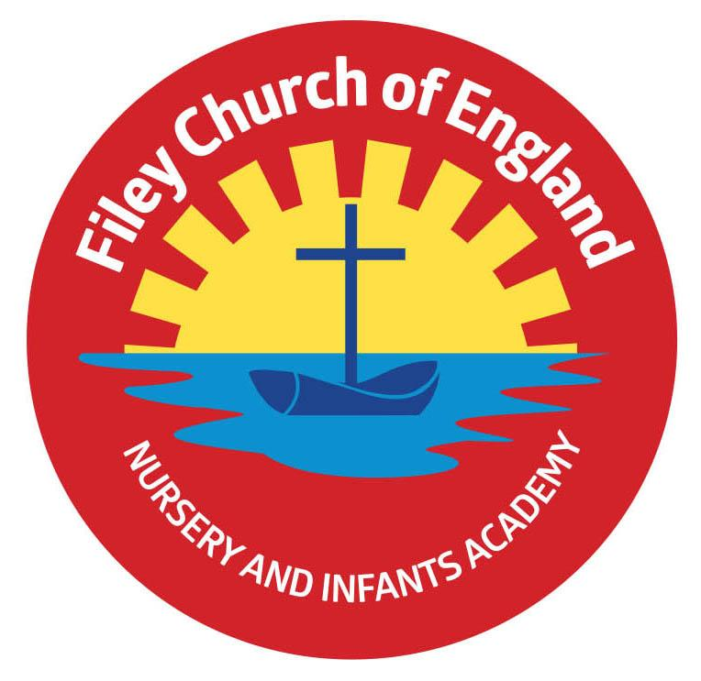
Friday 30th June 2023
Dear Parents/Carers
What a wonderful week in school! Year 1 had a super time in Glen Gardens on Thursday, enjoying many team-building activities. Our Reception children held their Pirate Enterprise events this week and were tremendous! It was great to see so many parents/carers at our open evening on Tuesday. I would like to sincerely thank you all for your kind comments and the great support that you give to myself and all the school staff and Governors, it really is very much appreciated and means a lot.
Mr Jackson’s class won the attendance award this week with 99%, well done to them.

Summer Fair
This year our Summer Fair will take place after school on Friday 14th July from 3pm-4.30pm. There will be a variety of stalls including tombola, raffle, cakes, hot dogs, face painting, games and competitions. Children are invited to wear non-uniform on Friday 7th July and bring a bottle to school for the tombola. This can be any kind of bottle including: bubble bath, juice, sauces, pop or alcohol (please ensure alcohol is passed over to a member of staff or dropped off at the office). As always, we thank you for your support.

Family Learning, Reading Club & Choir
There will be no Family Learning, Reading Club or Choir Practise next week (3rd-7th) due to transition days and various other commitments. All these activities will take place the week after (10th-14th) but these will be the last sessions before we break up for the summer holidays. Just to clarify there will be no extracurricular activities in the last week of term.

NHS 75th Birthday Competition
The National Health Service turns 75 on 5 July 2023 and Ebor schools are being asked to help celebrate the achievements of one of the nation’s most loved institutions.
We appreciate the vital role the service plays in our lives, recognise, and thank the extraordinary NHS staff – the everyday hero – who are there to guide, support and care for us, day in, day out. The NHS Humber and North Yorkshire Integrated care board would like to work with all primary and secondary schools in the area to launch a drawing competition, with the winner receiving a prize and a framed copy of the final artwork.

We want to encourage all schoolchildren to take part by submitting a picture of ‘what the NHS means to them’. The picture can be a line drawing, painting, charcoal…. The one and only criteria is it has to depict what the NHS means to the artist. Any child participating should ask their parent/carer to submit their entries electronically to the following email address: hnyicb.communications@nhs.net Entries must include Name, Age and Postcode only. Entries must be submitted by Sunday 9th July. The overall winning piece will be chosen at the end of NHS birthday month in July and the winner will be notified by email.

Reading Challenge
Children can once again sign up for the Summer Reading Challenge at Filey library during the holidays. This year the theme is Ready, Set, Read! and is all about the power of play, sport, games and physical activity.

Free Holiday Activities
There are a wide range of activities available through the FEAST programme over the summer holiday period. Ranging from sports to drama and cookery, the activities are free to eligible families through a voucher scheme. Eligibility includes Pupil Premium and children with additional needs. If you feel that you may be eligible and have not yet received vouchers (via email), please contact school and we will make sure that you are sent some.

The Story Garden
The Story Garden in Gristhorpe is an outdoor playgroup with every session starting with a story, which then leads to numerous free flow activities. It is suitable for toddlers to 6 years old and takes place on a Tuesday and Thursday morning 10am-11am. If you would like more information please see the leaflet attached to this email or visit ‘The Story Garden’ (Facebook) or @the.story.garden (Instagram) to book.

Thank you for your continued support, we are here to help our children and families in any way that we can. If you have any questions or concerns please do not hesitate to get in touch.
Best Wishes
Angela Clark
Mrs Angela Clark
Headteacher

Diary Dates
July
Tuesday 4th July – Transition day for Year 2 children to the Junior School
Wednesday 5th July – Transition day for all children in school including Year 2 (NO SWIMMING ON THIS DAY).
Thursday 6th July – Transition day for Year 2 children to the Junior School
Thursday 6th July – Outdoor Education day to Filey Beach for Reception children
Friday 7th July – Nursery Enterprise 2.15pm
Monday 10th July – Open the Book Collective Worship
Friday 14th July – School Summer Fayre 3pm – 4.30pm
Monday 17th July – Year 2 Sports Day 1pm
Tuesday 18th July – Year 1 Sports Day 1pm
Wednesday 19th July – Reception Sports Day 1pm
Thursday 20th July – Nursery Sports Day 1pm
Thursday 20th July – Year 2 Leavers Disco 5pm-6.30pm
Friday 21st July – Year 2 Leavers Collective Worship 11am
Friday 21st July – Family Picnic – everyone invited 12pm – School Closes at the usual time of 3.05pm

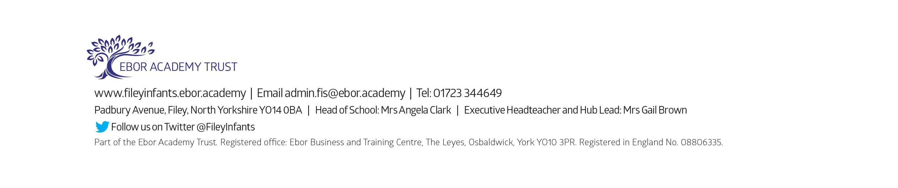
Tuesday 5th September – School opens for the start of the academic year 2023/2024

