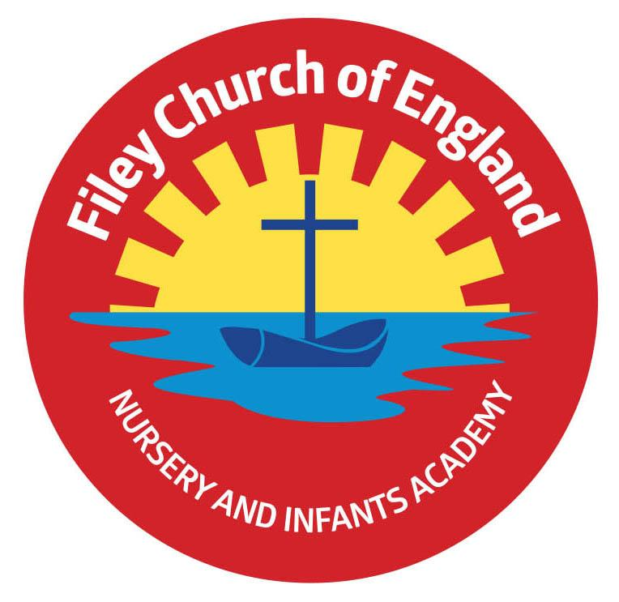
Friday 23rd June 2023
Dear Parents/Carers
The next teacher strike days are planned for Wednesday 5th and Friday 7th July. Wednesday 5th July is our school transition day and the year 2 children will be at Filey Junior School. I have liaised with Mr McCarthey and our transition days will go ahead as planned with no disruption caused by the upcoming strike action.
Mrs Mackay’s class won the attendance award this week with 97.5%, well done to them.

School Reports
School reports go out today. This envelope will also include assessment results for Reception and Year 2. It also includes your child’s attendance and who their teacher will be in September. Please note: Phonic screening results for Year 1 and some year 2 pupils will not come home until Monday 26th June, which is the official release date.

Outdoor Education Days
Year 1 children will take part in their outdoor education day in Glenn Gardens on Thursday 29th June. They will be able to order a school packed lunch on the morning of their trip. Please ensure that sun cream is applied before school, a sun hat is advised and extra drinks if the weather is hot. School uniform does not need to be worn, children will need comfortable clothes and shoes that are ok to get dirty.
Reception children have their outdoor education day to Filey Beach on Thursday 6th July. They will be able to order a school packed lunch on the morning of their trip. Please ensure that sun cream is applied before school, a sun hat is advised and extra drinks if the weather is hot. School uniform does not need to be worn, children will need comfortable clothes and shoes that are ok to get wet/dirty. Reception children are also invited to bring a named bucket and spade with them on this trip.

Reception Enterprise Projects
Parents/carers are invited to attend Mrs Stubbs and Miss Wither’s class enterprise events next week in the school hall. Mrs Stubbs’ class will hold theirs on Thursday 29th June at 2.30pm and Miss Withers will be on Friday 30th June 2.30pm. These are always good fun and a great opportunity for the children to share what they have been doing in class. Of course, it is an enterprise project so they are hoping to raise a little bit of money too, if you are able to support them with this venture, we are as ever grateful.

School Open Evening
On Tuesday 27th June between 4pm and 6pm, we will be holding our school open evening. This is a wonderful opportunity to have a look around school, visit your child’s old/new classroom and teachers and ask any questions that you may have.

Summer Fair
This year our Summer Fair will take place after school on Friday 14th July from 3pm-4.30pm. There will be a variety of stalls including tombola, raffle, cakes, hot dogs, face painting, games and competitions. Children are invited to wear non-uniform on Friday 7th July and bring a bottle to school for the tombola. This can be any kind of bottle including: bubble bath, juice, sauces, pop or alcohol (please ensure alcohol is passed over to a member of staff or dropped off at the office). As always, we thank you for your support.

Thank you for your continued support, we are here to help our children and families in any way that we can. If you have any questions or concerns please do not hesitate to get in touch.
Best Wishes
Angela Clark
Mrs Angela Clark
Headteacher

Diary Dates
June
Friday 23rd June – School Reports go out to parents
Tuesday 27th June – School Open Evening 4pm-6pm
Thursday 29th June – Outdoor Education day to Glenn Gardens for Year 1
Thursday 29th June – Mrs Stubbs Class Enterprise – 2.30pm in the school hall
Friday 30th June – Miss Withers Class Enterprise – 2.30pm in the school hall
July
Tuesday 4th July – Transition day for Year 2 children to the Junior School
Wednesday 5th July – Transition day for all children in school including Year 2 (NO SWIMMING ON THIS DAY).
Thursday 6th July – Transition day for Year 2 children to the Junior School
Thursday 6th July – Outdoor Education day to Filey Beach for Reception children
Friday 7th July – Nursery Enterprise 2.15pm
Monday 10th July – Open the Book Collective Worship
Friday 14th July – School Summer Fayre 3pm – 4.30pm
Monday 17th July – Year 2 Sports Day 1pm
Tuesday 18th July – Year 1 Sports Day 1pm
Wednesday 19th July – Reception Sports Day 1pm
Thursday 20th July – Nursery Sports Day 1pm
Thursday 20th July – Year 2 Leavers Disco 5pm-6.30pm
Friday 21st July – Year 2 Leavers Collective Worship 11am
Friday 21st July – Family Picnic – everyone invited 12pm – School Closes at the usual time of 3.05pm
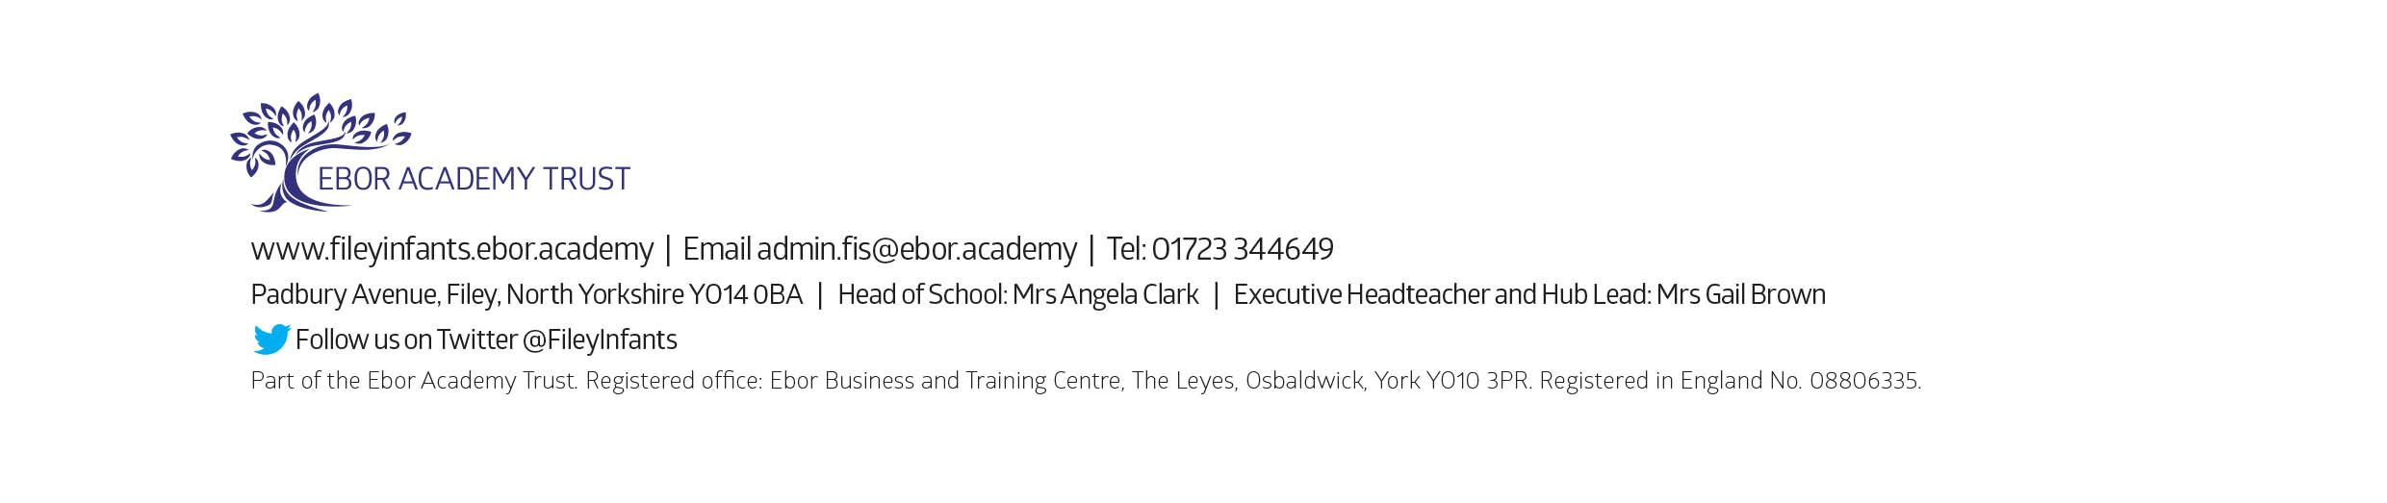
Tuesday 5th September – School opens for the start of the academic year 2023/2024

