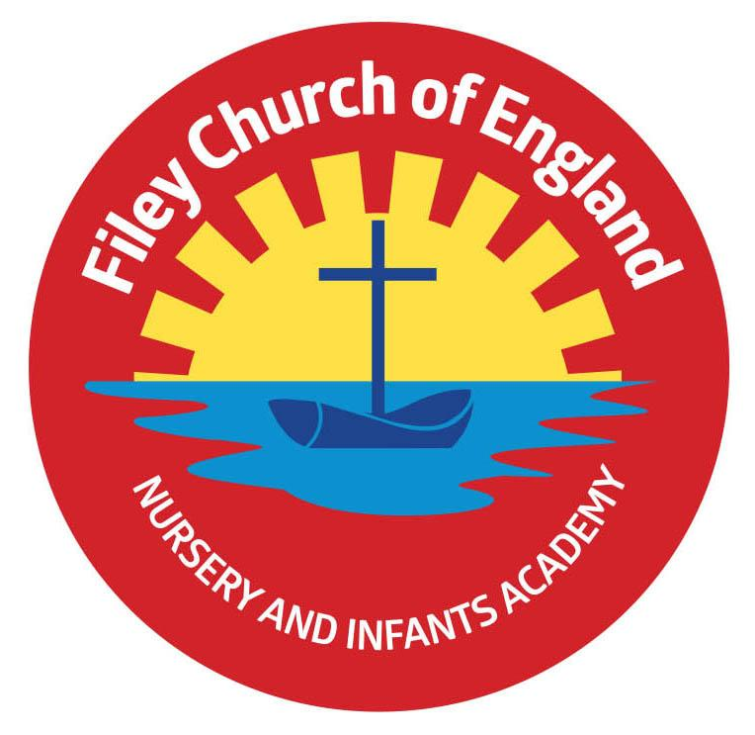
Friday 16th June 2023
Dear Parents/Carers
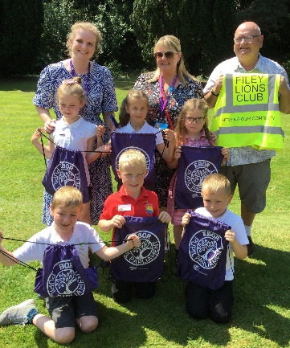
Another busy week in school with a very proud moment for our Pupil Parliament children who had the great honour of presenting their work to Ebor Academy Trustees this week in York. They were all fantastic and the youngest children at the event, a big thank you to John and Filey Lions for providing the transport. Miss Withers’ class won the attendance award this week with 97%, well done to them.

Outdoor Education Days
Our year two children enjoyed a wonderful day in Dalby Forest yesterday. They took part in team building and problem solving activities whilst also learning more about the environment around them.
Year 1 children will take part in their outdoor education day in Glenn Gardens on Thursday 29th June. They will be able to order a school packed lunch on the morning of their trip. Please ensure that sun cream is applied before school, a sun hat is advised and extra drinks if the weather is hot. School uniform does not need to be worn, children will need comfortable clothes and shoes that are ok to get dirty.
Reception children have their outdoor education day to Filey Beach on Thursday 6th July. They will be able to order a school packed lunch on the morning of their trip. Please ensure that sun cream is applied before school, a sun hat is advised and extra drinks if the weather is hot. School uniform does not need to be worn, children will need comfortable clothes and shoes that are ok to get wet/dirty. Reception children are also invited to bring a named bucket and spade with them on this trip.

School Open Evening
On Tuesday 27th June between 4pm and 6pm, we will be holding our school open evening. This is a wonderful opportunity to have a look around school, visit your child’s old/new classroom and teachers and ask any questions that you may have.

Classes for September
School staff and the senior leadership team are in the process of organising classes for September. It is important that parents/carers know that we take a great deal of time and care when placing children in their new classes. Classes do change each year as do teachers often move into different year groups. We consider many things when placing children in new classes including social, emotional and educational aspects of school life.
As I am sure you can appreciate, we are not in a position to let parents/carers choose who is or is not in their child’s class. Please understand that decisions are always made professionally and in the best interests of everyone concerned. Our school transition day is on Wednesday 5th July, this is an opportunity for children to meet their new teacher and their new classmates. This day is always a fun day in school and helps to reduce any anxiety children may have before breaking up for the Summer holidays.

Transition Days
Year 2 children have three transition days to the Junior School. They will need to come to our school as normal on Tuesday 4th July, we will then walk the children to the Junior School and say goodbye for now. You will need to collect your child from the Junior School at 3.30pm and drop them off the following two mornings. On Thursday 6th July, the Junior School teachers walk the children back to our school so you collect them from us at 3.05pm at the end of the last transition day.
Year 1 and Reception children should be dropped off and collected at their usual classroom on Wednesday 5th July. They will then spend the day with their new teacher in their new classroom so they can get to know everyone and alleviate any anxieties before September.

School Reports
School reports will go out on Friday 23rd June at the end of the day. This envelope will also include assessment results for Reception, Year 1 and Year 2. It also includes your child’s attendance and who their teacher will be in September.

Summer Fair
This year our Summer Fair will take place after school on Friday 14th July from 3pm-4.30pm. There will be a variety of stalls including tombola, raffle, cakes, hot dogs, face painting, games and competitions. Children are invited to wear non-uniform on Friday 7th July and bring a bottle to school for the tombola. This can be any kind of bottle including: bubble bath, juice, sauces, pop or alcohol (please ensure alcohol is passed over to a member of staff or dropped off at the office). As always, we thank you for your support.

Thank you for your continued support, we are here to help our children and families in any way that we can. If you have any questions or concerns please do not hesitate to get in touch.
Best Wishes
Angela Clark
Mrs Angela Clark
Headteacher

Diary Dates
June
Friday 23rd June – School Reports go out to parents
Tuesday 27th June – School Open Evening 4pm-6pm
Thursday 29th June – Outdoor Education day to Glenn Gardens for Year 1
Thursday 29th June – Mrs Stubbs Class Enterprise – 2.30pm in the school hall
Friday 30th June – Miss Withers Class Enterprise – 2.30pm in the school hall
July
Tuesday 4th July – Transition day for Year 2 children to the Junior School
Wednesday 5th July – Transition day for all children in school including Year 2 (NO SWIMMING ON THIS DAY).
Thursday 6th July – Transition day for Year 2 children to the Junior School
Thursday 6th July – Outdoor Education day to Filey Beach for Reception children
Friday 7th July – Nursery Enterprise 2.15pm
Monday 10th July – Open the Book Collective Worship
Friday 14th July – School Summer Fayre 3pm – 4.30pm
Monday 17th July – Year 2 Sports Day 1pm
Tuesday 18th July – Year 1 Sports Day 1pm
Wednesday 19th July – Reception Sports Day 1pm
Thursday 20th July – Nursery Sports Day 1pm
Thursday 20th July – Year 2 Leavers Disco 5pm-6.30pm
Friday 21st July – Year 2 Leavers Collective Worship 11am
Friday 21st July – Family Picnic – everyone invited 12pm – School Closes at the usual time of 3.05pm
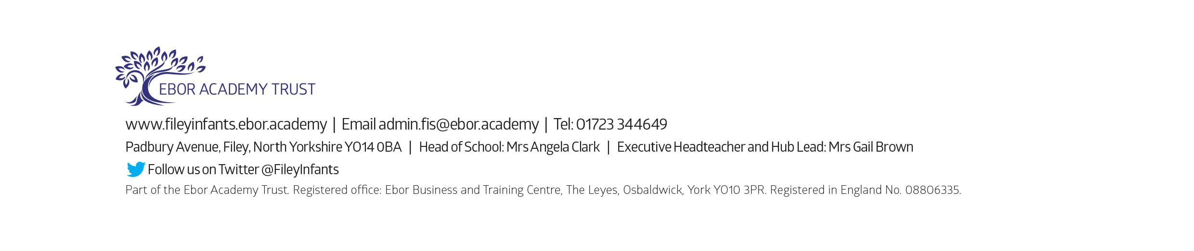
Tuesday 5th September – School opens for the start of the academic year 2023/2024

