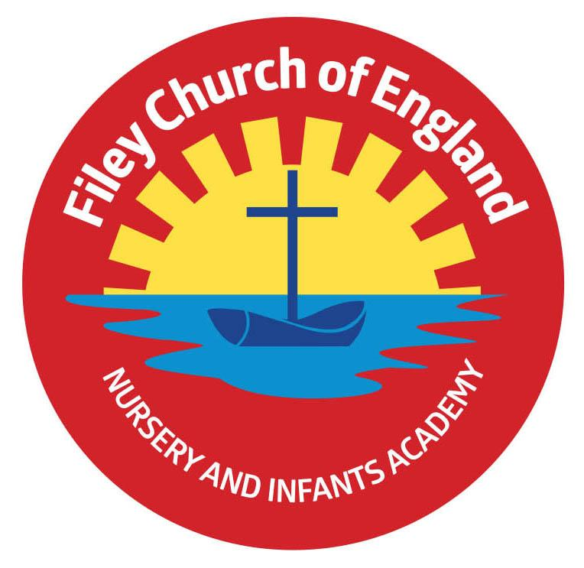
Friday 19th May 2023
Dear Parents/Carers
Thank you to Mrs Stubbs and Miss Withers classes for their recent poetry assemblies. They were both a real treat for everyone to watch and enjoy. If you were unable to attend, recordings can be found in the usual place on our school website: under TEACHING & LEARNING – Classes – Teachers name
Miss Withers’ class won the attendance award this week with 97%, well done to them.

CHANGE of DATE for Y2 Dalby Forest Outdoor Education Day
Unfortunately, we have had to rearrange our Year 2 outdoor education day to Dalby Forest. This will now take place on Thursday 15th June. All details remain the same, the date has just moved forward by one week. The letter and slip brought home by your child is still valid, please just note the change of date and return the slip with £7 voluntary contribution by Friday 9th June, 3pm.

Parent Painting Party!
Calling all parent volunteers! We are desperately in need of painting most of our outdoor woodwork, including sheds, benches, fences, flowerpots etc. Due to the rising costs of just about everything, we are hoping that a group of volunteers might offer an afternoon to come along and have fun painting! Our children will bring refreshments to keep you going and say thank you! (paint, brushes and gloves will be provided) If you are able to help with this project please telephone the school office on 344649 and we can arrange a suitable afternoon in June.

Pupil Parliament Invitation
Our pupil parliament children have been invited to present at a Trustees meeting on 13th June at The Parsonage, Escrick in York. They will have the opportunity to share the work they have done in school this year towards achieving our Global Goals and answer questions from Ebor Academy Trustees. We of course are delighted to attend with Miss Ring who has been leading this wonderful project in school. Pupil Parliament children will bring home a letter soon with more information regarding this exciting invitation.

Children’s Mental Health
Young Minds provide children and their families with reassurance and advice to help them make positive choices for their mental health. If your child is struggling with their mental health and you need to know what to do next this website could help: https://www.youngminds.org.uk/parent/parents-helpline-and-webchat/#ParentsHelpline

Class Photographs
You should have received an email regarding class photographs, follow the link if you would like to place an order. The last day to order with free delivery to school is 1st June 2023. Please contact the school office if you have not received the email.

FREE Uniform Cupboard
If you would like any good quality second-hand items from our uniform cupboard, please ask either your child’s class teacher or telephone the school office. We have summer dresses, skirts, trousers, polo tops, jumpers and cardigans in all sizes. We are also grateful to receive any uniform items that are still in good condition but are no longer required. Together we can recycle as much as possible, reduce landfill and save money at the same time.

If you have any questions please do not hesitate to get in touch. Please remember to follow us on Twitter to see what your children are doing in school.
Best Wishes
Angela Clark
Mrs Angela Clark
Headteacher

Diary Dates – (more dates may be added each week as they arise)
May
Monday 22nd May – Year 2 children visit Filey Museum.
Wednesday 24th May – Last Swimming Session for Miss Haldenby’s class
Friday 26th May – Break up for half term
June
Monday 5th June – School re-opens
Wednesday 7th June – Swimming lessons start for Miss Ring’s class
Monday 12th June – Open the Book Collective Worship
Thursday 15th June - After school PE club starts for Reception
Thursday 15th June - After school cookery club starts Year 1
Thursday 15th June – Outdoor Education Day to Dalby Forest for Year 2 NEW DATE
Thursday 22nd June – Outdoor Education day to Dalby Forest for Year 2 CHANGE of DATE!
Friday 23rd June – School Reports go out to parents
Monday 26th June – Lunchtime Wonder Time club starts for Year 1
Tuesday 27th June – School Open Evening 4pm-6pm
Thursday 29th June – Outdoor Education day to Glenn Gardens for Year 1
Thursday 29th June – Mrs Stubbs Class Enterprise – 2.30pm in the school hall
Friday 30th June – Miss Withers Class Enterprise – 2.30pm in the school hall
July
Tuesday 4th July – Transition day for Year 2 children to the Junior School
Wednesday 5th July – Transition day for all children in school including Year 2 (NO SWIMMING ON THIS DAY).
Thursday 6th July – Transition day for Year 2 children to the Junior School
Thursday 6th July – Outdoor Education day to Filey Beach for Reception children
Friday 7th July – Nursery Enterprise 2.15pm
Monday 10th July – Open the Book Collective Worship
Friday 14th July – School Summer Fayre 3pm – 4.30pm
Monday 17th July – Year 2 Sports Day 1pm
Tuesday 18th July – Year 1 Sports Day 1pm
Wednesday 19th July – Reception Sports Day 1pm
Thursday 20th July – Nursery Sports Day 1pm
Thursday 20th July – Year 2 Leavers Disco 5pm-6.30pm
Friday 21st July – Year 2 Leavers Collective Worship 11am
Friday 21st July – Family Picnic – everyone invited 12pm – School Closes at the usual time of 3.05pm
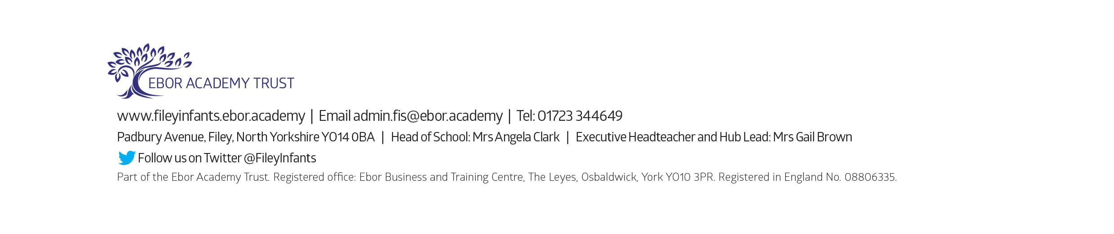
Tuesday 5th September – School opens for the start of the academic year 2023/2024

