Friday 28th April 2023
Dear Parents/Carers
Just a reminder that Monday 1st May is a National Bank holiday and school will not be open on this day. Tuesday 2nd May is due to be another National Strike day for teachers, please note this will not affect our school and we will be open as usual on this day.
Mrs Mackay’s class won the attendance award this week with 97.5%, well done to them.

Class Photographs
Whole class photographs are a great memory of your child’s year in school. They are taken professionally by Tempest Photography and will take place this year on Tuesday 9th May.
All children are included in this photograph unless you telephone the school office and inform us otherwise. You will then receive the sample photo via email and it is your choice whether or not you wish to make a purchase.

HSBC Visit
On Thursday 4th May Mrs Haywood from HSBC Bank will be working with children in school on financial skills for life. This will involve a story time session to help young children learn about spending money. Ed and Bunny Spend Some Money is aimed at children aged between 4 and 7. Interestingly 85% of young adults wish that they had been taught more about money management while they were at school.

World Immunisation Week
With one in ten children in England not up to date with their vaccinations and at risk of becoming seriously unwell, World Immunisation Week is encouraging parents to check if their children are up to date with their MMR vaccines. MMR vaccines protect against measles, mumps and rubella. To become fully protected children need two doses, the first at age one year and the second at 3 years 4 months. If you would like more information please see the leaflet attached to this email.

School FREE Uniform Cupboard
Please remember that we have our recycled uniform cupboard in school. If you would like some items, please just ask your child’s class teacher or telephone the school office. We have a selection of jumpers, cardigans, polo tops, summer dresses and PE kits in all sizes. Also remember to send in any good quality uniform that your child has outgrown. Together we will recycle as much as we can and save some money too!

Morning Dropping off Routines
Please ensure that you see your child come safely through the school gates in a morning. We do have staff on both school gates in a morning for extra safety but it is important that you watch your child pass through these gates before you leave. Our school day officially starts at 8.55am, gates open at 8.40am and are locked at 9am prompt. If you arrive after this time you will need to sign your child in at the school office.

King Charles III Coronation
A winning design has been chosen and will be announced on Friday 5th May during our coronation celebrations. This winning design will be preserved forever on a special plaque next to a tree planted in King Charles III honour. On Friday 5th May, we plan to parade through Filey dressed as Kings, Queens, Princes and Princesses to mark this very special occasion. We will gather at Filey Bandstand (approximately 2.15pm) to sing the National Anthem for anyone that would like to join us. Staff and children are invited to dress as Kings, Queens, Princes or Princesses for the day. All children will be making a royal crown in class so they can wear this on the day if they wish.
Thank you for your continued support, if you have any questions please remember we are here to help in any way that we can. Please remember to follow us on Twitter to see all the wonderful things happening in school.
Best Wishes
Angela Clark
Headteacher

Diary Dates – (more dates may be added each week as they arise)
May
Monday 1st May – Bank Holiday
Thursday 4th May – HSBC visit – Ed and Bunny Spend Some Money
Friday 5th May – Royal Parade around Filey for the coronation of King Charles III
Monday 8th May – National Bank Holiday for King Charles III Coronation
Tuesday 9th May – Class Photographs
Friday 12th May – Mrs Stubbs poetry assembly in the school hall at 9am
Friday 19th May – Miss Withers poetry assembly in the school hall at 9am
Wednesday 24th May – Last Swimming Session for Miss Haldenby’s class
Friday 26th May – Break up for half term
June
Monday 5th June – School re-opens
Wednesday 7th June – Swimming lessons start for Miss Ring’s class
Monday 12th June – Open the Book Collective Worship
Thursday 15th June - After school PE club starts for Reception
Thursday 15th June - After school cookery club starts Year 1
Thursday 22nd June – Outdoor Education day to Dalby Forest for Year 2
Friday 23rd June – School Reports go out to parents
Monday 26th June – Lunchtime Wonder Time club starts for Year 1
Tuesday 27th June – School Open Evening 4pm-6pm
Thursday 29th June – Outdoor Education day to Glenn Gardens for Year 1
Thursday 29th June – Mrs Stubbs Class Enterprise – 2.30pm in the school hall
Friday 30th June – Miss Withers Class Enterprise – 2.30pm in the school hall
July
Tuesday 4th July – Transition day for Year 2 children to the Junior School
Wednesday 5th July – Transition day for all children in school including Year 2
Thursday 6th July – Transition day for Year 2 children to the Junior School
Thursday 6th July – Outdoor Education day to Filey Beach for Reception children
Friday 7th July – Nursery Enterprise 2.15pm
Monday 10th July – Open the Book Collective Worship
Friday 14th July – School Summer Fayre 3pm – 4.30pm
Monday 17th July – Year 2 Sports Day 1pm
Tuesday 18th July – Year 1 Sports Day 1pm
Wednesday 19th July – Reception Sports Day 1pm
Thursday 20th July – Nursery Sports Day 1pm
Thursday 20th July – Year 2 Leavers Disco 5pm-6.30pm
Friday 21st July – Year 2 Leavers Collective Worship 11am
Friday 21st July – Family Picnic – everyone invited 12pm – School Closes at the usual time of 3.05pm
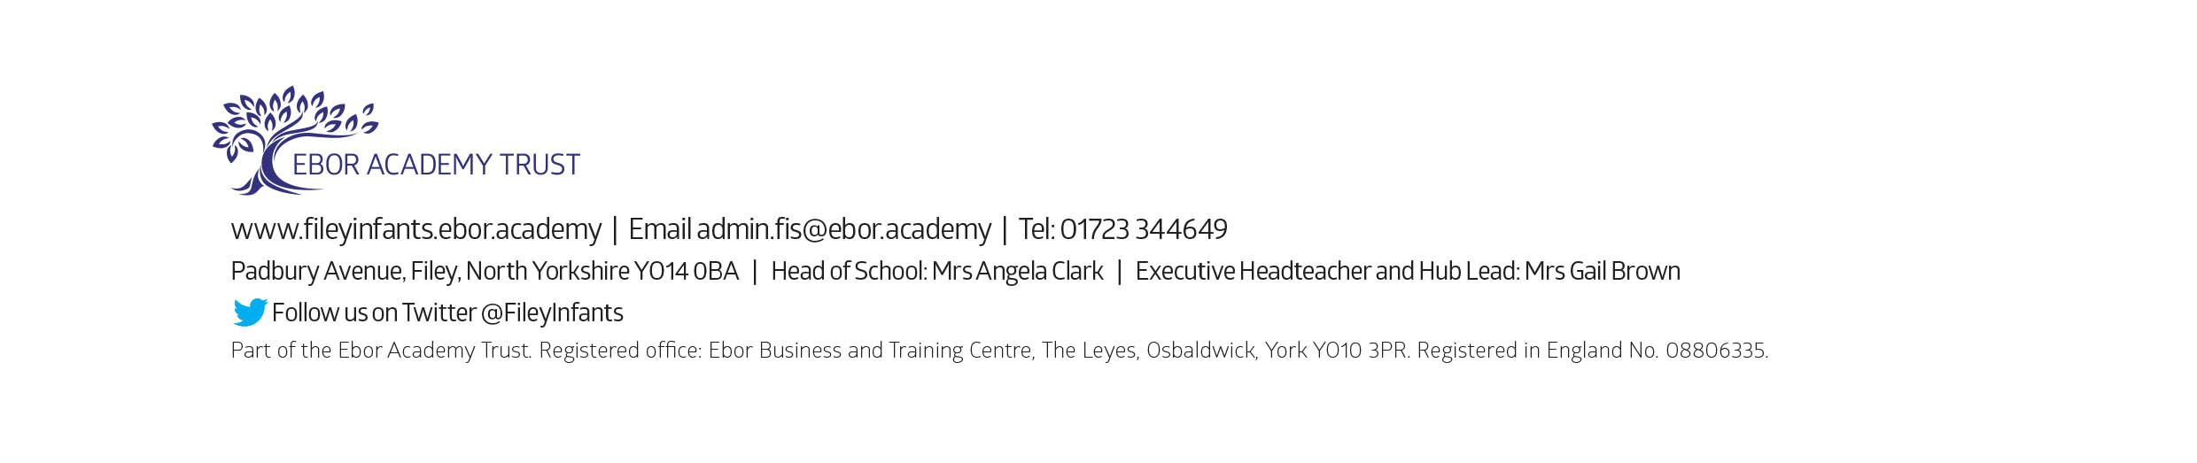
Tuesday 5th September – School opens for the start of the academic year 2023/2024

