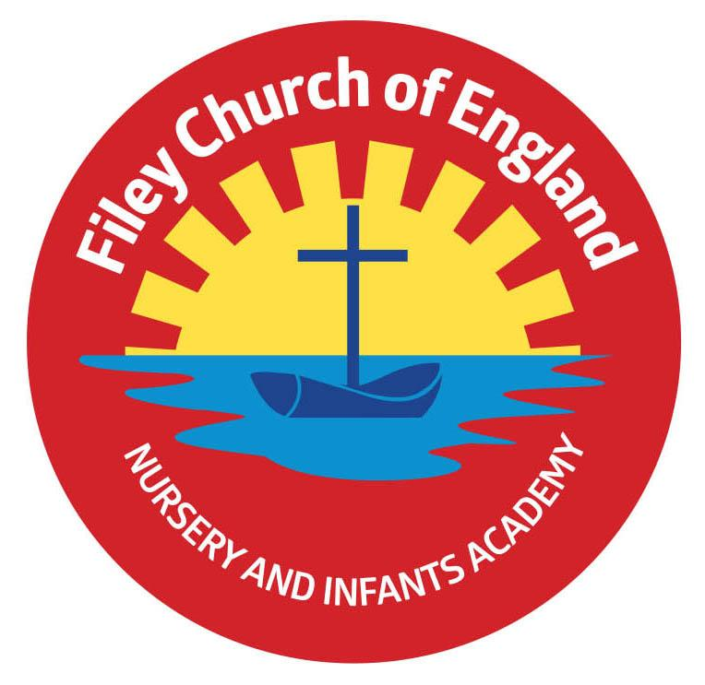
Friday 21st April 2023

Dear Parents/Carers
Welcome back! It has been a lovely week in school with everyone enjoying the sunshine. Please apply sun cream to your children before school in hot weather and provide a sunhat if required. Children are welcome to bring a drink bottle to school, please make sure this is a named bottle and only contains water or cordial (NO fizzy drinks OR energy drinks).
Thursday 27th April is due to be another National Strike day for teachers, please note this will not affect our school and we will be open as usual on this day.
Mrs Mackay’s class won the attendance award this week with 94.8%, well done to them.

Calling all Nursery new Starters! As you know, we have a very successful Nursery as part of our school with the wonderful Miss Hiley and her team. It is now the time of year when we need to allocate our Nursery places for September 2023. If you know anyone with children aged 3 before the 1st September 2023 please let them know that they need to get in touch with us as soon as possible to secure a place for their child. They can do this by phoning the office on 344649 or calling in.

32.5 Hour Week – Potential Future Change to School Hours
You may recall I asked for parental feedback regarding a possible change to our school hours. Thank you to everyone who shared their thoughts with us regarding this matter.
The Government have advised that all schools should offer a 32.5 hour week for all children. The difficulty we have is that our school and Filey Junior School are at opposite sides of Filey and we need to allow 20minutes for parents to walk between the two schools during drop off and collection times.

It was suggested by our Governors that our official start time would need to be 8.40am with a finish time of 3.10pm. Several parents raised concerns around this start time being too early for young children, with other concerns around a 3.10pm finish time being the same finish time as the Secondary school, which would then affect the volume of traffic.

I am sure you can see we are in a very difficult position! The school Governors, Ebor Academy trustees and I have decided that for the next academic year 2023/2024 (while this Government request is not a legal requirement) we will leave our official start and finish times the same (8.55am start and 3.05pm finish – giving us a 30hr 50min week). We do open our school gates/doors at 8.40am anyway for children to come into class and enjoy either a free breakfast or the early bird activities on offer (giving an optional 32hour 5min week).

I would encourage you to try bringing your children to school as close to 8.40am as you can in preparation for the future eventuality being that we have no other option than to make this our official start time for the academic year 2024/2025. If you have any questions, as always please just call into the office or telephone on 344649.

Children’s Book Swap!
Every Friday morning starting next week children are invited to bring a book to school that they have finished with and swap it with a different book to take home. There will be a selection of books on display in between Mrs Stubbs and Miss Withers class for Nursery and Reception children to choose from and a selection of books outside Miss Williams class for year 1 and year 2 children to choose from. This is a great way to enjoy many different books without having to buy them.
Parent Library Books
Starting next week there will be a selection of books for adults on ‘Big Red’ The Reading Bus. Adults are invited to come along to Family Reading Club and choose a book to take home to read. Family Reading club takes place on a Monday and Wednesday at 2.40pm, please come to the main reception area on either of these days if you would like to take part.

Chicken Pox
Just to let everyone know that we have had many cases of Chicken Pox in school over the last week. Chickenpox is a very contagious infection that causes an itchy, spotty rash. It is common in children but adults can get it too. Symptoms of chickenpox include itchy spots that become blisters, then scabs. It can be anywhere on the body, including in the mouth.
Chickenpox usually gets better on its own after 1 to 2 weeks. You can ease symptoms with cooling creams, antihistamines and paracetamol. Children remain infectious and would therefore need to stay absent from school until all the spots crust over (usually about five days after the rash appears).

King Charles III Coronation
Please make sure children have returned their competition sheet/design by 9am on Monday 24th April. The winning design will be preserved forever on a special plaque next to a tree planted in King Charles III honour. The winner will also receive a prize! If your child has misplaced the sheet given out before the Easter holiday it is attached to this email and can be printed.
On Friday 5th May, we plan to parade through Filey dressed as Kings, Queens, Princes and Princesses to mark this very special occasion. We will gather at Filey Bandstand (approximately 2.15pm) to sing the National Anthem for anyone that would like to join us. Staff and children are invited to dress as Kings, Queens, Princes or Princesses for the day. All children will be making a royal crown in class so they can wear this on the day if they wish.

Thank you for your continued support, if you have any questions please remember we are here to help in any way that we can. Please remember to follow us on Twitter to see all the wonderful things happening in school.
Best Wishes
Angela Clark
Headteacher

Diary Dates – (more dates may be added each week as they arise)
April
Tuesday 18th April – School re-opens for the start of the Summer term.
Thursday 20th April – After school PE club starts for Year 1
Thursday 20th April – After school cookery club starts for Year 2
Monday 24th April – Lunchtime Wonder Time club starts for Year 2
May
Monday 1st May – Bank Holiday
Friday 5th May – Royal Parade around Filey for the coronation of King Charles III
Monday 8th May – National Bank Holiday for King Charles III Coronation
Friday 12th May – Mrs Stubbs poetry assembly in the school hall at 9am
Friday 19th May – Miss Withers poetry assembly in the school hall at 9am
Wednesday 24th May – Last Swimming Session for Miss Haldenby’s class
Friday 26th May – Break up for half term
June
Monday 5th June – School re-opens
Wednesday 7th June – Swimming lessons start for Miss Ring’s class
Monday 12th June – Open the Book Collective Worship
Thursday 15th June - After school PE club starts for Reception
Thursday 15th June - After school cookery club starts Year 1
Thursday 22nd June – Outdoor Education day to Dalby Forest for Year 2
Friday 23rd June – School Reports go out to parents
Monday 26th June – Lunchtime Wonder Time club starts for Year 1
Tuesday 27th June – School Open Evening 4pm-6pm
Thursday 29th June – Outdoor Education day to Glenn Gardens for Year 1
Thursday 29th June – Mrs Stubbs Class Enterprise – 2.30pm in the school hall
Friday 30th June – Miss Withers Class Enterprise – 2.30pm in the school hall
July
Tuesday 4th July – Transition day for Year 2 children to the Junior School
Wednesday 5th July – Transition day for all children in school including Year 2
Thursday 6th July – Transition day for Year 2 children to the Junior School
Thursday 6th July – Outdoor Education day to Filey Beach for Reception children
Friday 7th July – Nursery Enterprise 2.15pm
Monday 10th July – Open the Book Collective Worship
Friday 14th July – School Summer Fayre 3pm – 4.30pm
Monday 17th July – Year 2 Sports Day 1pm
Tuesday 18th July – Year 1 Sports Day 1pm
Wednesday 19th July – Reception Sports Day 1pm
Thursday 20th July – Nursery Sports Day 1pm
Thursday 20th July – Year 2 Leavers Disco 5pm-6.30pm
Friday 21st July – Year 2 Leavers Collective Worship 11am
Friday 21st July – Family Picnic – everyone invited 12pm
Friday 21st July – School Closes at the usual time of 3.05pm

Tuesday 5th September – School opens for the start of the academic year 2023/2024

