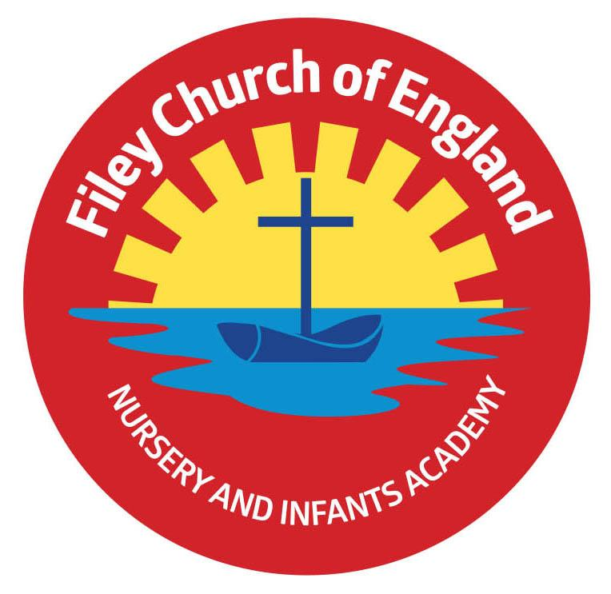
Friday 31st March 2023

Dear Parents/Carers
Thank you to everyone who has supported our Easter Eggstravaganza’s this week.
The children have enjoyed all the different activities, including our visit to St John’s Church this morning and all the fun of the parade this afternoon. A big thank you to our friends from St John’s Church for providing us with 14 wonderful Easter food bags, we are always very grateful for their kindness. Congratulations to everyone who won a prize today and a huge thank you for taking part.
Miss Haldenby’s class won the attendance award this week with 96%, well done to them.

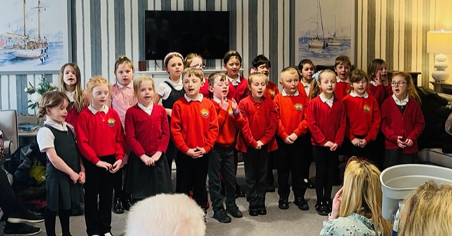
School Choir
A big thank you to our school choir who all sang beautifully on Tuesday and Thursday this week at Silver Birches, Filey Fields and Cayton Village Hall. They were a credit to our school and made many elderly people in our community very happy. Thank you to Filey Lions for providing the transport.

Emotional Wellbeing
Emotional well-being is all about keeping your mind and body healthy. There are lots of different things that we can do to keep our mind and body healthy. If you are interested to find out more, I have attached a booklet to this email that has been designed for you and your child to read together. The booklet explains a little bit about what emotional well-being is, and will give you some ideas on how to look after it.

Yorkshire Attractions
The Yorkshire Attractions voucher booklet contains discount vouchers for a variety of attractions throughout Yorkshire, for use during the Easter holidays and beyond.
The booklet can be downloaded by copying this link into your internet browser: https://yorkshireattractions.org/wp-content/uploads/YAG-Spring-Voucher-Book-2023.pdf

Feast Free Activities
If your child is entitled to free school meals, they will have received a letter from school about the Government offer of free activities. You will need the code that was printed on your letter to sign your child up to the activities on offer. Please follow this link to apply and find out more: https://bit.ly/NYCCEYT

Seaside SaLT
Seaside SaLT is an independent paediatric Speech and Language Therapy service, working with children from 0 to 18 years in the Scarborough, Whitby, and Ryedale areas. They hold regular free drop-in sessions to which parents and carers can go along, ask questions, and voice their concerns about their child’s speech, language, and communication development. If you would like more information, please see the leaflet attached to this email.

King Charles III Coronation
Your child will have brought home today a competition sheet for King Charles III coronation. We ask all children to create a design within the template of King Charles III head on the sheet provided. The winning design will be preserved forever on a special plaque next to a tree planted in King Charles III honour. The winner will also receive a prize! Please can all entries be handed in to class teachers by 9am on Monday 24th April.

On Friday 5th May, we plan to parade through Filey dressed as Kings, Queens, Princes and Princesses to mark this very special occasion. We will gather at Filey Bandstand (approximately 2.15pm) to sing the National Anthem for anyone that would like to join us. Staff and children are invited to dress as Kings, Queens, Princes or Princesses for the day. If your child would like to make a royal crown in school please let their class teacher know and this can be arranged.

Thank you for your continued support, if you have any questions please remember we are here to help in any way that we can. Please remember to follow us on Twitter to see all the wonderful things happening in school.
Best Wishes
Angela Clark
Headteacher

Diary Dates – (more dates may be added each week as they arise)
April
Tuesday 18th April – School re-opens for the start of the Summer term.
Thursday 20th April – After school PE club starts for Year 1
Thursday 20th April – After school cookery club starts for Year 2
Monday 24th April – Lunchtime Wonder Time club starts for Year 2
May
Monday 1st May – Bank Holiday
Friday 5th May – Royal Parade around Filey for the coronation of King Charles III
Monday 8th May – National Bank Holiday for King Charles III Coronation
Friday 12th May – Mrs Stubbs poetry assembly in the school hall at 9am
Friday 19th May – Miss Withers poetry assembly in the school hall at 9am
Wednesday 24th May – Last Swimming Session for Miss Haldenby’s class
Friday 26th May – Break up for half term
June
Monday 5th June – School re-opens
Wednesday 7th June – Swimming lessons start for Miss Ring’s class
Monday 12th June – Open the Book Collective Worship
Thursday 15th June - After school PE club starts for Reception
Thursday 15th June - After school cookery club starts Year 1
Thursday 22nd June – Outdoor Education day to Dalby Forest for Year 2
Friday 23rd June – School Reports go out to parents
Monday 26th June – Lunchtime Wonder Time club starts for Year 1
Tuesday 27th June – School Open Evening 4pm-6pm
Thursday 29th June – Outdoor Education day to Glenn Gardens for Year 1
Thursday 29th June – Mrs Stubbs Class Enterprise – 2.30pm in the school hall
Friday 30th June – Miss Withers Class Enterprise – 2.30pm in the school hall
July
Tuesday 4th July – Transition day for Year 2 children to the Junior School
Wednesday 5th July – Transition day for all children in school including Year 2
Thursday 6th July – Transition day for Year 2 children to the Junior School
Thursday 6th July – Outdoor Education day to Filey Beach for Reception children
Monday 10th July – Open the Book Collective Worship
Friday 14th July – School Summer Fayre 3pm – 4.30pm
Monday 17th July – Year 2 Sports Day 1pm
Tuesday 18th July – Year 1 Sports Day 1pm
Wednesday 19th July – Reception Sports Day 1pm
Thursday 20th July – Nursery Sports Day 1pm
Thursday 20th July – Year 2 Leavers Disco 5pm-6.30pm
Friday 21st July – Year 2 Leavers Collective Worship 11am
Friday 21st July – Family Picnic – everyone invited 12pm
Friday 21st July – School Closes at the usual time of 3.05pm

Tuesday 5th September – School opens for the start of the academic year 2023/2024

