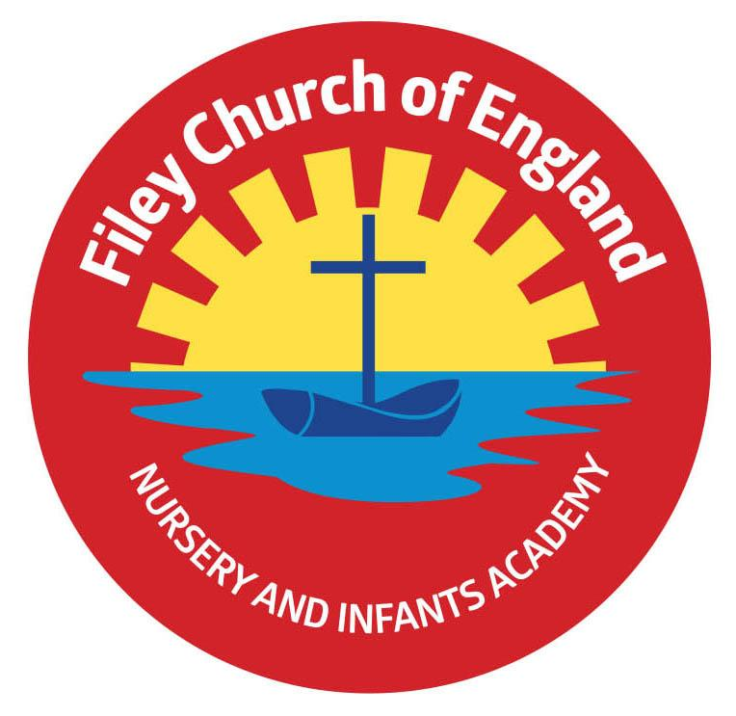
Friday 24th March 2023

Dear Parents/Carers
Thank you to everyone who has supported Miss Ring’s and Miss Haldenby’s class Enterprise projects this week. The children enjoyed the experience and are now deciding how to spend their profits!
Mrs MacKay’s class won the attendance award this week with 99.58%, well done to them.

Tesco Easter egg Picture Competition
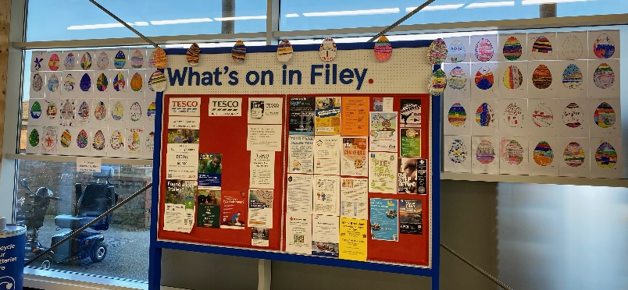
A big thank you to Tesco for the Easter egg picture competition our Year 2 children took part in this week. All children received a treat for taking part but the winners are as follows:
1st Place – Jenson F
2nd Place – Oliver H
3rd Place – Freya H
4th Place - Liliana M
Some of the pictures have been displayed in the Filey Tesco store.

Reminder for the Easter Hat & Egg Decorating Competition
On Friday 31st March, we will be taking part in an Easter hat parade around school, families are invited to join us for this. School gates will open at 2.20pm, you will need to go to your child’s class and take a seat. All children will start the parade around school at 2.30pm and pass through every classroom. Children are welcome to make an Easter headband in school if they do not want to make a hat at home.
Children are also invited to take part in the Egg decorating competition, the theme for each year group is as follows: Nursery & Reception – ‘Time to Grow’ e.g. plants, animals & springtime. Year 1 – ‘People Who Help Us’ e.g. police, doctors, nurses, teachers, firefighters etc. Year 2 – ‘Famous People in History’ e.g. Nelson Mandela, Stevie Wonder, Emmeline Pankhurst etc.

Reminder for the Easter Egg Fundraising Raffle
All the staff in school have kindly donated Easter eggs for a fundraising raffle. If you would like your child to buy a ticket, they cost 50p each and will be drawn on Friday 31st March before the Easter hat parade. Your child will have brought home some tickets, please return them with the correct money if you would like to take part.

School Book Fair
The last day for the scholastic book fair Monday 27th March. It is a great opportunity to use the voucher your child received on World Book Day whilst also raising money towards free books for school.
Thank you for your continued support, if you have any questions please remember we are here to help in any way that we can. Please remember to follow us on Twitter to see all the wonderful things happening in school.

Best Wishes
Angela Clark
Headteacher

Diary Dates – (more dates may be added each week as they arise)

Friday 17th March – Red Nose Day for Comic Relief
Monday 20th March - Reception children weights and heights measurement
Monday 20th March – Miss Ring’s Class Enterprise 2.30pm in the school hall
Tuesday 21st March – School Book Fair arrives
Wednesday 22nd March – Miss Haldenby’s Class Enterprise 2.30pm in the school hall
Monday 27th March – Open the Book Collective Worship
Monday 27th March – 3pm-5.30pm re-scheduled Nursery parent appointments
Tuesday 28th March – 3pm-5.30pm re-scheduled Nursery parent appointments
Tuesday 28th March – The School Choir sing at Silver Birches Care Home and Filey Fields
Wednesday 29th March - Miss Haldenby’s class start swimming lessons
Wednesday 29th March - 3pm-5.30pm re-scheduled Nursery parent appointments
Thursday 30th March – The School Choir sing at Cayton Village Hall for their elderly visitors
Friday 31st March – Children visit St John’s Church for an Easter Service
Friday 31st March – Bring decorated eggs into school for the competition – more details to follow.
Friday 31st March – Easter Egg fundraising raffle – 50p a ticket to win an Easter Egg kindly donated by all the teachers in school.
Friday 31st March – 2.30pm Easter Hat Parade around school – everyone welcome – more details to follow.

Tuesday 18th April – School re-opens for the start of the Summer term.
Monday 1st May – Bank Holiday
Friday 5th May – Royal Parade around Filey – more information to follow
Monday 8th May – National Bank Holiday for King Charles II Coronation
Friday 12th May – Mrs Stubbs poetry assembly in the school hall at 9am
Friday 19th May – Miss Withers poetry assembly in the school hall at 9am
Wednesday 24th May – Last Swimming Session for Miss Haldenby’s class
Friday 26th May – Break up for half term
Monday 5th June – School re-opens

