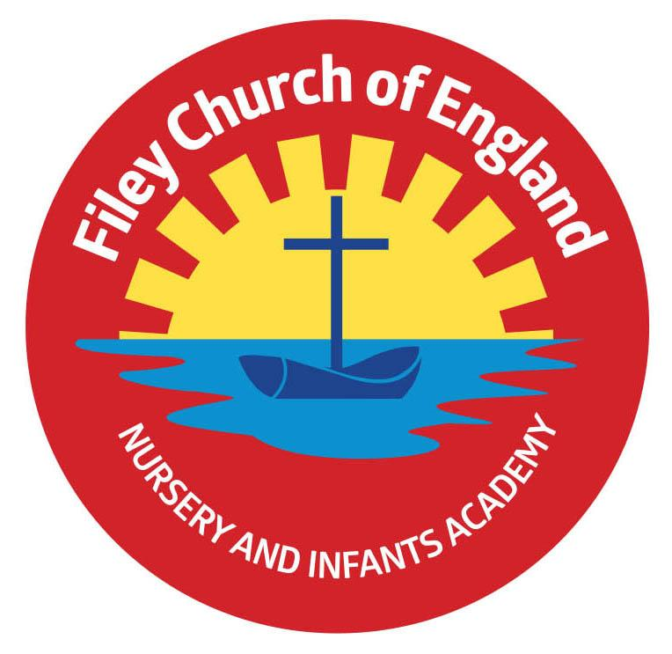
Friday 17th March 2023

Dear Parents/Carers
Thank you to everyone who has supported Comic Relief today, we have had a fun day in school and raised £154.10 for a wonderful charity. Remember to follow us on Twitter!
Mr Jackson’s class won the attendance award this week with 97.5%, well done to them.

Easter Hat & Egg Decorating Competition
On Friday 31st March, we will be taking part in an Easter hat parade around school, families are invited to join us for this. School gates will open at 2.20pm, you will need to go to your child’s class and take a seat. All children will start the parade around school at 2.30pm and pass through every class. Children are welcome to make an Easter headband in school if they do not want to make a hat at home.
Children are also invited to take part in the Egg decorating competition, the theme for each year group is as follows: Nursery & Reception – ‘Time to Grow’ e.g. plants, animals & springtime. Year 1 – ‘People Who Help Us’ e.g. police, doctors, nurses, teachers, firefighters etc. Year 2 – ‘Famous People in History’ e.g. Nelson Mandela, Stevie Wonder, Emmeline Pankhurst etc.

Easter Egg Fundraising Raffle
All the staff in school have kindly donated Easter eggs for a fundraising raffle. If you would like your child to buy a ticket, they cost 50p each and will be drawn on Friday 31st March before the Easter hat parade. Your child will have brought home some tickets, please return them with the correct money if you would like to take part.

Class Enterprise Events
Next week Miss Ring’s class will hold their class Enterprise on Monday 20th March at 2.30pm in the school hall. Miss Haldenby’s class will hold theirs on Wednesday 22nd March at 2.30pm in the school hall. Please come and support the children if you can.

Year 2 Recorder Club
After the Easter holidays our Year 2 Recorder club will move to Tuesday lunchtimes. This is so any children wanting to attend ‘Wondertime’ club on a Monday can do so without missing recorder lessons.

Share Old Book with Children in the Ukraine
Our school council would like to collect any unwanted books to share with children in Ukraine. Please see the poster attached to this email for more information. If you would like to help please bring your unwanted books to the school hall on Wednesday or Friday next week between 8.35am and 9am. Members of our school council will be there to collect the books.

Maths through Stories
Filey Library are holding a special Maths through Stories event on Saturday 25th March 10am – 12pm. This is a fun event for all the family with goody bags to give away. If you would like more information, please see the attached leaflet.

School Book Fair
The scholastic book fair arrives in our school on Tuesday 21st March. This will take place in the school hall each day after school, with the last day being Monday 27th March. It is a great opportunity to use the voucher your child received on World Book Day whilst also raising money towards free books for school.
Thank you for your continued support, if you have any questions please remember we are here to help in any way that we can. Please remember to follow us on Twitter to see all the wonderful things happening in school.

Best Wishes
Angela Clark
Headteacher

Diary Dates – (more dates may be added each week as they arise)

Friday 17th March – Red Nose Day for Comic Relief
Monday 20th March - Reception children weights and heights measurement
Monday 20th March – Miss Ring’s Class Enterprise 2.30pm in the school hall
Tuesday 21st March – School Book Fair arrives
Wednesday 22nd March – Miss Haldenby’s Class Enterprise 2.30pm in the school hall
Monday 27th March – Open the Book Collective Worship
Monday 27th March – 3pm-5.30pm re-scheduled Nursery parent appointments
Tuesday 28th March – 3pm-5.30pm re-scheduled Nursery parent appointments
Tuesday 28th March – The School Choir sing at Silver Birches Care Home and Filey Fields
Wednesday 29th March - Miss Haldenby’s class start swimming lessons
Wednesday 29th March - 3pm-5.30pm re-scheduled Nursery parent appointments
Thursday 30th March – The School Choir sing at Cayton Village Hall for their elderly visitors
Friday 31st March – Children visit St John’s Church for an Easter Service
Friday 31st March – Bring decorated eggs into school for the competition – more details to follow.
Friday 31st March – Easter Egg fundraising raffle – 50p a ticket to win an Easter Egg kindly donated by all the teachers in school.
Friday 31st March – 2.30pm Easter Hat Parade around school – everyone welcome – more details to follow.
Tuesday 18th April – School re-opens for the start of the Summer term.

