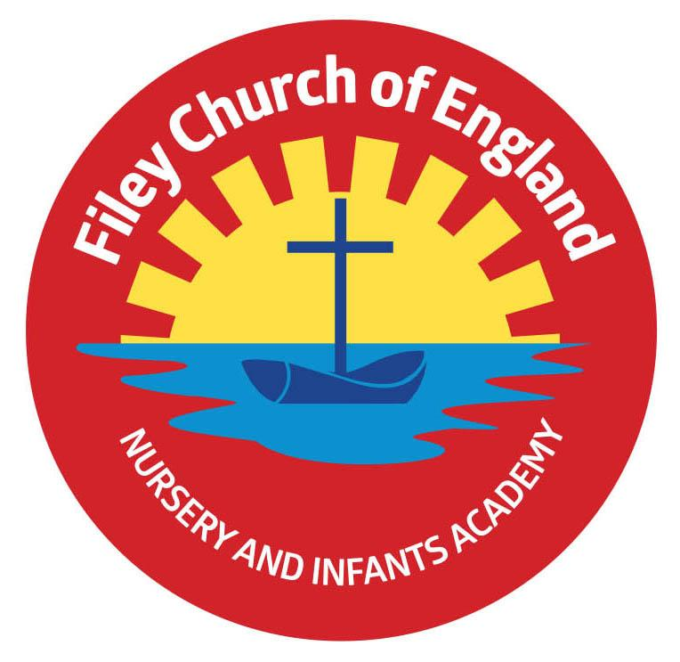
Friday 24th February 2023

Dear Parents/Carers
Welcome back after the half term break. This half term is set to be a busy one, with lots of exciting things happening in our school. Please remember to keep the list of dates at the bottom of this letter so you know what will be taking place and when.
Miss Williams’ class won the attendance award this week with 98.8%, well done to them.

Planned Strike Action I can inform you that the strike called by members of the National Education Union for Tuesday 28 February will not affect our school. Please send your child, or children, to school as normal on that day.
Future strike days are planned for Wednesday 15 March and Thursday 16 March but in advance of industrial action, we will review our position and let you know to give you sufficient notice to make alternative arrangements if needed.

Parent Appointments
These will take place over three evenings from 3pm – 5.30pm. Monday 13th, Tuesday 14th and Wednesday 15th March. Your child will have already brought a letter home for you to return indicating which day and preferred time slot you would like for your appointment.

Radio ‘Filey Infants’ with DJ Smiley Hiley!
If you follow us on Twitter, you may have already tuned in to DJ Smiley from Filey (AKA Miss Hiley)! This was our first try at recording a radio show from school to share with pupils and their families. It is our intention to set up a half hour weekly show that will include interviews with children, special school events and a story time. If you haven’t tuned in yet, just visit the school website for the link.

World Book Day
On Friday 3rd March, we will celebrate World Book Day in school. Children and staff are invited to dress up as a character from a favourite book. There is absolutely no pressure to dress up for children that do not want to and please do not feel like you have to spend money on outfits, it’s often the homemade ones that are the most interesting! If your child would like to borrow an outfit from school, we have plenty, please ask their class teacher or phone the school office in advance of the day.

Part-time Kitchen Assistant Vacancy
We have a vacancy for a part-time kitchen assistant in school. Please telephone the school office if you are interested in this position.

Comic Relief
On Friday 17th March it will be ‘Red Nose Day’, a great charity that we support each year. The theme this year is Mr Men & Little Miss characters with the message, dress for joy!
As a school we invite everyone to dress for fun…funny hair, funny faces or funny clothes…anything goes!! As always there is no pressure to take part, we will have some collection buckets on each school gate for those that would like to support this charity.

Head Lice
Unfortunately, head lice can be an ongoing problem for young children and we have had a few cases in school this week. You do not need to buy special treatments unless you want to and you certainly do not need to keep your child off school. You do however need to use the wet combing method quickly and thoroughly. Please see below:
WET COMBING is just as effective as medicated lotions and shampoos if done thoroughly.
You will need a special fine-toothed comb (detection comb) these can be purchased online or from local pharmacies. Follow these instruction:
- wash hair with ordinary shampoo
- apply lots of conditioner (any conditioner will do)
- comb the whole head of hair, from the roots to the ends

It usually takes about 10 minutes to comb short hair, and 20 to 30 minutes for long or curly hair. Do wet combing on days 1, 5, 9 and 13 to catch any newly hatched head lice. Check again that everyone's hair is free of lice on day 17.

Thank you for your continued support, if you have any questions please remember we are here to help in any way that we can. Please remember to follow us on Twitter to see all the wonderful things happening in school.
Best Wishes
Angela Clark
Headteacher

Diary Dates – (more dates may be added each week as they arise)
Monday 27th February – Open the Book Collective Worship
Monday 27th February – ‘Wonder Time’ lunchtime club starts for the second Y2 group.

Thursday 2nd March – Mrs Mackay’s class poetry assembly 9am in the school hall.
Friday 10th March – Miss William’s class poetry assembly 9am in the school hall.
Monday 13th March – Reception children weights and heights measurement
Monday 13th March – Parent Appointments 3pm-5.30pm
Tuesday 14th March – Parent Appointments 3pm-5.30pm
Wednesday 15th March - Parent Appointments 3pm-5.30pm
Friday 17th March – Red Nose Day for Comic Relief
Monday 20th March – Miss Ring’s Class Enterprise 2.30pm in the school hall
Tuesday 21st March – School Book Fair arrives
Wednesday 22nd March – Miss Haldenby’s Class Enterprise 2.30pm in the school hall
Monday 27th March – Open the Book Collective Worship
Tuesday 28th March – The School Choir sing at Silver Birches Care Home
Wednesday 29th March - Miss Haldenby’s class start swimming lessons
Thursday 30th March – The School Choir sing at Cayton Village Hall for their elderly visitors
Friday 31st March – Bring decorated eggs into school for the competition – more details to follow.
Friday 31st March – Easter Egg fundraising raffle – 50p a ticket to win an Easter Egg kindly donated by all the teachers in school.
Friday 31st March – 2.30pm Easter Hat Parade around school – everyone welcome – more details to follow.
Tuesday 18th April – School re-opens for the start of the Summer term.
