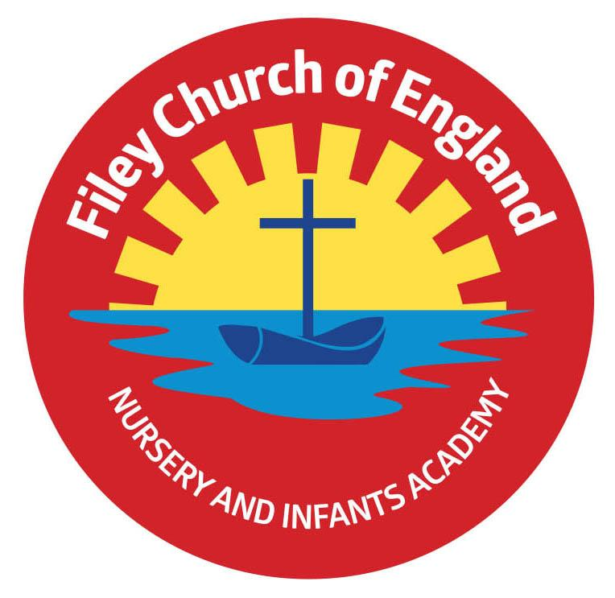
Friday 10th February 2023

Dear Parents/Carers
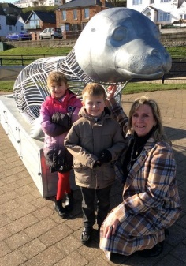
This week we enjoyed class enterprise events from our year 2 children. They have been learning about equality, diversity and have studied many famous people from around the world. They sold their newspapers, artwork and gave some incredible speeches.

Year 2 attended the unveiling of ‘Bonzo’ on Filey seafront this week. ‘Bonzo’ is a beautiful seal sculpture for plastic bottles. Our children posted their plastic bottles into ‘Bonzo’ so they can be taken away at a later date and recycled. We had many photographs taken; look out for them in the Scarborough News.

Mr Jackson’s class won the attendance award this week with 97.5%, well done to them.

Consultation on proposal to change the school opening and closing times
Last week’s newsletter invited parents to respond to the proposed change in school hours from September 2023. The email address printed in the letter was incorrect although it was correct at the bottom of the letter. You still have time to respond, the final date is Monday 6th March and the correct email address is admin.fis@ebor.academy or you can send your comments by letter.

Parent Appointments
Next half term teachers will be holding their parent evenings to give you an opportunity to come and discuss your child’s progress and wellbeing. These will take place over three evenings from 3pm – 5.30pm. Monday 13th, Tuesday 14th and Wednesday 15th March. You will receive a letter nearer the time to select which day and time you would like your appointment.

NSPCC Underwear Rule
Next half term in our PSHE lessons, we will be discussing the NSPCC’s Underwear Rule. During these discussions, we aim to teach our pupils the following important safety skills without giving explicit information or telling scary stories. The lessons will introduce a range of ideas, all delivered in a way that is fully age-appropriate. These include:
- “appropriate” and “inappropriate” touching
- your child’s right to say no to things that make them feel upset or uncomfortable
- naming parts of the body
- who your child can turn to if they feel upset or worried
If you would like to know more about the NSPCC’s campaign and see how you can help keep your children safe in partnership with school, more information can be found at nspcc.org.uk/underwearrule
If you have any questions or concerns please don’t hesitate to get in touch.

FREE books for Reception
Today all our reception children were given a FREE book from BookTrust. BookTrust is the UK’s largest children’s reading charity. Last year they gave more than 715,000 Time to Read packs to reception children in England. I hope our reception children enjoy their lovely book and share it with the whole family.
Thank you for your continued support, if you have any questions please remember we are here to help in any way that we can. Please remember to follow us on Twitter to see all the wonderful things happening in school. I hope everyone has a lovely half term break; school reopens on Monday 20th February.

Best Wishes
Angela Clark
Headteacher

Diary Dates – (more dates may be added each week as they arise)
Friday 10th February – Mr Jacksons Class Enterprise 2.30pm in the school hall
Friday 10th February – School closes for half term

Monday 20th February – School re-opens
Monday 20th February – Lunchtime recorder club starts for year two.
Thursday 23rd February – After school PE club starts for the second Year 2 group.
Thursday 23rd February – After school cookery club starts for the second group of Year 2.
Monday 27th February – Open the Book Collective Worship
Monday 27th February – ‘Wonder Time’ lunchtime club starts for the second Y2 group.

Thursday 2nd March – Mrs Mackay’s class poetry assembly 9am in the school hall.
Friday 10th March – Miss William’s class poetry assembly 9am in the school hall.
Monday 13th March – Reception children weights and heights measurement
Monday 13th March – Parent Appointments 3pm-5.30pm
Tuesday 14th March – Parent Appointments 3pm-5.30pm
Wednesday 15th March - Parent Appointments 3pm-5.30pm
Friday 17th March – Red Nose Day for Comic Relief
Monday 20th March – Miss Ring’s Class Enterprise 2.30pm in the school hall
Tuesday 21st March – School Book Fair arrives
Wednesday 22nd March – Miss Haldenby’s Class Enterprise 2.30pm in the school hall
Monday 27th March – Open the Book Collective Worship
Tuesday 28th March – The School Choir sing at Silver Birches Care Home
Wednesday 29th March - Miss Haldenby’s class start swimming lessons
Thursday 30th March – The School Choir sing at Cayton Village Hall for their elderly visitors
Friday 31st March – Bring decorated eggs into school for the competition – more details to follow.
Friday 31st March – Easter Egg fundraising raffle – 50p a ticket to win an Easter Egg kindly donated by all the teachers in school.
Friday 31st March – 2.30pm Easter Hat Parade around school – everyone welcome – more details to follow.

Tuesday 18th April – School re-opens for the start of the Summer term.
