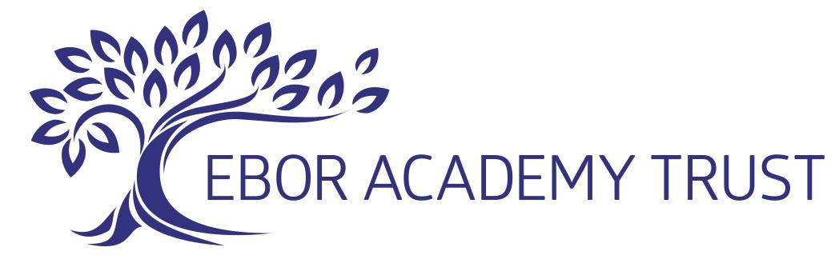

20 January 2023
To parents and carers of children at all schools
in Ebor Academy Trust

Dear parents and carers
Potential strike action at schools
Following my letter of 18 January, I have now met with all headteachers across our schools to discuss the implications of potential strike action, with the first day of the strike planned for Wednesday 1 February.
As a trust we will be following government guidance which is to keep all our schools open where possible.
However, as the trust has no means of knowing which staff are members of the National Education Union, who have successfully balloted for the industrial action, we are aware that some schools will be affected by the strikes and some schools will not. This means a single decision for all our schools is not practical.
We have agreed, therefore, that the headteacher of the school your child/children attend will contact you directly by Wednesday, 25 January, to inform you what the industrial action will mean to you as a parent/carer.
Hopefully, if necessary, this will give you sufficient notice to make any alternative arrangements.
Yours faithfully
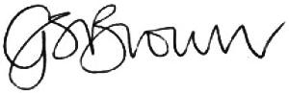
Gail Brown
Chief Executive Officer

