Friday 27th January 2023

Dear Parents/Carers
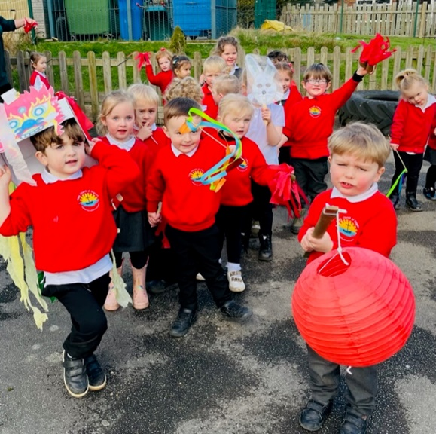
Another wonderful week in school where we all enjoyed a super Chinese Dragon Dance from our Nursery children. This year is the year of the rabbit “gong hay fat choy”

Well done to Miss Haldenby’s class for a super poetry assembly this morning.
Mr Jackson’s class won the attendance award this week with 98.3%, well done to them.

Potential Strike Action in Schools
Strike action in schools taking place on Wednesday 1st February 2023 will NOT affect our school. Please bring your children to school as normal on this day.
Unsuitable Games!
It has come to my attention this week that some of our children have been playing a game in the playground called ‘Huggy Wuggy’ from Poppy Playground. These games involve fighting, kicking and hitting and of course will not be tolerated in our school. Any children found to be fighting, kicking or hitting will miss their following playtime and have some time to think about the kind of games they could play instead.

I am concerned that some of our children have been watching Poppy Playground, which is not age appropriate and could be potentially harmful to young children. I have checked the common sense media site, which gives it a rating of 12+, this certainly means children in our school, should not be accessing this material. It also transpires that many unsettling scenarios from Poppy Playground feature on TikTok and YouTube. Please be vigilant and do not let your children watch or play on these inappropriate games.

Pupil Absence
If your child is not going to be in school for any reason please ensure you telephone the school office, leave us a voicemail or email on admin.fis@ebor.academy to let us know. If we do not hear from anyone, we will have to contact your emergency contacts. If we are still unable to ascertain the whereabouts of your child, we will make a home visit. If we are then still unable to make contact, we will contact North Yorkshire police services. All schools have a duty to report the whereabouts of each child on their register by 10.30am each day.
Please note this is a legal requirement for the safety of all, not simply our school policy.

Thank you for your continued support, if you have any questions please remember we are here to help in any way that we can.
Best Wishes
Angela Clark
Headteacher
Diary Dates – (more dates may be added each week as they arise)
Please see the error below highlighted in yellow!

Friday 27th January – Miss Haldenby’s Class Poetry Assembly 9am in the school hall
Monday 6th February – Open the Book Collective Worship
Wednesday 8th February – Mrs Mackay’s Class Enterprise 2.30pm in the school hall
Thursday 9th February – Miss Williams Class Enterprise 2.30pm in the school hall
Friday 10th February – Mr Jacksons Class Enterprise 2.30pm in the school hall
Friday 10th February – School closes for half term

Monday 20th February – School re-opens
Monday 20th February – Lunchtime recorder club starts for year two.
Thursday 23rd February – After school PE club starts for the second Year 2 group.
Thursday 23rd February – After school cookery club starts for the second group of Year 2.
Monday 27th February – Open the Book Collective Worship
Monday 27th February – ‘Wonder Time’ lunchtime club starts for the second Y2 group.
Thursday 2nd March – Mrs Mackay’s class poetry assembly 9am in the school hall.
Friday 10th March – Miss William’s class poetry assembly 9am in the school hall.
Friday 17th March – Red Nose Day for Comic Relief
Monday 20th March – Miss Ring’s Class Enterprise 2.30pm in the school hall
Wednesday 22nd March – Miss Haldenby’s Class Enterprise 2.30pm in the school hall
Monday 27th March – Open the Book Collective Worship
Wednesday 29th March – Miss Ring’s Class start swimming lessons
PLEASE NOTE this should be:
Wednesday 29th March - Miss Haldenby’s class start swimming lessons NOT Miss Ring’s class. Apologies for the error! Miss Ring’s class start their swimming lessons on Wednesday 7th June.
Friday 31st March – Bring decorated eggs into school for the competition – more details to follow.
Friday 31st March – Easter Egg fundraising raffle – 50p a ticket to win an Easter Egg kindly donated by all the teachers in school.
Friday 31st March – 2.30pm Easter Hat Parade around school – everyone welcome – more details to follow.
Tuesday 18th April – School re-opens for the start of the Summer term.
