Friday 20th January 2023

Dear Parents/Carers
Another wonderful week in school, although a little chilly! Well done to Miss Ring’s class for a super poetry assembly this morning, they also won the attendance award this week with 98.5%.
Free Food Table
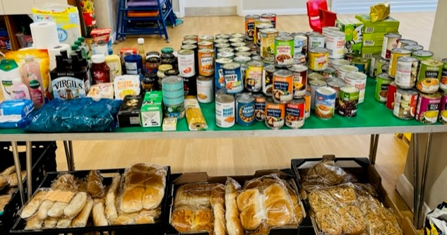
Just a reminder that we always send a text out to parents whenever we have our food table, usually on a Monday or Friday. This table is full of food that is completely FREE for all our parents to come along and help themselves. There is usually a range of tinned and packet food as well as fresh produce, bread and toiletry items. Especially during this time of rising costs, it is great to be offered something free. Please don’t be shy, take advantage of this offer and come along with a shopping bag whenever you get the text!

Parking around School
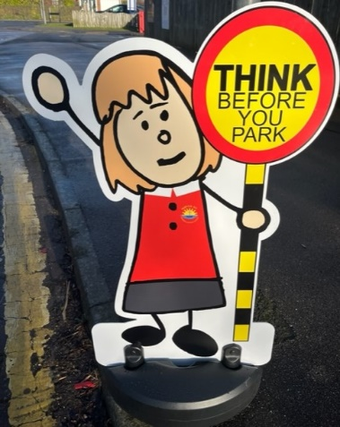
You may have noticed our new signs at the front of school. All schools have yellow zig lines in front of them for a clear reason, SAFETY! Our children are small and very precious! They cannot see around parked cars easily so the front of our school must be kept clear especially during school run times.
Parking on restricted areas or mounting the pavement is a traffic offence. Yellow zig-zag lines outside schools indicate the length of road where stopping or waiting is strictly prohibited. Our school also has an upright sign indicating a mandatory prohibition of stopping anywhere in the bus area. Parking in front of our school during school run times is both dangerous and inconsiderate! Please help us to keep our little people safe.

Please DO
- Try to make these initiatives work for the benefit of Pupil Safety, local Residents and yourselves.
- Leave plenty of time for your planned journey
- Try to leave your car at home as much as possible and walk instead.

Please DON'T
- Rush to arrive just before or at school class opening times, give your children time to interact with their friends before school starts!
- Stop on the Zig-Zag and yellow line markings.
- Park or drive on the pavements, double park or obstruct the residents' driveways.

Of course, if you are registered disabled or have any genuine problems with parking safely around school please contact myself so this can be discussed.

Miss Haldenby’s Class Poetry Assembly
On Friday 27th January at 9am, parents/carers of children in Miss Haldenby’s class are invited to join us in the school hall. The class will lead our Collective Worship time and perform their poetry for the rest of school.

Potential Strike Action in Schools
You may be aware that there is the potential of strike action in schools on 1st February 2023. I will be able to inform you by Wednesday 25th January if this will affect our school in any way. Please see the letter from Gail Brown (CEO Ebor Academy Trust) attached to this email for more information.

Thank you for your continued support, if you have any questions please remember we are here to help in any way that we can.
Best Wishes
Angela Clark
Headteacher

Diary Dates – (more dates may be added each week as they arise)
Please see the error below highlighted in yellow!

Wednesday 25th January – Swimming lessons start for Miss Williams Class
Friday 27th January – Miss Haldenby’s Class Poetry Assembly 9am in the school hall
Monday 6th February – Open the Book Collective Worship
Wednesday 8th February – Mrs Mackay’s Class Enterprise 2.30pm in the school hall
Thursday 9th February – Miss Williams Class Enterprise 2.30pm in the school hall
Friday 10th February – Mr Jacksons Class Enterprise 2.30pm in the school hall
Friday 10th February – School closes for half term

Monday 20th February – School re-opens
Monday 20th February – Lunchtime recorder club starts for year two.
Thursday 23rd February – After school PE club starts for the second Year 2 group.
Thursday 23rd February – After school cookery club starts for the second group of Year 2.
Monday 27th February – Open the Book Collective Worship
Monday 27th February – ‘Wonder Time’ lunchtime club starts for the second Y2 group.
Friday 17th March – Red Nose Day for Comic Relief
Monday 20th March – Miss Ring’s Class Enterprise 2.30pm in the school hall
Wednesday 22nd March – Miss Haldenby’s Class Enterprise 2.30pm in the school hall
Monday 27th March – Open the Book Collective Worship
Wednesday 29th March – Miss Ring’s Class start swimming lessons
PLEASE NOTE this should be:
Wednesday 29th March - Miss Haldenby’s class start swimming lessons NOT Miss Ring’s class. Apologies for the error! Miss Ring’s class start their swimming lessons on Wednesday 7th June.
Friday 31st March – Bring decorated eggs into school for the competition – more details to follow.
Friday 31st March – 2.30pm Easter Hat Parade around school – everyone welcome – more details to follow.
Tuesday 18th April – School re-opens for the start of the Summer term.

