Friday 9th December 2022

Dear Parents/Carers

Wow! Such wonderful Nativity performances from all our children in school this week. Photographs and recording of the production can be found on our school website under TEACHING & LEARNING – Classes. A big thank you to everyone who supported us at this year’s Christmas Fayre, we raised a wonderful £900 towards school funds. A big thank you as well from The Royal British Legion for raising a tremendous £225.24 for the Poppy Appeal. This week Mr Jackson’s class won the attendance with 95.83% well done!
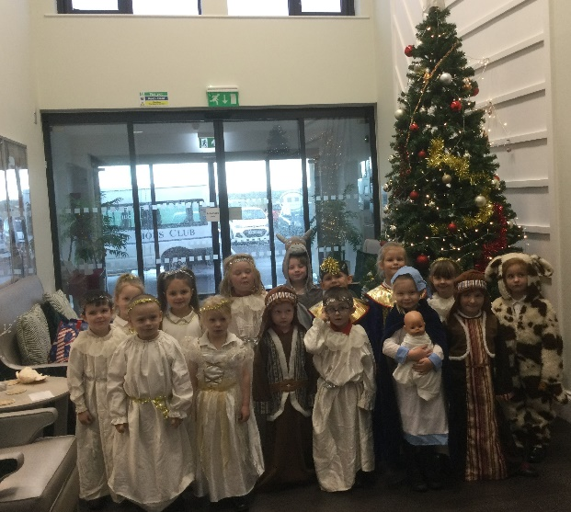
Some of our Reception children visited Filey Fields Court on Wednesday and sang beautifully. They were a huge hit with the residents; in fact, they wanted them to stay!
Year one and two children enjoyed a super Pantomime today at The Spa Theatre, this was paid for with money from our Summer Fayre and Sponsored Walk.
Children are invited to wear Christmas jumpers to school on Thursday 15th December. This is the day of our Christmas dinner in school. We will not be fundraising for this event and there is absolutely no pressure to wear a Christmas jumper. Just for fun!
Christmas Parties
Next week we will be having our Christmas parties. Please could Nursery & Reception children contribute crisps, Year 1 children contribute biscuits and Year 2 children contribute buns. We would be grateful if all your contributions to the party food can be brought into school on Monday 12th December. Children are invited to come to school in their party clothes on the day of their party. Year 1 and 2 party is on Tuesday 13th December 1pm and Nursery & Reception party is Wednesday 14th December 1pm.

Tapestry
If your child is now in Year 1 and you would like to keep all the information on Tapestry from Nursery & Reception you will need to download this before Wednesday 4th January 2023. If you do not download before this date, it will be no longer available.

Scarlet Fever
You may have seen the growing concerns regarding this infection on recent news broadcasts. If you would like more information regarding the signs, symptoms and the actions to be taken if you think that you or your child may have scarlet fever please read the letter attached to this email. This information can also be found on our school website under: PARENTS – Support for Parents.

Vacancy for an Apprentice Teaching Assistant
We are advertising for an apprentice teaching assistant to start in January 2023. If you are interested, the position is advertised on our school website under: Ebor Academy Trust – Carers & Vacancies. The closing date for applications is Monday 12th December and interviews will take place on Wednesday 14th December.

Nursery & Reception Theatre Visit
On Tuesday 13th December, our Nursery & Reception children will visit The Stephen Joseph Theatre in Scarborough. If your child does not normally attend Nursery on this day and you would like them to come please ensure you let us know in advance so that we can book their ticket.

Thank you for your continued support. If you have any questions or concerns please just ask, we are here to help in any way that we can. Remember to follow us on Twitter to see some of the wonderful things happening in our school.
Best Wishes
Angela Clark
Headteacher

Diary Dates – (more dates may be added as and when they arise)

Monday 12th December – Open the Book Collective Worship
Tuesday 13th December – Nursery & Reception children visit the SJT in Scarborough to watch ‘Sammy the Shoemakers ‘Impossible Day’
Tuesday 13th December – Year 1 and 2 classes Christmas Party 1pm
Wednesday 14th December – Salvation Army band visits school.
Wednesday 14th December – Nursery & Reception Christmas Party
Thursday 15th December – Christmas Lunch – invited to wear Christmas jumpers.
Friday 16th December – School Closes

Tuesday 3rd January – Staff Training Day
Wednesday 4th January – School Opens for the start of the Spring Term
Thursday 5th January – After school PE club starts for Year 1
Monday 9th January – Open the Book Collective Worship
Monday 9th January – ‘Wonder Time’ lunchtime club starts for Year 2
Monday 9th January – Family Reading club starts again
Tuesday 10th January – Family Learning starts again
Wednesday 25th January – Swimming lessons start for Miss Williams Class
Monday 6th February – Open the Book Collective Worship
Friday 10th February – School closes for half term

