Friday 2nd December 2022

Dear Parents/Carers
Christmas cheer is definitely here in our school this week. The children have been practising for their Nativity plays and we attended a beautiful Christingle service at St John’s Church this morning. Today after school is our Christmas Fayre, please come along and support us if you can. This week Mr Jackson’s class won the attendance with 95.83% well done to them. A big thank you to Sarah our ‘Dementia Friend’ for visiting us in school this week. Sarah went around all our classes raising
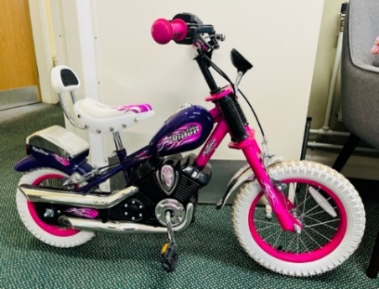
awareness of Dementia, we also had Health & Social Care students from Filey Secondary School join us for some training.

We have kindly been given a girls bike aged 5-6, it is second hand but in extremely good condition. I am sure this would make a lovely Christmas gift for one of our girls.
It is FREE to anyone who can make use of this, please phone the school office (first person to call gets the bike)!

Christmas Jumpers
Children are invited to wear Christmas jumpers to school on Thursday 15th December. This is the day of our Christmas dinner in school. We will not be fundraising for this event and there is absolutely no pressure to wear a Christmas jumper. Just for fun!

‘Big Red’ the Reading Bus
Next week will be the last week to visit the reading bus. Please come along on either Monday or Wednesday at 2.40pm, you are welcome to come to both if you wish. Family reading club will start again from Monday 9th January 2023.

Family Learning
Unfortunately, Lucy was ill this week and could not make the sessions. Lucy will pop into school next week to sort out all the children’s crafts and deliver them to your children. Family Learning will start again on Tuesday 10th January 2023.

Family Christmas Crafts
Friday 2nd, 9th and 16th December from 1.30pm-2.45pm we will be holding Christmas craft afternoons. All family members are welcome to attend.

After School PE Club
Mr Ellis will continue with his after school PE club for Reception children until we break up for the Christmas holiday. When we return in January, it will be Year 1 children’s turn, look out for the letter coming home with your child soon.

Year Group Nativity Performances
Please ensure you have your tickets for next week’s performances. Please bring your tickets to the performance. We will be recording each year groups Nativity plays and uploading them onto the school website for anyone who is unable to attend.

Filey Fishtree Festivities
This Saturday 3rd December at 6pm the fishtree festival will have their lights switch on and firework display. Get there early to join in with the festivities and see if you can spot your child’s fish on our school display board.

Thank you for your continued support. If you have any questions or concerns please just ask, we are here to help in any way that we can. Remember to follow us on Twitter to see some of the wonderful things happening in our school.
Best Wishes
Angela Clark
Headteacher

Diary Dates – (more dates may be added as and when they arise)

Friday 2nd December – Christingle Service at St John’s Church.
Friday 2nd December – School Christmas Fair 3pm-4.30pm
Monday 5th December – Nursery & Reception Christmas Production 2pm
Tuesday 6th December - Nursery & Reception Christmas Production 10am
Tuesday 6th December – Year 1 Christmas Production 1.30pm
Wednesday 7th December - Year 1 Christmas Production 10am
Wednesday 7th December – Year 2 Dress Rehearsal (parents NOT invited)
Thursday 8th December – Year 2 Christmas Production 9.30am & 1.30pm
Friday 9th December – Year 1 and Year 2 pupils visit Scarborough Spa Panto ‘Dick Whittington’
Monday 12th December – Open the Book Collective Worship
Tuesday 13th December – Nursery & Reception children visit the SJT in Scarborough to watch ‘Sammy the Shoemakers ‘Impossible Day’
Tuesday 13th December – Year 1 and 2 classes Christmas Party 1pm
Wednesday 14th December – Salvation Army band visits school.
Wednesday 14th December – Nursery & Reception Christmas Party
Thursday 15th December – Christmas Lunch – invited to wear Christmas jumpers.
Friday 16th December – School Closes

Tuesday 3rd January – Staff Training Day
Wednesday 4th January – School Opens for the start of the Spring Term
Thursday 5th January – After school PE club starts for Year 1
Monday 9th January – Open the Book Collective Worship
Monday 9th January – Family Reading club starts again
Tuesday 10th January – Family Learning starts again
Wednesday 25th January – Swimming lessons start for Miss Williams Class
Monday 6th February – Open the Book Collective Worship
Friday 10th February – School closes for half term

