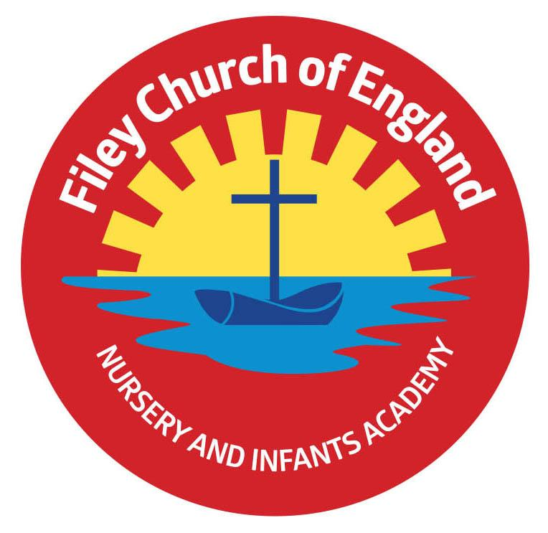
Friday 16th December 2022

Dear Parents/Carers

What a wonderfully Christmassy week in school!
Here is a festive rundown of all the exciting events that have taken place in our school this week.

Monday
On Monday, we had our last Open the Book Collective Worship with Reverend Nigel before he retires in January. We know we will all miss him but we do wish him a very happy retirement and thank him for all he has done for our school over the years.
Tuesday
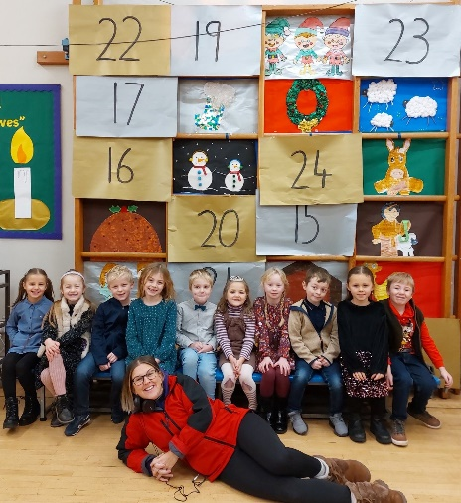
On Tuesday, some of our year 2 children were on BBC Radio York talking about Christmas. If you would like to listen in to our four separate broadcasts, you can play them back on BBC IPlayer. It was the Georgey Spanswick at Breakfast show, times 1:44:38, 2:20:16, 2:48:52 and 3:11:10. Later that morning our Nursery and Reception children went to The Stephen Joseph Theatre to watch Sammy the Shoemakers Impossible Day. This was a real treat and thoroughly enjoyed by all.
In the afternoon Year 1 and Year 2 had their Christmas Party. They played some great games and ate lots of crisps, biscuits and buns!

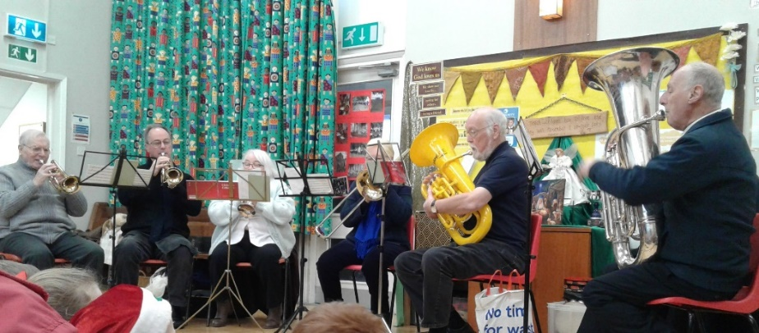
Wednesday
On Wednesday, the Salvation Army Band came to play for us. We sang along to some Christmas Carols and played tambourines.
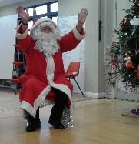
In the afternoon, the Nursery & Reception children had their Christmas Party. They played some traditional party games and were all very excited to see Santa!
At the end of the day, we gave out some fabulous Christmas food hampers provided by our friends from Filey Churches together. If you would like to be added to our FREE food bag list please just phone the office and let us know for next time.

Thursday
On Thursday, we had a delicious Christmas Lunch all together in the school hall. The teachers served the children their food while they were busy pulling crackers and reading the jokes!

Friday
Today we had a visit from the local police to talk about keeping safe. The children learnt about road safety and stranger danger. It did come to light that not all children sit in a car seat/booster seat when travelling in a car. It is the law that children should use a car seat until they are 12 years old or 135cm tall, whichever comes first.

We also had a special Collective Worship and gave out the 100% attendance certificates, Mindfulness Club certificates and certificates for all those that contributed to the Scarborough Hospital Urgent & Emergency Care Appeal.
We finished by singing the 12 days of Christmas, opening our giant advent calendar and wished everyone a very happy Christmas!

Filey Community Fridge
From 11am on Wednesday 21st December, Filey Community Fridge have pre-wrapped gifts to hand out to anyone who can make use of this kind gesture. Everyone welcome!

Christmas Eve!
Our friends at St Oswald’s Church are inviting parents & children to their Nativity on Christmas Eve at 4.30pm. Everyone is welcome and you can dress up as a Nativity character e.g. Mary or Joseph, an angel or star, wise man or shepherd, or perhaps a stable animal.

Thank you for your continued support. If you have any questions or concerns please just ask, we are here to help in any way that we can. Remember to follow us on Twitter to see some of the wonderful things that have been happening in our school.

I wish you all a very Merry Christmas & Happy New Year! School re-opens for the start of the Spring term on Wednesday 4th January 2023.

Best Wishes
Angela Clark
Headteacher

