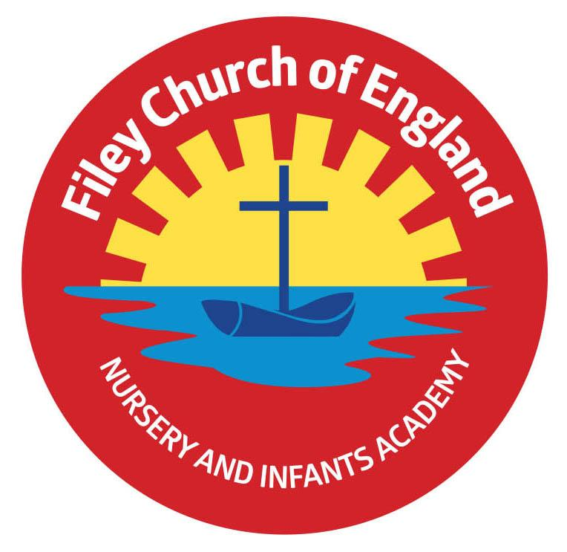
Friday 25th November 2022

Dear Parents/Carers
It was lovely to see the children in their casual clothes today and a big thank you to everyone who sent in a bottle for the bottle tombola. This week Miss Withers’ class won the attendance award with 95.3% well done to them.

Christmas Jumpers
Children are invited to wear Christmas jumpers to school on Thursday 15th December. This is the day of our Christmas dinner in school. We will not be fundraising for this event and there is absolutely no pressure to wear a Christmas jumper.

Attendance
At this time of year especially with sickness bugs and colds doing their rounds we always see a dip in school attendance. Having good school attendance is important and we encourage all children to attend as much as possible. Please see the attached guidance and further information on attendance in schools.

Drink Bottles
We do have drinking fountains in school although children are very welcome to bring drinks bottles into school. If children bring their own drink bottles into school please ensure that they contain either water, flavoured water or cordial. Please NO energy drinks or fizzy drinks.

FREE Children’s Holiday Club
‘Happy Healthy Kidz’ are delighted to offer some FREE places in a holiday club at Scarborough Sports Village 19th – 22nd December. If your child is entitled to free school meals and you would like more information please see the leaflet attached to this email.

Cakes & Raffle Prizes
If anyone would like to send in cakes, buns or raffle prizes for the Christmas Fayre, we would be delighted to receive these on the morning of Friday 2nd December. Once again thank you for your support.

Christmas Fayre – Friday 2nd December 3.10pm-4.30pm
We are in the process of planning a very special Christmas Fayre again this year with lots of wonderful prizes and stalls.
The fayre will take place in the school hall and Reception / Nursery classes. Stalls and activities will be as follows:
- Santa’s Grotto will be in the Nursery classroom.
- Cakes, hotdogs and refreshments will be in the school hall.
- The bottle tombola, raffle stall, guess the weight of the Christmas cake and adopt a bear for Christmas will also take place in the school hall.
- Christmas sand decorations, face painting and many other festive games and activities will take place in the Reception classrooms.

Christmas Fayre Raffle Tickets
We have some amazing prizes this year for our Christmas raffle. Prizes include a 32in Colour Smart TV, Christmas Hamper worth £50, children’s board games, toys and much, much more. Tickets cost £1 each and the prizes will be drawn at 4.20pm during the Christmas Fayre. Please complete the raffle ticket sheet and return to school in an envelope with the correct money if you would like to buy tickets in advance of the Fayre.
Reminder - Dementia Friends
On Wednesday 30th November we have arranged a visit to school from our Dementia Friends. They will be raising awareness of dementia through age appropriate stories and discussion.
Staff will also have some Dementia Friend training after school and we are delighted to offer a session for parents at either 2pm or 5pm. Dementia effects so many people at some point in their lives and raising awareness helps us to understand this terrible illness. Please join us in the school hall at either 2pm or 5pm to become a Dementia Friend.

Thank you for your continued support. If you have any questions or concerns please just ask, we are here to help in any way that we can. Remember to follow us on Twitter to see some of the wonderful things happening in our school.

Best Wishes
Angela Clark
Headteacher

Diary Dates – (more dates may be added as and when they arise)

Wednesday 30th November – Dementia Friends session for parents 2pm OR 5pm in the school hall.

Friday 2nd December – Christingle Service at St John’s Church.
Friday 2nd December – School Christmas Fair 3pm-4.30pm
Monday 5th December – Nursery & Reception Christmas Production 2pm
Tuesday 6th December - Nursery & Reception Christmas Production 10am
Tuesday 6th December – Year 1 Christmas Production 1.30pm
Wednesday 7th December - Year 1 Christmas Production 10am
Wednesday 7th December – Year 2 Dress Rehearsal (parents NOT invited)
Thursday 8th December – Year 2 Christmas Production 9.30am & 1.30pm
Friday 9th December – Year 1 and Year 2 pupils visit Scarborough Spa Panto ‘Dick Whittington’
Monday 12th December – Open the Book Collective Worship
Tuesday 13th December – Nursery & Reception children visit the SJT in Scarborough to watch ‘Sammy the Shoemakers ‘Impossible Day’
Tuesday 13th December – Year 1 and 2 classes Christmas Party 1pm
Wednesday 14th December – Salvation Army band visits school.
Wednesday 14th December – Nursery & Reception Christmas Party
Thursday 15th December – Christmas Lunch – invited to wear Christmas jumpers.
Friday 16th December – School Closes

Tuesday 3rd January – Staff Training Day
Wednesday 4th January – School Opens for the start of the Spring Term
