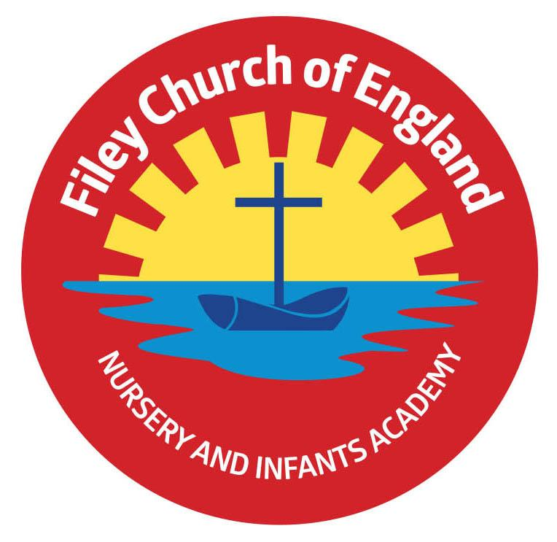
Tuesday 22nd November 2022
Dear Parents/Carers
An early newsletter this week with a few important updates.

Casual Clothes Day – Friday 25th November
This Friday the 25th November is casual clothes day and we ask all pupils to ‘Bring a Bottle’ for our Christmas Fayre Tombola. Please send bottles to the classrooms or the school office on casual clothes day. We welcome bottles of shampoo, bubble bath, wine, sauce, spirits, soft drinks etc. (unopened bottles only please). Thank you for your support.

Christmas Fayre – Friday 2nd December 3.10pm-4.30pm
We are in the process of planning a very special Christmas Fayre again this year with lots of wonderful prizes and stalls.
The fayre will take place in the school hall and Reception / Nursery classes. Stalls and activities will be as follows:
- Santa’s Grotto will be in the Nursery classroom.
- Cakes, hotdogs and refreshments will be in the school hall.
- The bottle tombola, raffle stall, guess the weight of the Christmas cake and ‘Adopt a Bear’ for Christmas will also take place in the school hall.
- Christmas sand decorations, face painting and many other festive games and activities will take place in the Reception classrooms.

Christmas Fayre Raffle Tickets
Please turn over this letter to see a sheet of raffle tickets should you want to buy some in advance of the Christmas Fayre. Tickets cost £1 each and the prizes will be drawn at 4.20pm during the Christmas Fayre. Prizes include a 32in Colour Smart TV, Christmas Hamper worth £50, children’s board games, toys and much, much more. Please complete the raffle tickets and return to school in an envelope with the correct money.

Adopt a Bear for Christmas
If you have any unwanted teddy bears at home that can be adopted by a new family this Christmas please send them into school by Monday 28th November. All these bears will be displayed at the Christmas Fayre with special birth certificates just waiting for a new friend to adopt them!

Christmas Productions
Tickets are now available! Tickets are issued so that we can monitor the number of people attending each performance (they DO NOT have a charge). Initially ONLY 2 tickets will be issued to each child. I am sure everyone understands this is done in the interest of safety. You can request extra tickets with your child’s class teacher and they will add your request to a wish list. Extra tickets can only be given out if they are left over after everyone has had their allocation. When parents are separated, they can of course have two tickets each for different performances.
Best Wishes
Angela Clark
Headteacher
Diary Dates – (more dates may be added as and when they arise)

Wednesday 23rd November – Influenza Immunisations in school change of date
Friday 25th November – Influenza Immunisations in school
Friday 25th November – Casual clothes day – bring a bottle for the Christmas Fayre
Wednesday 30th November – Dementia Friends session for parents 2pm OR 5pm in the school hall.

Friday 2nd December – Christingle Service at St John’s Church.
Friday 2nd December – School Christmas Fayre 3pm-4.30pm
Monday 5th December – Nursery & Reception Christmas Production 2pm
Tuesday 6th December - Nursery & Reception Christmas Production 10am
Tuesday 6th December – Year 1 Christmas Production 1.30pm
Wednesday 7th December - Year 1 Christmas Production 10am
Wednesday 7th December – Year 2 Dress Rehearsal (parents NOT invited)
Thursday 8th December – Year 2 Christmas Production 9.30am & 1.30pm
Friday 9th December – Year 1 and Year 2 pupils visit Scarborough Spa Panto ‘Dick Whittington’
Monday 12th December – Open the Book Collective Worship
Tuesday 13th December – Nursery & Reception children visit the SJT in Scarborough to watch ‘Sammy the Shoemakers ‘Impossible Day’
Tuesday 13th December – Year 1 and 2 classes Christmas Party 1pm
Wednesday 14th December – Salvation Army band visits school.
Wednesday 14th December – Nursery & Reception Christmas Party
Thursday 15th December – Christmas Lunch
Friday 16th December – School Closes

Tuesday 3rd January – Staff Training Day
Wednesday 4th January – School Opens for the start of the Spring Term
