Friday 18th November 2022

Dear Parents/Carers
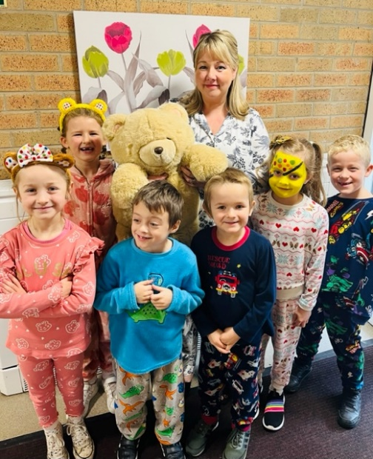
This week Miss Williams’ class won the attendance award with 98% well done to them. We
We have had a fun pyjama day in school today to raise money for Children in Need. Together we raised a wonderful £145.18. Thank you to everyone who donated to this worthwhile cause.
Remember to follow us on Twitter to see photographs of each class having fun in their pyjamas.

Nasal Flu Vaccinations in school
The date has changed for the nasal flu vaccinations. They will now take place on Friday 25th November. Your child will only receive this vaccination if you have registered online. The information was in the 4th November newsletter.

Reminder Asthma Card
If your child has asthma, you will have received an asthma card from school to complete. It is important that we have this asthma card returned to school as soon as possible. If you have misplaced this card or have any questions, please telephone the school office on 344649

Christmas Productions
Tickets will be available for each of the Christmas productions from Monday 21st November. Tickets are issued so that we can monitor the number of people attending each performance (they DO NOT have a charge). Initially ONLY 2 tickets will be issued to each child. I am sure everyone understands this is done in the interest of safety. You can request extra tickets with your child’s class teacher and they will add your request to a wish list. Extra tickets can only be given out if they are left over after everyone has had their allocation. When parents are separated, they can of course have two tickets each for different performances.

Football Fever!
England’s first game in the world cup takes place on Monday at 1pm. We will be showing the game for any children that do not want to miss out. All other games are out of school hours so this is the only one that will be shown during school time. Come on England!!

Reminder - Dementia Friends
On Wednesday 30th November we have arranged a visit to school from our Dementia Friends. They will be raising awareness of dementia through age appropriate stories and discussion.
Staff will also have some Dementia Friend training after school and we are delighted to offer a session for parents at either 2pm or 5pm. Dementia effects so many people at some point in their lives and raising awareness helps us to understand this terrible illness. Please join us in the school hall at either 2pm or 5pm to become a Dementia Friend.
Thank you for your continued support. If you have any questions or concerns please just ask, we are here to help in any way that we can. Remember to follow us on Twitter to see some of the wonderful things happening in our school.

Best Wishes
Angela Clark
Headteacher

Diary Dates – (more dates may be added as and when they arise)

Wednesday 23rd November – Influenza Immunisations in school change of date
Friday 25th November – Influenza Immunisations in school
Wednesday 30th November – Dementia Friends session for parents 2pm OR 5pm in the school hall.

Friday 2nd December – Christingle Service at St John’s Church.
Friday 2nd December – School Christmas Fair 3pm-4.30pm
Monday 5th December – Nursery & Reception Christmas Production 2pm
Tuesday 6th December - Nursery & Reception Christmas Production 10am
Tuesday 6th December – Year 1 Christmas Production 1.30pm
Wednesday 7th December - Year 1 Christmas Production 10am
Wednesday 7th December – Year 2 Dress Rehearsal (parents NOT invited)
Thursday 8th December – Year 2 Christmas Production 9.30am & 1.30pm
Friday 9th December – Year 1 and Year 2 pupils visit Scarborough Spa Panto ‘Dick Whittington’
Monday 12th December – Open the Book Collective Worship
Tuesday 13th December – Nursery & Reception children visit the SJT in Scarborough to watch ‘Sammy the Shoemakers ‘Impossible Day’
Tuesday 13th December – Year 1 and 2 classes Christmas Party 1pm
Wednesday 14th December – Salvation Army band visits school.
Wednesday 14th December – Nursery & Reception Christmas Party
Thursday 15th December – Christmas Lunch
Friday 16th December – School Closes

Tuesday 3rd January – Staff Training Day
Wednesday 4th January – School Opens for the start of the Spring Term
