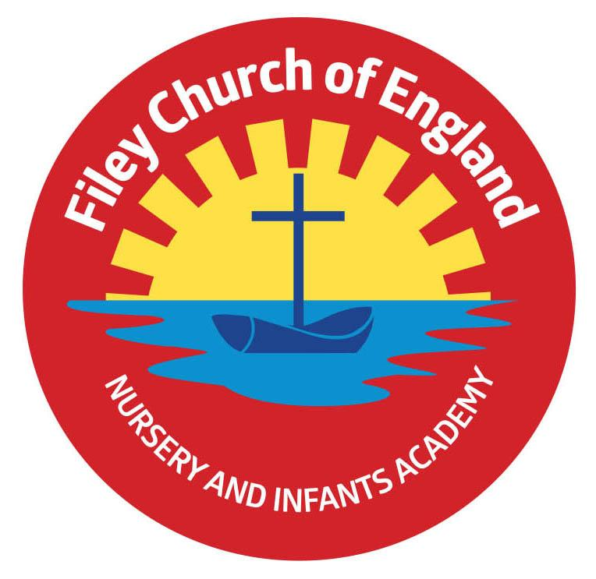
Nursery Welcome Letter

Dear Parents and carers,
Welcome to Miss Hiley’s class! We have had a fantastic start to the year and are very much enjoying getting to know each other. I am writing to you to welcome you as a Nursery parent and to give you some more information about what to expect in Nursery.
Our Curriculum
As a school we work tirelessly to make sure our curriculum is up-to-date as well as exciting and engaging for all our children. This half-term our theme is Getting to know you! Our themes for the year and more information about our long term plan can be found on the school website.
PE
Children will have twice-weekly PE sessions, Tuesday and Fridays. Nursery children do NOT need a P.E kit.
Uniform
Don’t forget, as a school we are trying to do our bit for the planet and recycle as much as possible. If you would like some good quality second hand uniform from our uniform cupboard, please phone the office or catch me on the door.
Library
During the week children will visit our Big Red Reading Bus twice. We will have a whole class story time on the bus, as well as allowing another opportunity for children to choose and borrow their own book. Please support your child to remember to bring their library book to change every Wednesday. If your child does not attend Nursery on a Wednesday we will endeavour to change it on a day they do attend.
Weekly Newsletters
As always Mrs Clark will continue to write weekly newsletters to keep you up-to-date with all the exciting things happening in school. To reduce our paper use and do our part for the planet, these will be emailed out every Friday. Please contact the office if you are not receiving them. These newsletters also include important upcoming dates that you need to be aware of so please take the time to check them weekly.

Thank you in advance for all of your support. Please remember we are always here to help if we can.
Kind regards
Miss Hiley
