Monday 31st October 2022

Welcome back to everyone after the half term holiday.

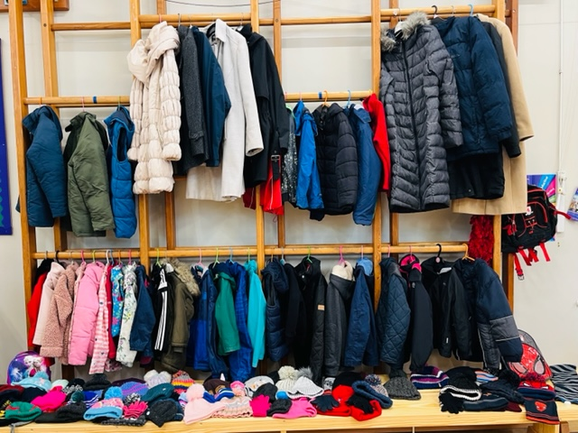
As a school, we try to be as environmentally friendly as we can! Our children learn about looking after the planet and the importance of recycling rather than sending huge amounts of waste to landfill. There are good reasons to seek out alternatives to throwing clothes in the bin – globally the fashion industry is responsible for 10% of all greenhouse gas emissions, with textile production alone estimated to release 1.2 billion tonnes of greenhouse gases into the atmosphere every year.
At the same time we are buying more clothes than ever – the average consumer now buys 60% more clothing than they did 15 years ago. More than two tonnes of clothing is bought every minute in the UK, more than any other country in Europe.

Our Christian vision of ‘Community, Compassion & Friendship’ are also key to life in Filey CE Nursery & Infants Academy and we like to recycle and share whenever we can!

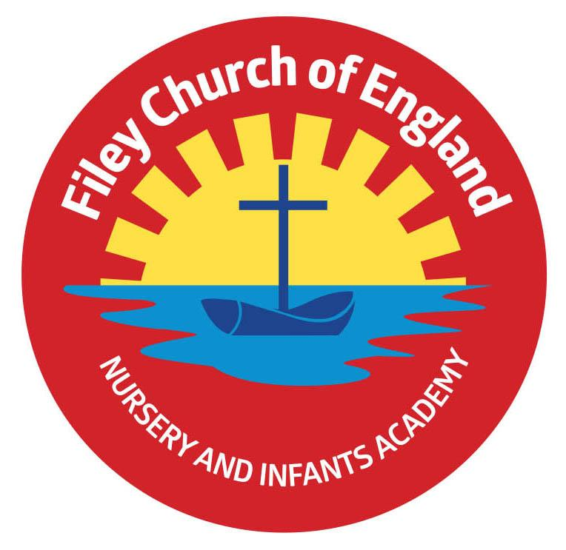
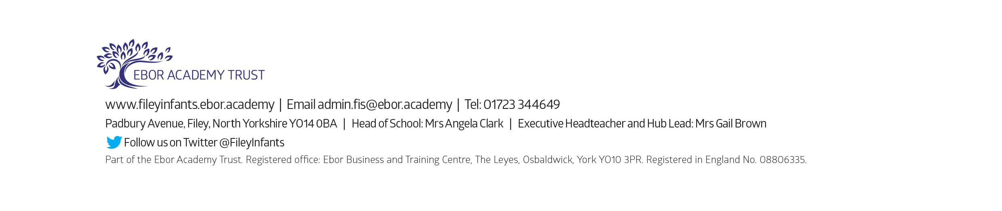
This week we will be holding a ‘Recycle Ready for Winter’ event in our school hall. We have already started to display coats, hats, scarves and gloves that are no longer needed in the school hall and invite everyone to take part.

What to do next:

1. Send into school tomorrow (Tuesday 1st November) any unwanted coats, hats, scarves or gloves to add to the above collection. (All ages/sizes gratefully received).

2. Pop into school any time between 8.40am and 4pm on Wednesday 2nd November to take your pick and re-use what you can.

3. Wear your new FREE items knowing that you have helped to reduce waste and saved some money!

Warmest Regards
Angela Clark
Headteacher

