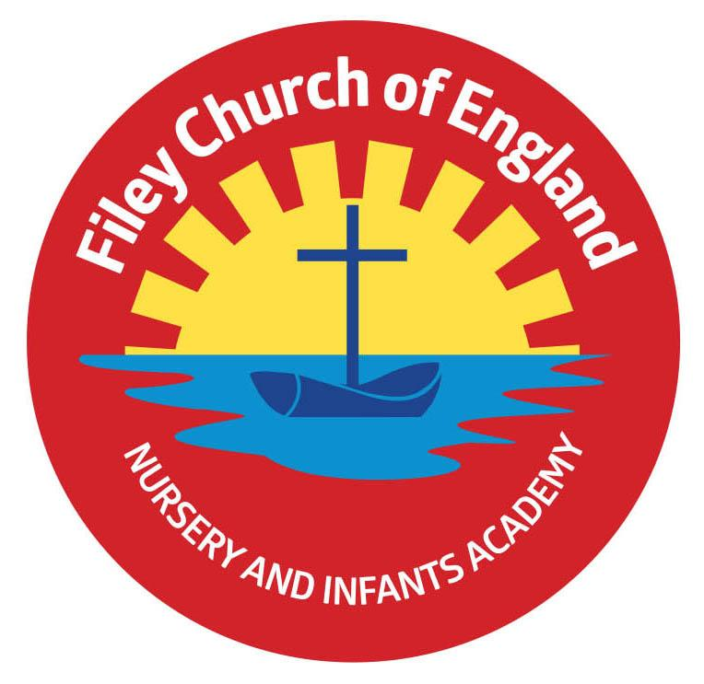
Friday 30th September 2022

Dear Parents/Carers
We celebrated with a wonderful Harvest Festival in school this morning. Thank you to everyone who came to watch the children perform, if you were unable to join us don’t worry, recordings will be on our school website later today: found under Key Info – Christian Distinctiveness. As you can see in the picture below the Harvest table was over flowing with generous gifts.
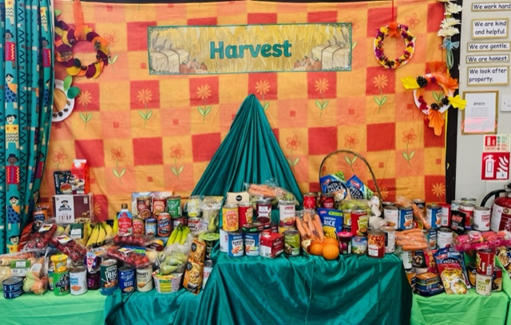
We used paper bags for our individual Harvest gifts to show that we try to be as environmentally friendly as possible. This morning we took all the tins and packets to St John’s Church and this afternoon some of our year two children delivered Harvest gifts to the elderly and our neighbours around school. This week Mrs Stubbs class won the attendance award with 97.8% well done to them.

Cross Country Running
On Thursday 13th October 4pm at Scarborough Rugby Club there will be a cross country-running race for Yr 2 pupils, Yr 1 pupils are allowed to take part with the Yr 2’s if they wish as there is not a separate race for them. If your child is interested, they will need to collect a race number from Miss Williams. You will need to accompany your child at this event.

Momo & Piggy
Unfortunately, some of our children have been talking about these characters in school this week. It appears that these online characters ask children to do dangerous things, which could ultimately end up with them hurting themselves or others. We teach about ESafety in school on a regular basis and the children involved have had a discussion with their teacher. Please ensure you have the necessary age restrictions on all the devices that your children play on independently.

Scholastic Book Club
Your child will have brought home a Scholastic Book Club leaflet today. You can browse the latest books and order online. For every £1 you spend, our school will earn 20p towards buying lovely new books for ‘Big Red’ the reading bus.

Best Wishes
Mrs Angela Clark
Angela Clark
Headteacher

Diary Dates – (up to the end of term, more dates will be added as they arise)
Monday 10th October – Parents Evening – 3pm-5pm
Tuesday 11th October – Parents Evening – 3pm-5pm
Wednesday 12th October – Parents Evening – 3pm-5pm
Monday 17th October – Mr Jackson’s class visit Filey Library
Tuesday 18th October – Miss William’s class visit Filey Library
Wednesday 19th October – Mrs Mackay’s class visit Filey Library
Friday 21st October – Mr Jackson’s class poetry assembly in the school hall 9am
Friday 21st October – School closes for half term
Monday 31st October – School reopens
Monday 31st October – Year 2 choir starts

Thursday 3rd November – After school PE club starts for Y1 children
Monday 7th November – Open the Book Collective Worship
Wednesday 16th November – Mrs Mackay’s class start swimming lessons
Wednesday 23rd November – Influenza Immunisations in school
Friday 2nd December – School Christmas Fair 3pm-4.30pm
Monday 5th December – Nursery & Reception Christmas Production 2pm
Tuesday 6th December - Nursery & Reception Christmas Production 10am
Tuesday 6th December – Year 1 Christmas Production 1.30pm
Wednesday 7th December - Year 1 Christmas Production 10am
Wednesday 7th December – Year 2 Dress Rehearsal (parents NOT invited)
Thursday 8th December – Year 2 Christmas Production 9.30am & 1.30pm
Friday 9th December – Year 1 and Year 2 pupils visit Scarborough Spa Panto ‘Dick Whittington’
Monday 12th December – Open the Book Collective Worship
Tuesday 13th December – Nursery & Reception children visit the SJT in Scarborough to watch ‘Sammy the Shoemakers ‘Impossible Day’
Tuesday 13th December – Year 1 and 2 classes Christmas Party 1pm
Wednesday 14th December – Nursery & Reception Christmas Party
Thursday 15th December – Christmas Lunch
Friday 16th December – School Closes
