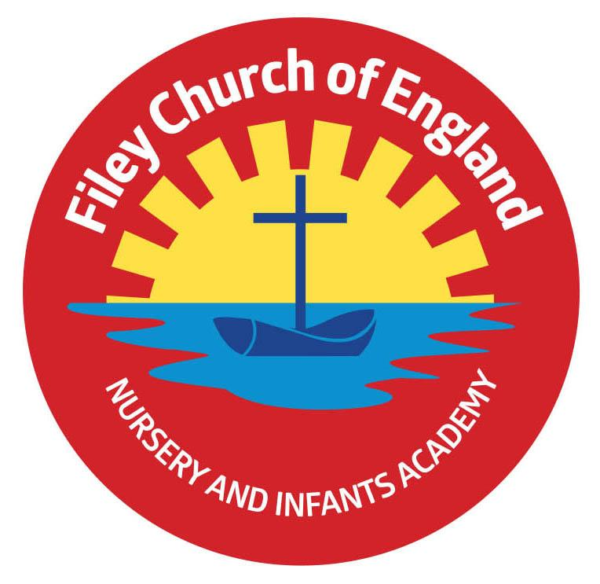
Friday 14th October 2022

Dear Parents/Carers

Another lovely week in school with children working hard and having fun. Please remember to name all school uniform; it is very difficult to return items without a child’s name.
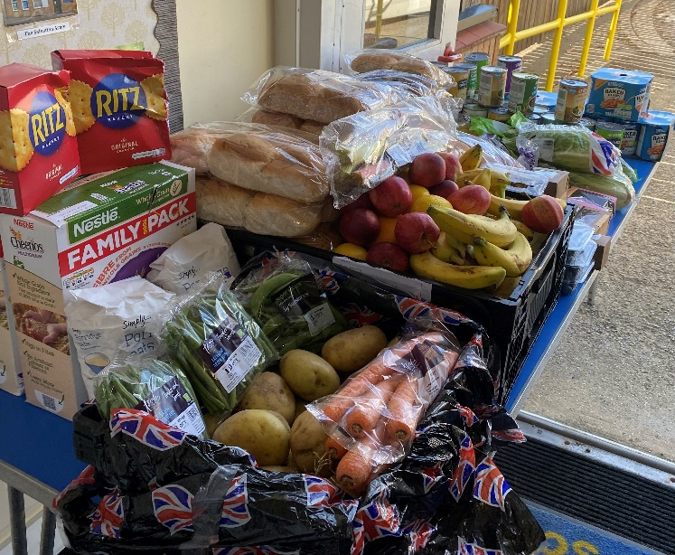
Each week we receive free food from local supermarkets to share with our families. This is for everyone to enjoy, we invite you to come along with a bag and take the items that your family will like. You can see from the picture that the table is full of lovely fruit, vegetables, tins, packets, sauces, cakes and bread.

As a school we teach our children how to care for the environment, the importance of recycling and reducing waste. Please don’t be shy! Especially in these times of rising household costs, lets help each other to save money and save waste! Look out for the text message to say we have food to collect.

This week Miss Withers and Mrs Mackay classes won the attendance award with 98.75% well done to both classes.

Head Lice
Unfortunately, head lice can be an ongoing problem for young children and we have had a few cases in school this week. You do not need to buy special treatments unless you want to and you certainly do not need to keep your child off school. You do however need to use the wet combing method quickly and thoroughly. Please see below:
WET COMBING is just as effective as medicated lotions and shampoos if done thoroughly.

You will need a special fine-toothed comb (detection comb) these can be purchased online or from local pharmacies. Follow these instruction:
- wash hair with ordinary shampoo
- apply lots of conditioner (any conditioner will do)
- comb the whole head of hair, from the roots to the ends

It usually takes about 10 minutes to comb short hair, and 20 to 30 minutes for long or curly hair. Do wet combing on days 1, 5, 9 and 13 to catch any newly hatched head lice. Check again that everyone's hair is free of lice on day 17.

Mr Jackson’s Class Poetry Assembly
On Friday 21st October, Mr Jackson’s class will lead a poetry assembly. Parents and family members are invited to join us in the school hall at 9am. It will last approximately 20 minutes.

If you have any questions or concerns please just ask, we are here to help in any way that we can.

Best Wishes
Mrs Angela Clark
Angela Clark
Headteacher

Diary Dates – (up to the end of term, more dates will be added as they arise)
Monday 17th October – Mr Jackson’s class visit Filey Library
Tuesday 18th October – Miss William’s class visit Filey Library
Wednesday 19th October – Mrs Mackay’s class visit Filey Library
Friday 21st October – Mr Jackson’s class poetry assembly in the school hall 9am
Friday 21st October – School closes for half term
Monday 31st October – School reopens
Monday 31st October – Year 2 choir starts

Thursday 3rd November – After school PE club starts for Y1 children
Monday 7th November – Open the Book Collective Worship
Wednesday 16th November – Mrs Mackay’s class start swimming lessons
Wednesday 23rd November – Influenza Immunisations in school
Friday 2nd December – School Christmas Fair 3pm-4.30pm
Monday 5th December – Nursery & Reception Christmas Production 2pm
Tuesday 6th December - Nursery & Reception Christmas Production 10am
Tuesday 6th December – Year 1 Christmas Production 1.30pm
Wednesday 7th December - Year 1 Christmas Production 10am
Wednesday 7th December – Year 2 Dress Rehearsal (parents NOT invited)
Thursday 8th December – Year 2 Christmas Production 9.30am & 1.30pm
Friday 9th December – Year 1 and Year 2 pupils visit Scarborough Spa Panto ‘Dick Whittington’
Monday 12th December – Open the Book Collective Worship
Tuesday 13th December – Nursery & Reception children visit the SJT in Scarborough to watch ‘Sammy the Shoemakers ‘Impossible Day’
Tuesday 13th December – Year 1 and 2 classes Christmas Party 1pm
Wednesday 14th December – Nursery & Reception Christmas Party
Thursday 15th December – Christmas Lunch
Friday 16th December – School Closes
