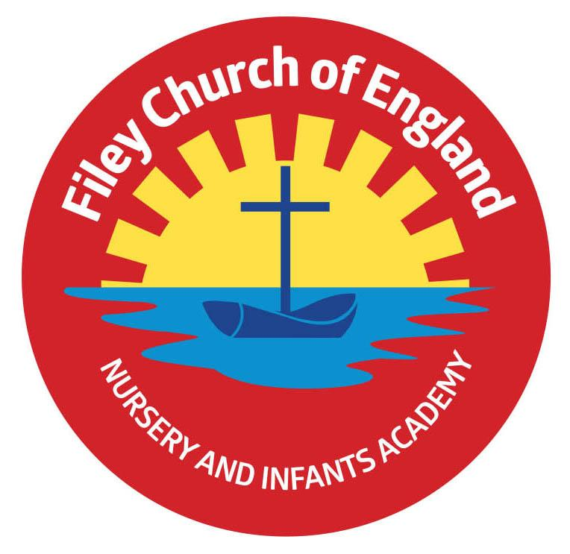
Friday 9th September 2022

Dear Parents/Carers
What a wonderful week we have had back at school. Our KS1 children have confidently entered school each morning and enjoyed being in their new classes. Our new starters are beginning to settle into the school routine and by Wednesday next week we will have all our new Nursery & Reception children in their classes. We are very much looking forward to getting to know everyone in school.

Queen Elizabeth II
Yesterday we heard the sad news of the passing of our beloved Queen. KS1 children shared a special Collective Worship in school today and discussed their memories of the Queen in their classes. There will be a service of prayer and thanksgiving for the life of the Queen taking place at
St. Oswald's Church in Filey tonight at 7pm. All are welcome.
We stand with the rest of the nation in expressing our gratitude for the life of Her Majesty The Queen, her loyal service and devotion to duty. As a mark of respect, we will not be posting on social media for the duration of national mourning.

Free Breakfast
Each morning we offer free breakfast in the classrooms at 8.40am. This includes a choice of cereal with milk and a drink of water. Your child will bring home a letter today with a return slip so you can indicate whether you would like your child to have breakfast each morning or not. Please return this slip on Monday morning to ensure your child receives breakfast.
Milk
All children under the age of five receive free milk in school. If your child is in Year 1 or Year 2 and you would like them to have milk in school you will need to pay for this via coolmilk.com
Please note: If your child is entitled to free school meals, you will not need to pay for milk.

Family Learning – Starting again next week!
This is a wonderful opportunity to come into school and work with your child. We offer a choice of three sessions on either Tuesday’s at 9am, Wednesday’s at 9am OR Thursday’s 1pm. Your child will bring home a letter with more information. If you would like to attend these very popular sessions please return the slip by Tuesday 12th September.
‘Big Red’ the reading bus!
We will be starting our family reading club Monday 12th September. It will take place on ‘Big Red’ and starts at 2.40pm. Parents/family members are welcome to come and read with their child on the reading bus. Children will collect a stamp each time they attend the club with a grown up and earn prizes. This is a weekly club on either Monday or Wednesday, please come to the main office on either day at 2.35pm. Everyone welcome! Please try to arrive just before 2.40pm if possible, as Collective Worship will be taking place in the school hall.

School Photos
Thursday 22nd September will be our school photograph day. If you would like to bring siblings that do not attend our school to have a group photo you can do this between 8.15am and 9am. All children will have their photograph taken individually and with any siblings that they have in our school. If your child is in Nursery and you would like them to have their photograph taken, please bring them to the office at 10am. ONLY if they do not normally attend Nursery on a Thursday morning.

Every Day Counts
You will have a leaflet attached to this email all about school attendance. Please take the time to read this as it explains why good attendance is so important. It also explains attendance laws, the rules around holiday requests and answers many questions.
Year 2 PE Club
Mr Ellis will be starting his after school PE club for Year 2 pupils on Thursday 22nd September in the school hall from 3pm-4pm. Your child will be bringing a letter home, please return the slip ASAP if your child would like to take part. Places will be offered on a first come first served basis although we do have a small list of children already because they missed out in the Summer term.
‘Wonder Time’ Church Group
‘Wonder Time’ church group for Y1 & Y2 children will take place each Monday lunchtime in school and is organised by our friends from St John’s Church. Children will enjoy Bible stories, craft activities and music. Your child will have been given a letter today with more information.
Swimming Lessons
We are extremely fortunate to be able to offer all Year 2 children a block of 8 one hour swimming lessons totally FREE of charge. This year we are also happy to offer all Year 1 children a block of 7 one hour swimming lessons totally FREE of charge. These lessons take place every Wednesday throughout the year and will start with Mr Jackson’s class. Your child will be bringing home a letter with more information and a consent slip that must be returned before they can start their lessons.
School Parent Governor
We have a vacancy for a parent governor although our current parent governor is happy to serve another term. If you would like to register an interest in becoming a school governor, please let me know by Tuesday 20th September.

Thank you for your support. Please keep the diary dates below for your information.
Best Wishes
Mrs Angela Clark
Angela Clark
Headteacher

Diary Dates – (for this half term)
Monday 12th September – Family Reading Club starts on ‘big Red’ 2.40pm
Tuesday 13th September – Family Learning - group 1 commences 9am-11am.
Wednesday 14th September - Family Reading Club on ‘big Red’ 2.40pm
Wednesday 14th September – Family Learning – group 2 commences 9am-11am.
Thursday 15th September – Family Learning – group 3 commences 1pm-3pm.
Monday 19th September – ‘Wonder Time’ church group commences lunchtimes.
Thursday 22nd September – School Photographs am
Thursday 22nd September – Year 2 after school PE club with Mr Ellis 3pm-4pm.
Friday 30th September – Family Sponsored Walk 1pm
Friday 7th October – School Harvest Festival 9am in the school hall
Monday 10th October – Parents Evening – 3pm-5pm
Tuesday 11th October – Parents Evening – 3pm-5pm
Wednesday 12th October – Parents Evening – 3pm-5pm
Friday 21st October – Mr Jackson’s class poetry assembly in the school hall 9am
Friday 21st October – School closes for half term
Monday 31st October – School reopens

