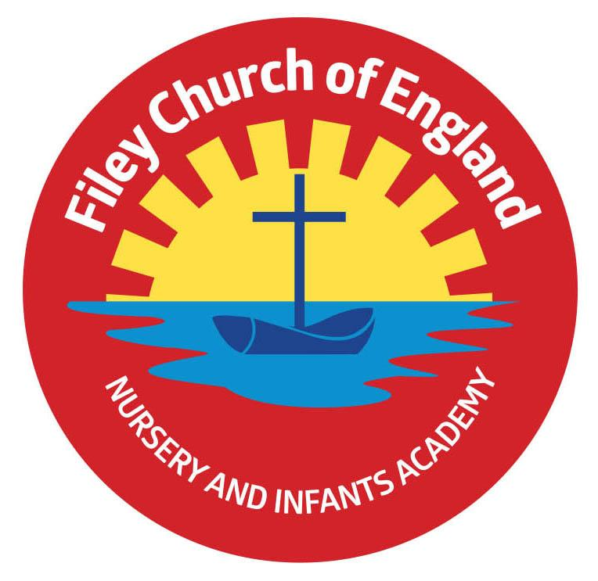
Friday 23rd September 2022

Dear Parents/Carers
Another lovely week in school with children having fun and working hard. You should receive a copy of your child’s school photograph next week with an order form should you wish to purchase any of the photographs. I have included as many dates as I can taking us up to the end of the Autumn term, although more will be added as time goes on. I appreciate that many people need to arrange time off work for Christmas productions etc. so I try to give as much notice as possible.

Bright Smiles, Bright Futures!
We are taking part in the ‘Bright Smiles, Bright Futures’ schools programme from Colgate. Your child will bring home with them today a toothpaste sample, a toothbrush and an educational family leaflet. If you would like any further information or activities, you can visit www.bsbf-getinvolved.uk/resources

School Sponsored Walk
If you are joining us on Friday 30th September for our Sponsored Walk please come to either the front or back school gates at 1pm. You will then need to wait outside your child’s outside classroom door. Your child has already been given a sponsor form if you would like to support our school theatre visits and Cancer Research. If you did not receive a sponsor form please ask your child’s class teacher.

School Absences
If your child is not going to be in school, you must let us know. You can do this by telling us in advance, by leaving a voicemail or by sending an email to admin.fis@ebor.academy If we do not hear from you and are unable to make contact a home visit will be made. If we are still unable to ascertain the whereabouts of your child we will need to make a welfare call to North Yorkshire police. All schools legally have to account for each child on their register by 10am each morning. Please help us to do this by letting us know!

Nasal Flu Vaccinations
All Primary aged children are offered the nasal flu vaccination in school. This will be taking place on Wednesday 23rd November. If you would like your child to have this vaccination please follow this link to give your consent. https://www.hdftsais.co.uk/Forms/Flu You will need to school code: HD144274

Free School Meals Application
All children in Reception, Year 1 and Year 2 are entitled to a Government funded free school meal, however we still need to apply because extra funding is allocated to school for each child that qualifies. If you have not yet returned the application form to school please do this as soon as possible, every pound towards our school budget makes a big difference!

School Website
Our school website has now been updated; you can find information about our curriculum, classes, school governors, staff, school policies and much more at www.fileyinfants.ebor.academy Please remember you can also follow us on Twitter to see some of the wonderful things that happen in school.

Thank you for your support. If you have any questions or concerns please talk to your child’s class teacher or phone the office on 344649, we are here to help in any way we can. Please keep the diary dates below for your information.
Best Wishes
Mrs Angela Clark
Angela Clark
Headteacher

Diary Dates – (up to the end of term, more dates will be added as they arise)
Monday 26th September - ‘Wonder Time’ church group commences lunchtimes.
Friday 30th September – Family Sponsored Walk 1pm
Monday 3rd October – Open the Book Collective Worship
Mondat 3rd October – Year 2 classes visit St Oswald’s Church
Friday 7th October – School Harvest Festival 9am in the school hall
Monday 10th October – Parents Evening – 3pm-5pm
Tuesday 11th October – Parents Evening – 3pm-5pm
Wednesday 12th October – Parents Evening – 3pm-5pm
Monday 17th October – Mr Jackson’s class visit Filey Library
Tuesday 18th October – Miss William’s class visit Filey Library
Wednesday 19th October – Mrs Mackay’s class visit Filey Library
Friday 21st October – Mr Jackson’s class poetry assembly in the school hall 9am
Friday 21st October – School closes for half term
Monday 31st October – School reopens

Thursday 3rd November – After school PE club starts for Y1 children
Monday 7th November – Open the Book Collective Worship
Wednesday 23rd November – Influenza Immunisations in school
Friday 2nd December – School Christmas Fair 3pm-4.30pm
Monday 5th December – Nursery & Reception Christmas Production 2pm
Tuesday 6th December - Nursery & Reception Christmas Production 10am
Tuesday 6th December – Year 1 Christmas Production 1.30pm
Wednesday 7th December - Year 1 Christmas Production 10am
Wednesday 7th December – Year 2 Dress Rehearsal (parents NOT invited)
Thursday 8th December – Year 2 Christmas Production 9.30am & 1.30pm
Friday 9th December – Year 1 and Year 2 pupils visit Scarborough Spa Panto ‘Dick Whittington’
Monday 12th December – Open the Book Collective Worship
Tuesday 13th December – Nursery & Reception children visit the SJT in Scarborough to watch ‘Sammy the Shoemakers’ Impossible Day’
Tuesday 13th December – Year 1 and 2 classes Christmas Party 1pm
Wednesday 14th December – Nursery & Reception Christmas Party
Thursday 15th December – Christmas Lunch
Friday 16th December – School Closes
