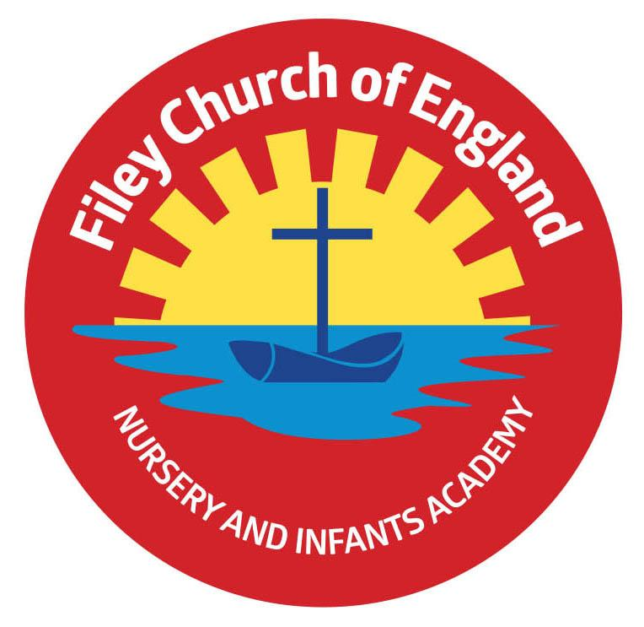
Friday 16th September 2022

Dear Parents/Carers
All children are now settled in their new classes and doing well. Your child should have brought home a class welcome letter with important information about your child’s class. If you did not receive this letter, please let us know.
Please note: school will not be open on Monday 19th September due to Queen Elizabeth II state funeral. We stand with the rest of the nation in expressing our gratitude for the life of Her Majesty The Queen, her loyal service and devotion to duty. As a mark of respect, we will not be posting on social media for the duration of national mourning.

Free Food and Toiletries
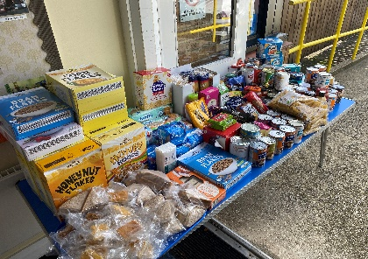
We are very fortunate to receive many wonderful food and toiletry items completely free of charge each Friday! Please help us take advantage of this generous offer by bringing a carrier bag and helping yourself. The table full of goodies is in the main reception area. Please don’t be shy, this is there for everyone to enjoy…and who doesn’t likes a little something free in the ever-increasing costly world in which we live?

School Sponsored Walk
Each year we hold a school sponsored walk and invite family members to join us. This is a whole school event and the money raised pays for all children to visit the theatre at Christmas. This year we are delighted to donate £100 towards The Relay for Life Cancer Research Event, which took place on Saturday 3rd September. One of our Y1 pupils, Mani Tapper took part in this event and his group have raised a wonderful £10’000 towards this worthwhile charity. Well done Mani!
Your child will have been given a sponsor form today so you can start collecting sponsors if you would like to support our school theatre visit and Cancer Research.

Nasal Flu Vaccinations
All Primary aged children are offered the nasal flu vaccination in school. This will be taking place on Wednesday 23rd November. If you would like your child to have this vaccination please follow this link to give your consent. https://www.hdftsais.co.uk/Forms/Flu If you would like more information please read the letter attached to this email.

Lunchtime Raffle Tickets
During lunchtimes in the hall staff give out special raffle tickets to children eating nicely and being sensible. Each Friday in Collective Worship, we will draw the raffle tickets out of a bag and the lucky winners will be rewarded with a dip in the ‘Treasure Box’. This is just another way we encourage and reward good behaviour.

School Photos
Thursday 22nd September will be our school photograph day. If you would like to bring siblings that do not attend our school to have a group photo you can do this between 8.15am and 9am. All children will have their photograph taken individually and with any siblings that they have in our school. If your child is in Nursery and you would like them to have their photograph taken, please bring them to the office at 10am. ONLY if they do not normally attend Nursery on a Thursday morning.

School Uniform
Please ensure your child’s uniform has their name clearly written inside each item. Young children easily misplace jumpers etc. and I am sure you will appreciate we are unable to replace lost items.
School Website
We have been unable to update our school website due to technical difficulties. The curriculum plans, class information and staffing etc. should be up to date by the end of next week. Thank you for your patience.

Thank you for your support. If you have any questions or concerns please talk to your child’s class teacher or phone the office on 344649, we are here to help in any way we can.
Please keep the diary dates below for your information.

Best Wishes
Mrs Angela Clark
Angela Clark
Headteacher

Diary Dates – (for this half term)
Monday 12th September – Family Reading Club starts on ‘big Red’ 2.40pm
Tuesday 13th September – Family Learning - group 1 commences 9am-11am.
Wednesday 14th September - Family Reading Club on ‘big Red’ 2.40pm
Wednesday 14th September – Family Learning – group 2 commences 9am-11am.
Thursday 15th September – Family Learning – group 3 commences 1pm-3pm.
Monday 19th September – ‘Wonder Time’ church group commences lunchtimes. School closed!
Thursday 22nd September – School Photographs am
Thursday 22nd September – Year 2 after school PE club with Mr Ellis 3pm-4pm.
Monday 26th September - ‘Wonder Time’ church group commences lunchtimes.
Friday 30th September – Family Sponsored Walk 1pm

Monday 3rd October – Open the Book Collective Worship
Friday 7th October – School Harvest Festival 9am in the school hall
Monday 10th October – Parents Evening – 3pm-5pm
Tuesday 11th October – Parents Evening – 3pm-5pm
Wednesday 12th October – Parents Evening – 3pm-5pm
Monday 17th October – Mr Jackson’s class visit Filey Library
Tuesday 18th October – Miss William’s class visit Filey Library
Wednesday 19th October – Mrs Mackay’s class visit Filey Library
Friday 21st October – Mr Jackson’s class poetry assembly in the school hall 9am
Friday 21st October – School closes for half term
Monday 31st October – School reopens

