EYFS - Cycle 1
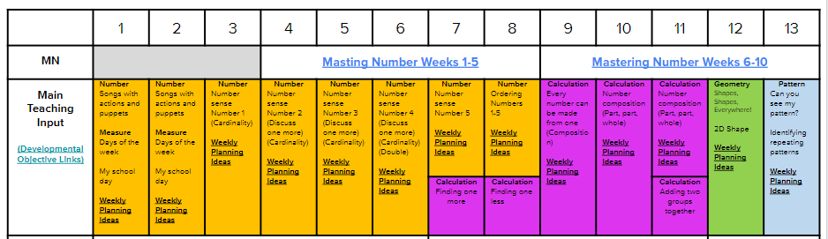
EYFS - Cycle 2
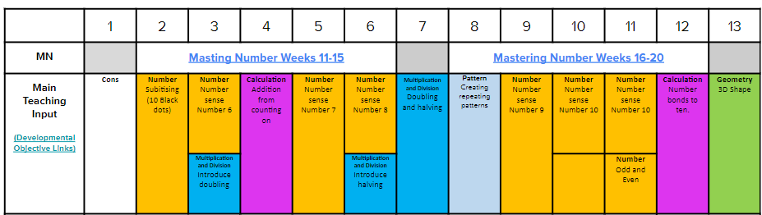
EYFS - Cycle 3
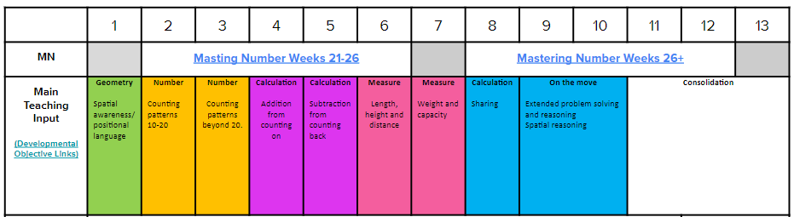
Year 1
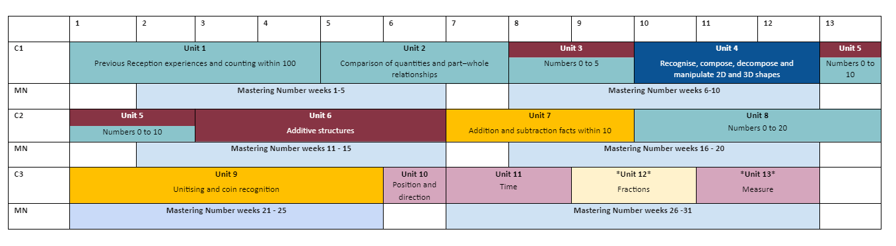

Year 2
