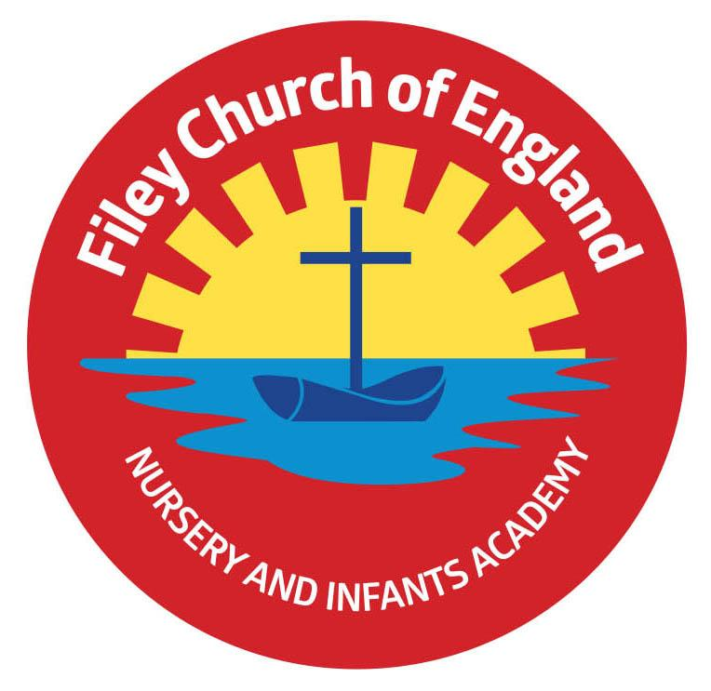
Friday 1st July 2022

Dear Parents/Carers
Our year 1 children enjoyed a wonderful day in Glenn Gardens and Filey Beach yesterday with lots of team building opportunities, outdoor adventure and sandcastle competitions. We also enjoyed Mr Jackson’s class poetry assembly this morning, a recording will be uploaded onto the school website later today. This can be found in the usual place: TEACHING & LEARNING – Classes – Mr Jackson

Parent Questionnaires
Thank you so much to everyone who returned their questionnaires. We received 23 back which is a great response. I have attached ALL responses to the end of this letter for your information. We really do take on board everything you say in these questionnaires and use your responses to help shape the future of our school.
It was wonderful to see that all 23 out of 23 of you said that your children are happy in school and all 23 out of 23 of you said that you would recommend our school to other parents. Thank you so much for all the wonderful comments it really does mean a lot to myself and all the staff in school.

Open Evening
Thank you to everyone who attended our school open evening on Wednesday, it was great to see so many families. For clarification purposes here are just a few answers to questions raised:
- Miss Williams has a small number of year 1 pupils within her year 2 class in September, these are our more mature, socially and emotionally developed Y1 pupils. This group of Y1 pupils will still access the whole of the year 1 curriculum and join the Y1 cohort each day for phonics lessons. They will also still take part in all whole year 1 group events e.g. Christmas productions & outdoor education visits. Please note this is nothing new, it happened this academic year and does happen most academic years.
- The majority of schools operate a staggered start for new to Nursery and Reception pupils. This is done to ensure pupils do not feel overwhelmed when starting a new school at a young age and also enables staff to give more attention to children on their very first day. Most schools (especially schools with large cohorts like ours) run staggered starts over a two week period. We, however make sure all children are in school within a week of opening so no one is waiting too long. I am sure you will appreciate this system like everything we do in school is done in the best interests of all children.
- All children in Reception, Year 1 and Year 2 are entitled to Universal Free School meals. They have a choice of either a hot meal, jacket potato with various fillings or a sandwich option. Unfortunately Nursery children are not funded for meals by the Government and will need to pay for their meals at £1.80 per day.
- All teachers in our school have PPA (planning, preparation & assessment) time out of class each week (this is a legal requirement). Members of the school leadership team have slightly more time out of class due to their increased responsibilities. All teachers in our school are covered by highly qualified staff who are part of a strong dedicated team of professionals and of course are legally allowed to teach your children.

Family Learning Sessions
There will be no family learning sessions next week due to transition days. The last family learning sessions for this academic year will be on Tuesday 12th, Wednesday 13th and Thursday 14th July. A big thank you to Lucy, Mrs Keary and Mrs Wilson for their hard work.

Reception Outdoor Education Day
On Thursday 14th July our reception children will spend the day on Filey Beach. They will not need to wear school uniform although we do request they wear their red jumper/cardigan for easy identification and appropriate footwear. If it is a hot day they will need sun cream, sunhats and extra drinks. You can order a school packed lunch via the school office by Friday 8th July. Children are welcome to bring a bucket and spade (please write their name on these items).

School Sports Days
Last year’s sports days were a great success and we plan to have separate year group events again this year.
Monday 18th July 1pm – Year 2 Sports Day
Tuesday 19th July 1pm – Reception Sports Day
Wednesday 20th July 1pm – Year 1 Sports Day
Thursday 21st July 1pm – Nursery Sports Day

Summer Fair
This year our Summer Fair will take place after school on Friday 15th July from 3pm-4.30pm. There will be a variety of stalls including tombola, raffle, cakes, hot dogs, face painting, games and competitions. Children are invited to wear non-uniform on Friday 8th July and bring a bottle to school for the tombola. This can be any kind of bottle including: bubble bath, juice, sauces, pop or alcohol (please ensure alcohol is passed over to a member of staff or dropped off at the office). Your child will bring home a sheet of raffle slips if you would like to buy tickets in advance. As always we thank you for your support.

Year 2 Leavers Party
All year 2 children are invited to attend a leaver’s party after school on Thursday 21st July. This takes place between 5pm-6.30pm in the school hall. A letter will be sent out next week with more information.

Scarborough Library
If you are interested to know what is going on throughout July at Scarborough Library please see the flyer attached to your email.

All the final diary dates taking us to the end of this academic year are included below. As always if you have any questions or concerns please talk to your child’s class teacher or phone the office on 344649. We are here to help however we can.

Warm Wishes
Mrs Angela Clark
Angela Clark
Headteacher

Dates for your diary:
Monday 4th July – Last Open the Book Collective Worship for this academic year (date changed)
Tuesday 5th, Wednesday 6th & Thursday 7th July – Year 2 transition days to the Junior School
Wednesday 6th July – Transition day for all other year groups in school
Friday 8th July – Non uniform day – bring a bottle for the Summer Fair tombola
Friday 8th July – Nursery Enterprise 2.15pm
Monday 11th July – Last Open the Book Collective Worship of this academic year
Thursday 14th July – Reception Outdoor Education Day – Filey Beach
Thursday 14th July – Last after school PE club for Nursery
Friday 15th July – Summer Fair 3pm-4.30pm
Monday 18th July – Year 2 Sports Day 1pm
Tuesday 19th July – Reception Sports Day 1pm
Wednesday 20th July – Year 1 Sports Day 1pm
Thursday 21st July – Nursery Sports Day 1pm
Thursday 21st July – Year 2 leavers party 5pm – 6.30pm
Friday 22nd July – Year 2 leavers assembly 11am
Friday 22nd July – Whole School Family Picnic 12pm – everyone invited!
School reopens on Wednesday 7th September 2022

Parental Questionnaire Comments – Summer 2022
As a school what do you think we do well?
Great teaching, full range of subjects and excellent communication.
Everything!
Support children to reach their full potential and offer extra help for children struggling.
Support interests and encourage children to develop their skills.
Family learning – my child has really enjoyed this.
Everyone is very friendly and welcoming.
Range of real life learning experiences to teach them about the world.
Understanding.
Care for every child’s needs no matter how big or small.
Teach manners and provide a good education.
Communication, supporting charities and give recognition and rewards.
You can tell the teachers have a lot of love for the children.
Making a safe and enjoyable environment for children to learn. Keeping parents updated and informed. Providing children with many opportunities.
The teaching is very good, especially phonics.
Promoting the wellbeing of families and keeping parents updated on their children’s progress.
Teaching children about other cultures and religions. Encouraging positive behaviour with the headteacher awards.
I am happy with how my child is treated and the things she learns.
Regular, informative home/school letters. Lots of positive praise & reinforcement – my child loves coming home with stickers or a ‘treasure’!
How do you feel our school supports children & families?
Newsletters every week, food bags for all that need it and communication.
Very supportive.
I feel supported and valued as a parent.
Very well supported.
I feel very supported by everyone at the school.
Lots of open sessions and opportunities to see what my child does in school. All staff are very welcoming and know you and your child.
Not sure never had to ask for the school’s help.
Filey Infants have supported me and my daughter when needed.
We have asked for support with our child’s behaviour and we don’t feel we have received it.
By always keeping us informed, offering help and support when needed and ensuring each child is treated as an individual.
Very supported with morning and after school clubs. Good chances to discuss child’s growth and regular parent’s evenings.
By listening and having activities and updating us on social media.
Loads of fun activities throughout the year for families to get involved in. Very approachable, fun and friendly. Education for parents and future employment opportunities.
Very well, food parcels, family learning etc.
Staff are approachable and caring. Recent letters have highlighted some playground issues with yr2 boys which I feel school are clearly taking seriously to make the playground a safe place for all the children.
Really well, you should all be very proud, you are a wonderful team!
What do you think to the quality of education we provide for your child?
Excellent and really trying to catch up on missed lessons.
Very good!
I can’t fault it, my child comes home with lots of stories about what he has learnt and that speaks volumes.
Very happy with the standard of education.
So far my child has received an excellent education.
We couldn’t ask for any better, he is happy, safe and every day comes out of school with something new that he has learnt.
Fun for children
1000%
Excellent both my children have loved your curriculum.
10 out of 10!
Excellent, it’s fun, interesting and there is a wide range of knowledge taught.
Very good, my son is fantastic at phonics and this has helped him read very well.
Excellent, at 28 phonics still confuses me but the children learn really well and it shows on parents evening when we see their work.
Excellent, my child has come on massively since being at this school.
I am very pleased with all the different types of lessons my child receives.
Very good, my child was selected for some extra after school sessions, which we 100% agreed with and has come home happy and positive after these sessions.
Marvellous! My little girl has come on so well.
Have you any suggestions to further develop, improve or enhance provision for our children and families?
None – you are doing a great job!
Advanced warning on when parents are allowed into school to watch children do their shows etc.
Can’t think of any, just having swimming facilities in Filey.
More information passed through on child’s progress, any issues, what they are learning about in class and upcoming things.
More after school activities, instruments?
N/A GREAT JOB!
Recognise some children can’t help how they behave.
Perhaps more extra-curricular activities for children that parents are able to be involved in too.
The Nativity play was fantastic at Christmas it would be nice to see them do more performances in school. Holiday clubs would be welcomed.
The only thing would be to try to explain to the children of working parents that we can’t always make every event, mum guilt.
No issues or concerns.
Keep doing what you are doing. The school is a caring, inclusive environment for all and staff take any worries seriously and are restorative in how they deal with children and their ‘fall outs’.
Is your child happy in school?
23 out of 23 said YES!
He most definitely is, looks forward to attending Nursery every day.
Absolutely!
Yes, he loves school and all his teachers.
Very!
Would you recommend this school to another parent?
23 out of 23 said YES!
100%
Yes, absolutely
No question, definitely!

