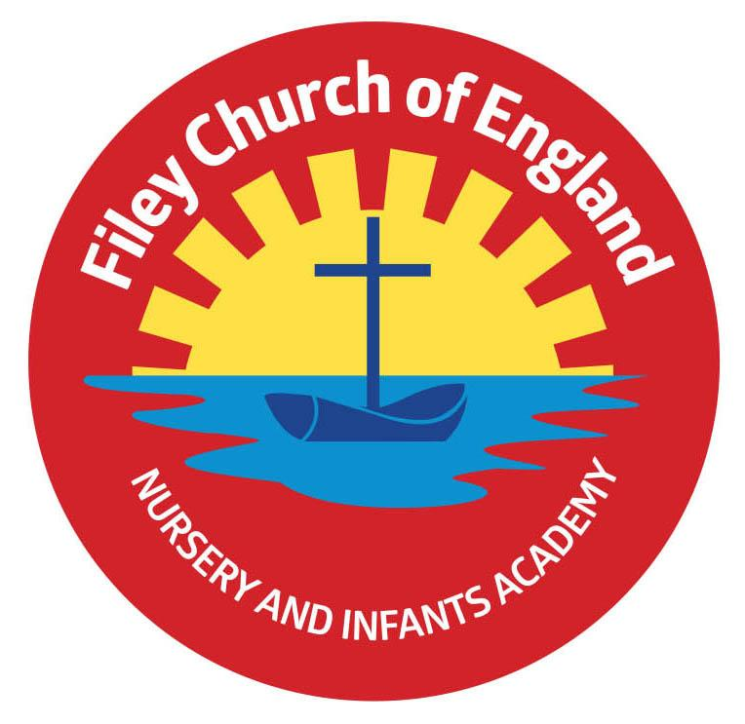
Friday 10th June 2022
Dear Parents/Carers
A big well done to all our year one children who have tried very hard completing their phonic screening check this week. It is wonderful to see how hard our children try and just how much progress they have made throughout the year.
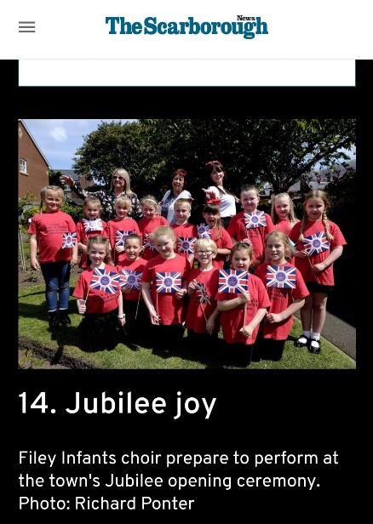

Thank you to our year two school choir for a wonderful performance in Filey Memorial Gardens last Thursday for the Jubilee celebrations. We were all very proud of them and their behaviour was a credit to our school. On Friday 27th May we enjoyed a lovely Jubilee tea party at school and all children had their photo taken with Queen Elizabeth. Class teachers are busy printing these photos and your child should be bringing them home very soon. Each child was also given a commemorative cup as a special memory of this wonderful occasion.

Whole Class Photos
Class photographs are a lovely reminder of your child’s time in their class with all their friends and class teachers. If you would like to order a photograph you will need to follow this link. https://htmp.st/FileyCEInfantSch the closing date for free delivery to school is Friday 24th June.

Year 2 Trip to Dalby Forest
We still have some outstanding consent slips to receive for Y2 pupils to take part in the outdoor education day in Dalby Forest. This is due to take place Thursday 16th June, the coach will leave at 9am prompt. If you require a school packed lunch for your child you must return the packed lunch slip to the school office/class teacher. Children do not need to wear school uniform on this day, they do however need to wear clothes/shoes suitable for a forest adventure. Please also apply sun cream in the morning or send your child with a waterproof coat (weather dependent). If you have any questions please ask your child’s class teacher or contact the school office on 344649.

Group 3 Y2 Swimmers
Unfortunately because one of the swimming sessions is on the transition day to Filey Junior School group 3 will have to miss one of their sessions. I had hoped the pool would be able to change this session but they are unable to accommodate this request. I can only apologise for this in advance and ensure that group 3 swimmers arrive early at every other session to maximise their time in the pool.

Friday’s Free Food Bags
Most Friday’s (some Monday’s) we are very lucky to receive lots of food from Sainsbury’s in Scarborough. Instead of bagging up this food for collection we are simply going to display it all on a table outside the front reception area. We will send a text message out as usual inviting everyone interested to bring a bag and take what they would like. This way you are able to choose items suitable for you and your family. Please help yourself so we can reduce the amount of food waste in the local area.

Head lice
We have had quite a few cases of head lice in school this week. Please ensure you check your child’s hair regularly and treat if required.

All the final diary dates taking us to the end of this academic year are included below. As always if you have any questions or concerns please talk to your child’s class teacher or phone the office on 344649. We are here to help however we can.

Warm Wishes
Mrs Angela Clark
Angela Clark
Headteacher

Dates for your diary:

Tuesday 7th June – School re-opens
Thursday 9th June – First after school PE club for Nursery
Monday 13th June – Open the Book Collective Worship
Thursday 16th June – Year 2 Outdoor Education Day – Dalby Forest
Friday 24th June – Mrs Stubbs’ class poetry assembly
Friday 24th June – School reports go out to parents
Wednesday 29th June – Open Evening 4pm-6pm
Thursday 30th June – Year 1 Outdoor Education Day – Glenn Gardens & Filey Beach

Friday 1st July – Mr Jackson’s poetry assembly 9am in the school hall
Friday 1st July – Year 2 leavers service at St Martin’s Church in Scarborough
Tuesday 5th, Wednesday 6th & Thursday 7th July – Year 2 transition days to the Junior School
Wednesday 6th July – Transition day for all other year groups in school
Friday 8th July – Nursery Enterprise 2.15pm
Monday 11th July – Last Open the Book Collective Worship of this academic year
Thursday 14th July – Reception Outdoor Education Day – Filey Beach
Thursday 14th July – Last after school PE club for Nursery
Friday 15th July – Summer Fair 3pm-4.30pm
Monday 18th July – Year 2 Sports Day 1pm
Tuesday 19th July – Reception Sports Day 1pm
Wednesday 20th July – Year 1 Sports Day 1pm
Thursday 21st July – Nursery Sports Day 1pm
Thursday 21st July – Year 2 leavers party 5pm – 6.30pm
Friday 22nd July – Year 2 leavers assembly 11am
Friday 22nd July – Whole School Family Picnic 12pm – everyone invited!

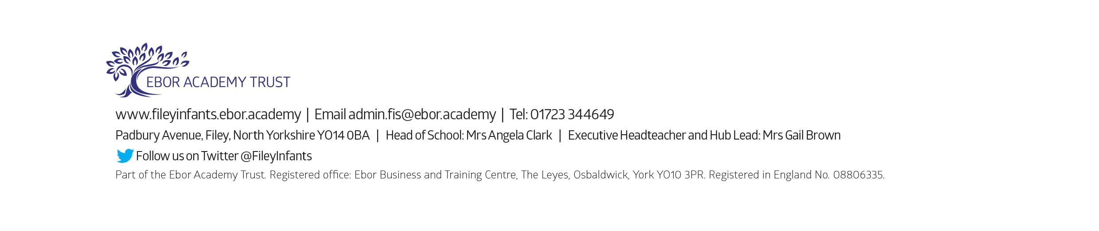
School reopens on Wednesday 7th September 2022

