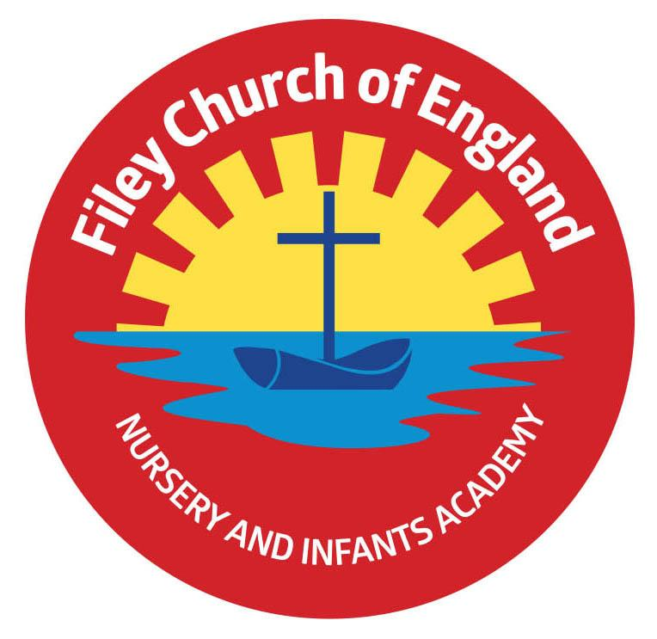
Friday 13th May 2022
Dear Parents/Carers

Calling all Nursery new Starters! As you know we have a very successful Nursery as part of our school with the wonderful Miss Hiley and her team. It is now the time of year when we need to allocate our Nursery places for September 2022. If you know anyone with children aged 3 before the 1st September 2022 please let them know that they need to get in touch with us as soon as possible to secure a place for their child. They can do this by phoning the office on 344649 or calling in.

Term Dates 2022/2023
I have attached next academic years term dates to this email for your information. These can also be found on our school website. Please note school does not reopen until Wednesday 7th September 2022.

Allergies
We have a few children in school with nut allergies, please could I request that children do not bring nuts to school including peanut butter sandwiches. It has also been brought to my attention that a number of children have had rashes recently caused by Nivea sun cream containing almond oil as an ingredient.

Parental Questionnaires
Your opinions really do matter to us and help us to shape the future of our school. Towards the end of each academic year we ask our parents/carers to complete a short questionnaire. Your child should have brought a questionnaire home with them today. It would be greatly appreciated if you could find the time to complete and return this questionnaire before we break up for half term. All comments and suggestions will then be shared with yourselves, staff and Governors before the end of this academic year.

Chicken Pox
Just to let everyone know that we have had a lot of cases of Chicken Pox in school over the last week. Chickenpox is a very contagious infection that causes an itchy, spotty rash. It's common in children but adults can get it too. Symptoms of chickenpox include itchy spots that become blisters, then scabs. It can be anywhere on the body, including in the mouth.
Chickenpox usually gets better on its own after 1 to 2 weeks. You can ease symptoms with cooling creams, antihistamines and paracetamol. Children remain infectious and would therefor need to stay absent from school until all the spots crust over (usually about five days after the rash appears).

Online Uniform Orders
Please note that the last day to order uniform online is the 1st August 2022. You will need to visit price-buckland.co.uk to place your order. Remember we have a free second hand uniform cupboard to promote recycling, please phone the school office if you would like any items sending home with your child. We welcome any good quality second hand uniform that your child no longer needs.

All the final diary dates taking us to the end of this academic year are included on the next page. As always if you have any questions or concerns please talk to your child’s class teacher or phone the office on 344649. We are here to help however we can.
Warm Wishes
Mrs Angela Clark
Angela Clark
Headteacher
Dates for your diary:

Monday 16th May – Open the Book Collective Worship
Wednesday 18th May – Last swimming session for group 2
Wednesday 25th May – First swimming session for group 3
Thursday 26th May – Year 2’s visit St John’s Church
Thursday 26th May – Last after school PE club for Year 1
Friday 27th May – Afternoon tea party to celebrate the Queen’s jubilee.
Friday 27th May – School closes for half term

Thursday 2nd June – School choir sing for HM Queen Elizabeth II Platinum Jubilee in Filey Memorial Gardens – 11am

Friday 1st June – Year 2 leaver’s service at St Martin’s Church 1st July NOT 1st June
Tuesday 7th June – School re-opens
Thursday 9th June – First after school PE club for Nursery
Monday 13th June – Open the Book Collective Worship
Thursday 16th June – Year 2 Outdoor Education Day – Dalby Forest
Friday 24th June – Mrs Stubbs’ class poetry assembly
Friday 24th June – School reports go out to parents
Wednesday 29th June – Open Evening 4pm-6pm
Thursday 30th June – Year 1 Outdoor Education Day – Glenn Gardens & Filey Beach

Friday 1st July – Mr Jackson’s poetry assembly 9am in the school hall
Friday 1st July – Year 2 leavers service at St Martin’s Church in Scarborough
Tuesday 5th, Wednesday 6th & Thursday 7th July – Year 2 transition days to the Junior School
Wednesday 6th July – Transition day for all other year groups in school
Friday 8th July – Nursery Enterprise 2.15pm
Monday 11th July – Last Open the Book Collective Worship of this academic year
Thursday 14th July – Reception Outdoor Education Day – Filey Beach
Thursday 14th July – Last after school PE club for Nursery
Friday 15th July – Summer Fair 3pm-4.30pm
Monday 18th July – Year 2 Sports Day 1pm
Tuesday 19th July – Reception Sports Day 1pm
Wednesday 20th July – Year 1 Sports Day 1pm
Thursday 21st July – Nursery Sports Day 1pm
Thursday 21st July – Year 2 leavers party 5pm – 6.30pm
Friday 22nd July – Year 2 leavers assembly 11am
Friday 22nd July – Whole School Family Picnic 12pm – everyone invited!

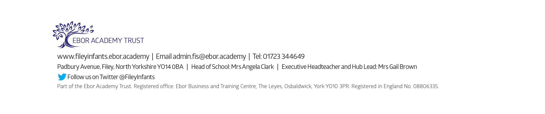
School reopens on Wednesday 7th September 2022

