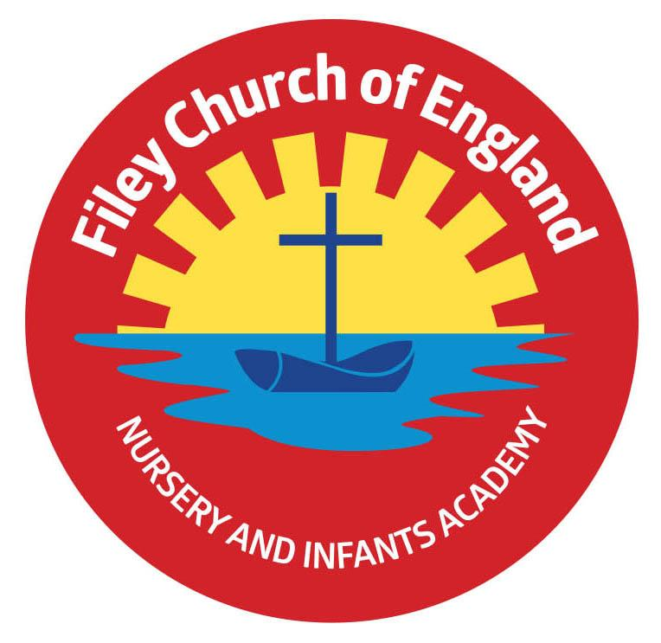

Friday 8th April 2022
Dear Parents/Carers
It has been with great sadness that I have missed these last few days in school before the Easter break due to finally contracting Coronavirus, it was only a matter of time!
I have enjoyed hearing about all the wonderful activities in school this week and seen some super photographs taken by each class. Remember to follow us on Twitter to see these photographs.

We say a temporary goodbye to Mrs George today who will start a yearlong secondment after the Easter break. We wish her well in this new venture and look forward to welcoming her back after this secondment finishes. Mrs Faye MacKay is joining our team from Monday 25th April and will be teaching Mrs George’s year two class. Miss Roen and Mrs Moore will continue to work with this class until the end of the academic year.
Gymnastics Celebration
Well done to everyone for sharing their gymnastics skills over the last two weeks for parents and carers in school. Mr Ellis does a fantastic job in teaching our children PE and it was a lovely opportunity to share the great work that goes on in school with families and friends. Some children find it harder than others to perform in front of an audience and here at Filey CE Nursery & Infants Academy we celebrate all achievements no matter how large or small. We encourage all children to take part or watch from the side-lines in order to promote team spirit and build resilience.
Nursery children did not get to perform their gymnastics celebration because we had to close our school Nursery for three days last week due to Coronavirus. This will still go ahead and will now take place at 2pm on Thursday 28th April.

Easter Hat Parade & Decorated Egg Competition
I hope everyone enjoyed the Easter hat parade around school this afternoon, I have certainly enjoyed looking at the many photographs that have been taken. The competition winners will be on Twitter later today. Here are just a few photographs taken this morning:

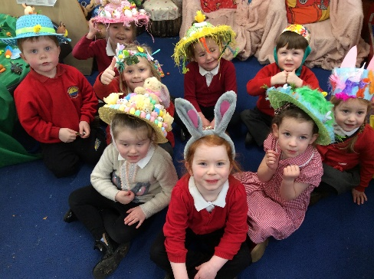
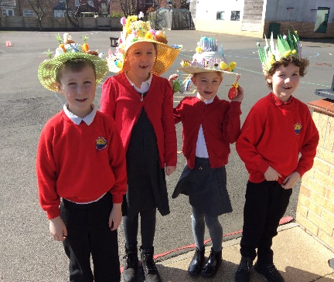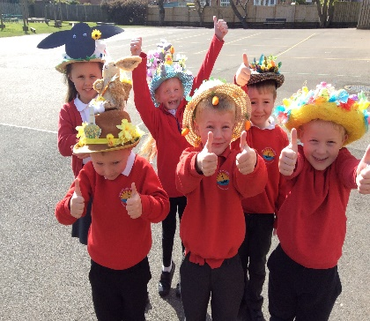

School Cook
We are very happy to welcome our new school cook Teresa Morton. Teresa has been with us for a few weeks now and is certainly proving to be a big hit with the delicious meals she provides. Please remember all Reception, Year 1 and Year 2 children are entitled to Universal Free School Meals, this includes either a hot meal, jacket potato & choice of filling or a sandwich option. The current menu will continue next half term, beginning with week 2.

We would like to thank everyone for their continued support and wish you all a very happy Easter. Warm Wishes
Mrs Angela Clark
Angela Clark
Headteacher

