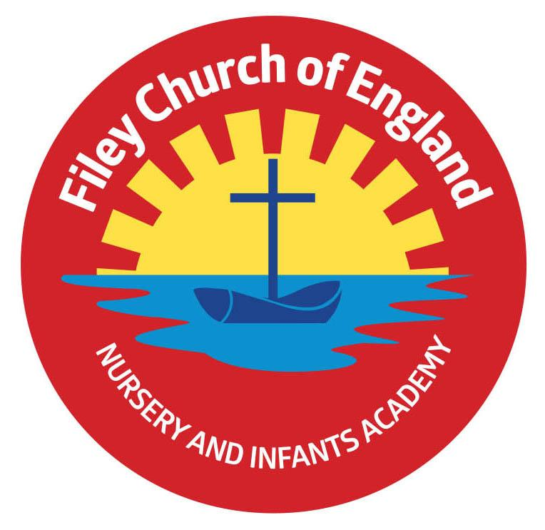
Friday 1st April 2022

Dear Parents/Carers
It was with sadness that we had to close our school Nursery this week for three days due to staff Covid cases. We have tried hard to avoid this in school over the last few weeks but unfortunately this week we just had too many staff absences. If your child is having different teachers at the moment, please understand we are doing our best to keep school open and running the best we can. We also had to cancel the year two children’s visit to St John’s Church and two of our Family Learning sessions this week. Hopefully things will get better soon and next week can return to some kind of normality!

Gymnastic Celebration
Unfortunately our Nursery children did not get to show their gymnastic skills on Friday this week but I am sure Mr Ellis can rearrange this for after the Easter holidays. Date to be rearranged.
The Reception children still shared their wonderful activities with family and all received a gymnastics achievement certificate for their hard work. Children are unique and show differing abilities at different ages, here at Filey Infants we enjoy celebrating everyone’s achievements no matter how large or small. Well done to all our Reception children!
Next week is the turn of our year one and two pupils, please see the date and times below:
Thursday 7th April
Miss William’s Class - 9am-9.45am
Mrs George’s Class – 9.50am-10.35am
Miss Haldenby’s Class - 10.40am-11.25am
Miss Ring’s Class - 1.15pm-2pm
Miss Ghorst’s Class - 2.10pm-2.55pm

Updated Coronavirus Guidance
Unfortunately we have been hit hard with the virus in school this week and staffing has been a challenge. Although there is no legal requirement to isolate anymore we do have the following guidance from public health:
- Children who are unwell and have a high temperature should stay at home and avoid contact with other people. They can go back to school, when they no longer have a high temperature, and they are well enough to attend.
- Adults with a positive COVID-19 test result should try to stay at home and avoid contact with other people for 5 days, which is when they are most infectious. For children and young people aged 18 and under, the advice is now 3 days.
We are asking staff and parents to follow this suggested guidance for everyone’s safety and to try stop/slow down the spread of this virus throughout school. For the full Covid-19 guidance please read the information attached to this email.

Easter Hat Parade
You are all invited to attend our Easter Hat Parade at 2.30pm on Friday 8th April. You will need to arrive via the main office entrance or the gate at the back of school on Clarence Drive, go to your child’s classroom and take a seat! The whole school will then parade through each classroom sharing their Easter hat creations. It is a competition so prizes will be given out on the day. If your child does not want to wear an Easter hat, there of course is no pressure to do so.

Decorated Egg Competition
We will be holding a decorated egg competition on Friday 8th April. If your child wants to take part they will need to bring their egg to school on the morning of the 8th April. The decorated eggs will be displayed in class groups in the school hall ready to be judged mid-morning. There will be a 1st, 2nd and 3rd prize for each class. Good Luck!

It’s all about you!
The Opportunity Centre in Scarborough offers a variety of services for unemployed parents/carers.
They are currently offering a range of ‘It’s all about you’ sessions that build on people’s strengths by developing skills, abilities and overcoming challenges. If you are interested please see the flyer attached to this email.

Book Fair
Thank you to everyone who purchased books from the book fair recently. The Scholastic company gives 20% back to school to spend on books which means we have £162.80 to spend on lovely new books for our Reading Bus!

I have added dates to take us to the end of this academic year. Please be aware that more dates will be added as we progress through the Summer term. As always if you have any questions or concerns please talk to your child’s class teacher or phone the office on 344649. We are here to help however we can. Remember to follow us on Twitter to see what is happening in school.

Warm Wishes
Mrs Angela Clark
Angela Clark
Headteacher

Dates for your diary:
Taking us to the end of this academic year – more dates will be added as we progress through the term.

Monday 4th April – ‘Open the Book’ Collective Worship
Thursday 7th April – Gymnastics Celebration for Year 1 and Year 2 classes
Thursday 7th April – Last after school PE club with Mr Ellis for Year 2
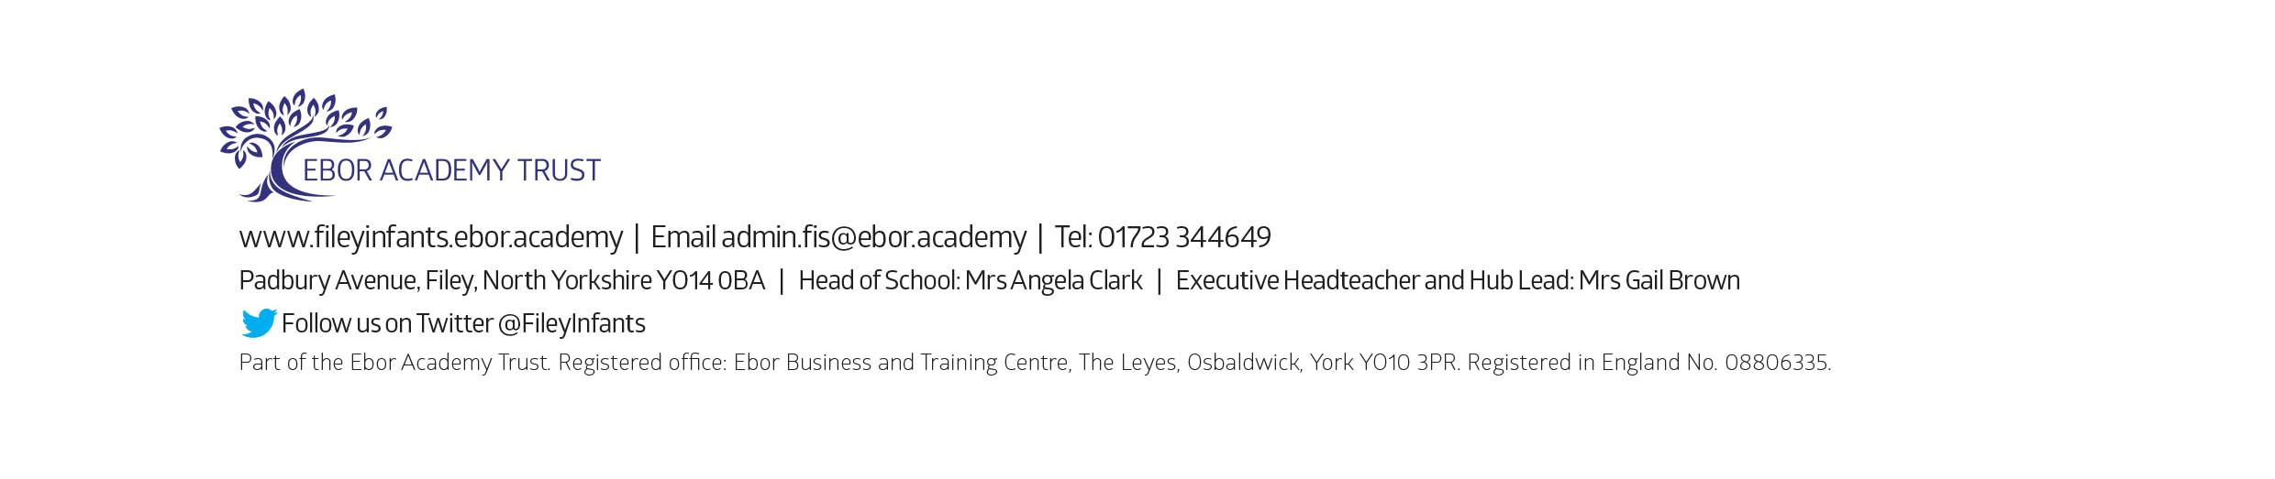
Friday 8th April – Easter hat parade/decorated egg competition & school closes for the end of term

Monday 25th April – School reopens for the Summer Term
Thursday 28th April – First after school PE club for Year 1
Monday 2nd May – Bank Holiday – School Closed
Monday 16th May – Open the Book Collective Worship
Wednesday 18th May – Last swimming session for group 2
Wednesday 25th May – First swimming session for group 3
Thursday 26th May – Last after school PE club for Year 1
Friday 27th May – School closes for half term

Thursday 2nd June – School choir sing for HM Queen Elizabeth II Platinum Jubilee in Filey Memorial Gardens – 11am

Tuesday 7th June – School re-opens
Thursday 9th June – First after school PE club for Nursery
Monday 13th June – Open the Book Collective Worship
Thursday 16th June – Year 2 Outdoor Education Day – Dalby Forest
Friday 24th June – Mrs Stubbs’ class poetry assembly
Thursday 30th June – Year 1 Outdoor Education Day – Glenn Gardens & Filey Beach

Friday 1st July – Mrs Jackson’s poetry assembly
Friday 8th July – Nursery Enterprise 2.15pm
Monday 11th July – Last Open the Book Collective Worship of this academic year
Thursday 14th July – Reception Outdoor Education Day – Filey Beach
Thursday 14th July – Last after school PE club for Nursery
Friday 15th July – Summer Fair 3pm-4.30pm
Monday 18th July – Year 2 Sports Day
Tuesday 19th July – Year 1 Sports Day
Wednesday 20th July – Reception Sports Day
Thursday 21st July – Nursery Sports Day
Thursday 21st July – Year 2 leavers party 5pm – 6.30pm
Friday 22nd July – Year 2 leavers assembly 11am
Friday 22nd July – Whole School Family Picnic 12pm – everyone invited!

