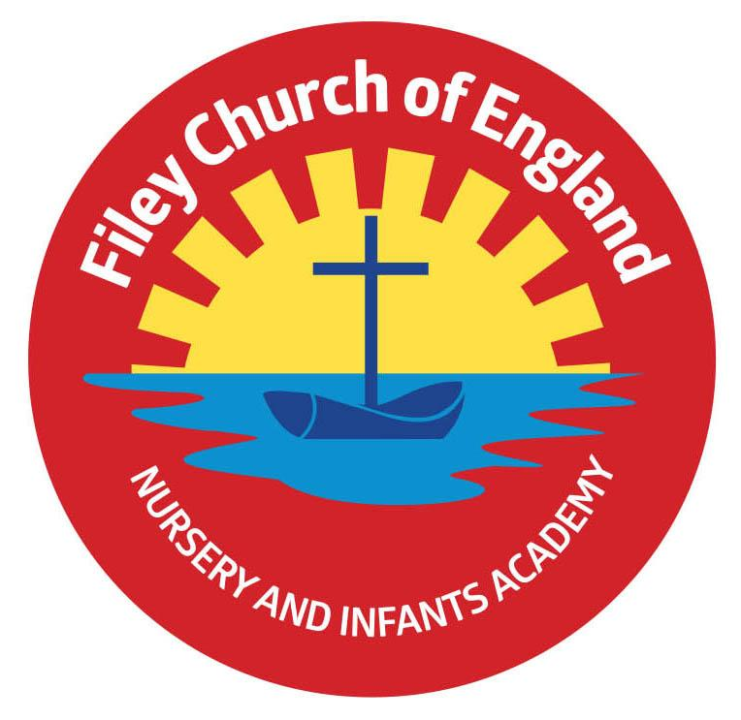
Friday 25th March 2022

Dear Parents/Carers
A longer letter today…that’s what happens when I miss a week!
Well done and thank you to everyone who came to school with funny hair for Comic Relief Day last Friday. As a school we raised £182.34 which will go towards helping people to live a life free of poverty, violence and discrimination.

Gymnastic Celebration – Please note a change of date.
Mr Ellis has been teaching our children gymnastics throughout this half term and we would like to invite parents to attend a Gymnastic celebration in the school hall. Gymnastics is a part of the National Curriculum and all children take part. Please note: this is not a competition but a celebration of the wonderful activities on offer to all children within our school. Please see the following dates and times if you would like to come and share your child’s class gymnastic celebration in our school hall:
Friday 1st April
Miss Hiley’s Class (Nursery am) – 9.15am-10am
Mrs Stubbs’ Class – 10.15am-11am
Miss Hiley’s Class (Nursery pm) – 1.15pm-2pm
Mr Jackson’s Class – 2.10pm-2.55pm
Thursday 7th April
Miss William’s Class - 9am-9.45am
Mrs George’s Class – 9.50am-10.35am
Miss Haldenby’s Class - 10.40am-11.25am
Miss Ring’s Class - 1.15pm-2pm
Miss Ghorst’s Class - 2.10pm-2.55pm

Easter Hat Parade
You are all invited to attend our Easter Hat Parade at 2.30pm on Friday 8th April. You will need to arrive via the main office entrance or the gate at the back of school on Clarence Drive, go to your child’s classroom and take a seat! The whole school will then parade through each classroom sharing their Easter hat creations. It is a competition so prizes will be given out on the day. If your child does not want to wear an Easter hat, there of course is no pressure to do so.

Decorated Egg Competition
We will be holding a decorated egg competition on Friday 8th April. If your child wants to take part they will need to bring their egg to school on the morning of the 8th April. The decorated eggs will be displayed in class groups in the school hall ready to be judged mid-morning. There will be a 1st, 2nd and 3rd prize for each class. Good Luck!

HM Queen Elizabeth II Platinum Jubilee
We would be delighted if members of our newly formed Y2 school choir would be able to perform in Filey Memorial Gardens for HM Queen Elizabeth II Platinum Jubilee. I know this is during the half term holiday and many families will have made plans, however if your child is in our school choir and is able to attend this would be very much appreciated. The planned date is Thursday 2nd June, more information will follow nearer the time.
Holidays in Term Time
If your child is of legal school age (5) and taking them on holiday during term time results in their attendance falling below 90% North Yorkshire County Council will be issuing fines.
In line with school policy we send out regular attendance letters informing you if your child’s attendance is below 90%. These letters follow Government guidance and are given to raise awareness and offer support if needed. They are not intended to upset or antagonise our families in any way. If you have any questions or concerns please come in for a chat or telephone the school office.

Early Years Stay & Play Session
Scarborough, Whitby & Ryedale SEND Hub will be holding a FREE stay & play session on Saturday 2nd April at Overdale School in Scarborough. There will be focused activities to promote language development for early years children. If you would like more information please see the flyer attached to this email.

Beyond Housing
I have received a letter from Beyond Housing to ask if I am able to politely pass on a request. When bringing your children to school in a morning and collecting them at the end of the day please be mindful of blocking resident’s cars. Residents need access to their cars and the road at all times. Please show consideration for our school neighbours whilst continuing to park in a safe and responsible manner.

Free Uniform Cupboard
We have lots of girls Summer dresses, please just ask at the office and give the size you require. Other items are also available please just ask. If you have any good quality uniform that is no longer needed we will gratefully recycle these in school.

Head lice
Please check you child’s hair regularly for head lice, we have had a few cases in school recently. If you do notice head lice in your child’s hair please treat immediately. There is no need for your child to miss school as the treatment process can be done relatively quickly on a morning/evening.

Book Fair
Monday will be the last day to visit the book fair in the school hall.

I have added dates to take us to the end of this academic year. Please be aware that more dates will be added as we progress through the Summer term. As always if you have any questions or concerns please talk to your child’s class teacher or phone the office on 344649. We are here to help however we can. Remember to follow us on Twitter to see what is happening in school.

Warm Wishes
Mrs Angela Clark
Angela Clark
Headteacher

Dates for your diary:
Taking us to the end of this academic year – more dates will be added as we progress through the term.
Monday 28th March – Last day to visit the Book Fair
Thursday 31st March – Year 2 children will visit St John’s Church to take part in some Easter activities.

Friday 1st April – Gymnastics Celebration for Reception classes and Nursery
Friday 1st April – Visitor - Ebor Academy Trustee
Monday 4th April – ‘Open the Book’ Collective Worship
Thursday 7th April – Gymnastics Celebration for Year 1 and Year 2 classes
Thursday 7th April – Last after school PE club with Mr Ellis for Year 2
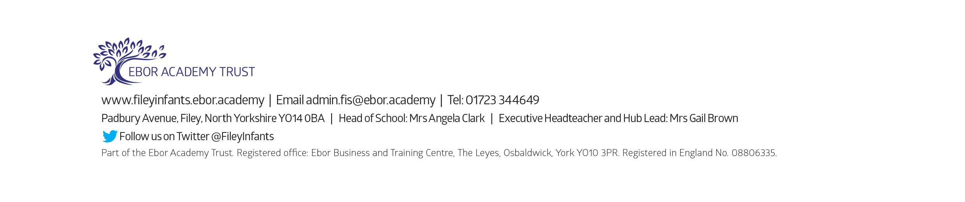
Friday 8th April – Easter hat parade/decorated egg competition & school closes for the end of term

Monday 25th April – School reopens for the Summer Term
Thursday 28th April – First after school PE club for Year 1
Monday 2nd May – Bank Holiday – School Closed
Monday 16th May – Open the Book Collective Worship
Wednesday 18th May – Last swimming session for group 2
Wednesday 25th May – First swimming session for group 3
Thursday 26th May – Last after school PE club for Year 1
Friday 27th May – School closes for half term

Thursday 2nd June – School choir sing for HM Queen Elizabeth II Platinum Jubilee in Filey Memorial Gardens – time to be arranged.

Tuesday 7th June – School re-opens
Thursday 9th June – First after school PE club for Nursery
Monday 13th June – Open the Book Collective Worship
Thursday 16th June – Year 2 Outdoor Education Day – Dalby Forest
Friday 24th June – Mrs Stubbs’ class poetry assembly
Thursday 30th June – Year 1 Outdoor Education Day – Glenn Gardens & Filey Beach

Friday 1st July – Mrs Jackson’s poetry assembly
Friday 8th July – Nursery Enterprise 2.15pm
Monday 11th July – Last Open the Book Collective Worship of this academic year
Thursday 14th July – Reception Outdoor Education Day – Filey Beach
Thursday 14th July – Last after school PE club for Nursery
Friday 15th July – Summer Fair 3pm-4.30pm
Monday 18th July – Year 2 Sports Day
Tuesday 19th July – Year 1 Sports Day
Wednesday 20th July – Reception Sports Day
Thursday 21st July – Nursery Sports Day
Thursday 21st July – Year 2 leavers party 5pm – 6.30pm
Friday 22nd July – Year 2 leavers assembly 11am
Friday 22nd July – Whole School Family Picnic 12pm – everyone invited!

