Friday 4th March 2022

Dear Parents/Carers
A lovely week back in school with Reception and Nursery children making delicious pancakes on Shrove Tuesday. On Thursday we celebrated World Book Day with many fabulous costumes and book related activities. Remember to follow us on Twitter to see what your children have been doing in school.

The War in Ukraine
It has been brought to my attention that a few parents have raised concerns (via social media) regarding school staff discussing the war in Ukraine with our children. I have worked with children for 28 years and know that children care passionately about the world around them. It is our responsibility as education professionals to answer children’s questions in a sensitive and age appropriate manner. We would certainly not hide what is happening, but support children in trying to understanding it. Children are constantly learning about the world around them, they use these experiences to find their voice and become empowered members of society.
Many children in our school returned after the half term holiday talking about this current world news with their friends and teachers. It is completely age appropriate for teachers to discuss in a simplified and sensitive way the facts with our children.
It was mentioned on social media that we are collecting money to buy tanks & guns. Please note! It has NOT and NEVER WOULD be said that we are collecting money in school to buy tanks & guns. This would be completely inappropriate and unprofessional. In fact we are not collecting anything for the war in Ukraine at this moment in time.

If any parents/carers have concerns or questions regarding anything in this school PLEASE talk to your child’s class teacher or myself. I do strongly believe that we are a very approachable team of staff in this school and work hard to provide the very best education for your children. Posting negative comments on social media is both very upsetting for staff and does not resolve issues or answer questions.

Mindful March
Action for happiness has called this month ‘Mindful March’. If you are interested in taking part in some mindfulness activities at home with your children please see the activity sheet attached to this email. ‘I am Peace’ is also a lovely mindfulness story that can be shared with children to help them feel calm: copy and paste the link below to listen to the story. https://www.youtube.com/watch?v=hXA3837uv3w

Comic Relief
Friday the 18th March is Red Nose Day! Children and staff are invited to fashion funny hair on this day and make a donation towards Comic Relief. Red Noses will be available to purchase from the school office at £1.50 from Thursday 10th March. Each class will have a collection pot in their classroom on Friday 18th March.

Book Fair
From Tuesday 22nd March until Monday 28th March we will be holding a school book fair. This will take place in the school hall after school on each of these days. We invite you and your child to come and have a look at the many books for sale. You can also save your £1 World Book Day voucher to use against the price of a book.

Parent Appointments
Please remember to return your letter indicating which date and time you would like to come and talk with your child’s class teacher. If you no longer have the letter please phone the school office to make your appointment.

Please see the updated list of dates for your dairy. If you have any questions or concerns please talk to your child’s class teacher or phone the office on 344649. We are here to help however we can.

Warm Wishes
Mrs Angela Clark
Angela Clark
Headteacher

Dates for your diary:
Thursday 3rd March – World Book Day
Thursday 3rd March – After school PE club with Mr Ellis starts again for Year Two
Monday 7th March – ‘Open the Book’ Collective Worship
Wednesday 9th March – Last swimming lesson for group 1
Friday 11th March – Miss Ghorst’s poetry assembly 9am in the school hall
Monday 14th March – Mrs George’s & Miss Hiley’s Parent Appointments only 3pm-5.30pm
Tuesday 15th March – Parent Appointments 3pm-5.30pm (not including Mrs George)
Wednesday 16th March – Parent Appointments 3pm-5.30pm
Wednesday 16th March – First swimming lesson for group 2
Friday 18th March – Red Nose Day
Tuesday 22nd March – Book Fair arrives in school
Monday 28th March – Last day to visit the Book Fair

Monday 4th April – ‘Open the Book’ Collective Worship
Thursday 7th April – Last after school PE club with Mr Ellis for Year 2
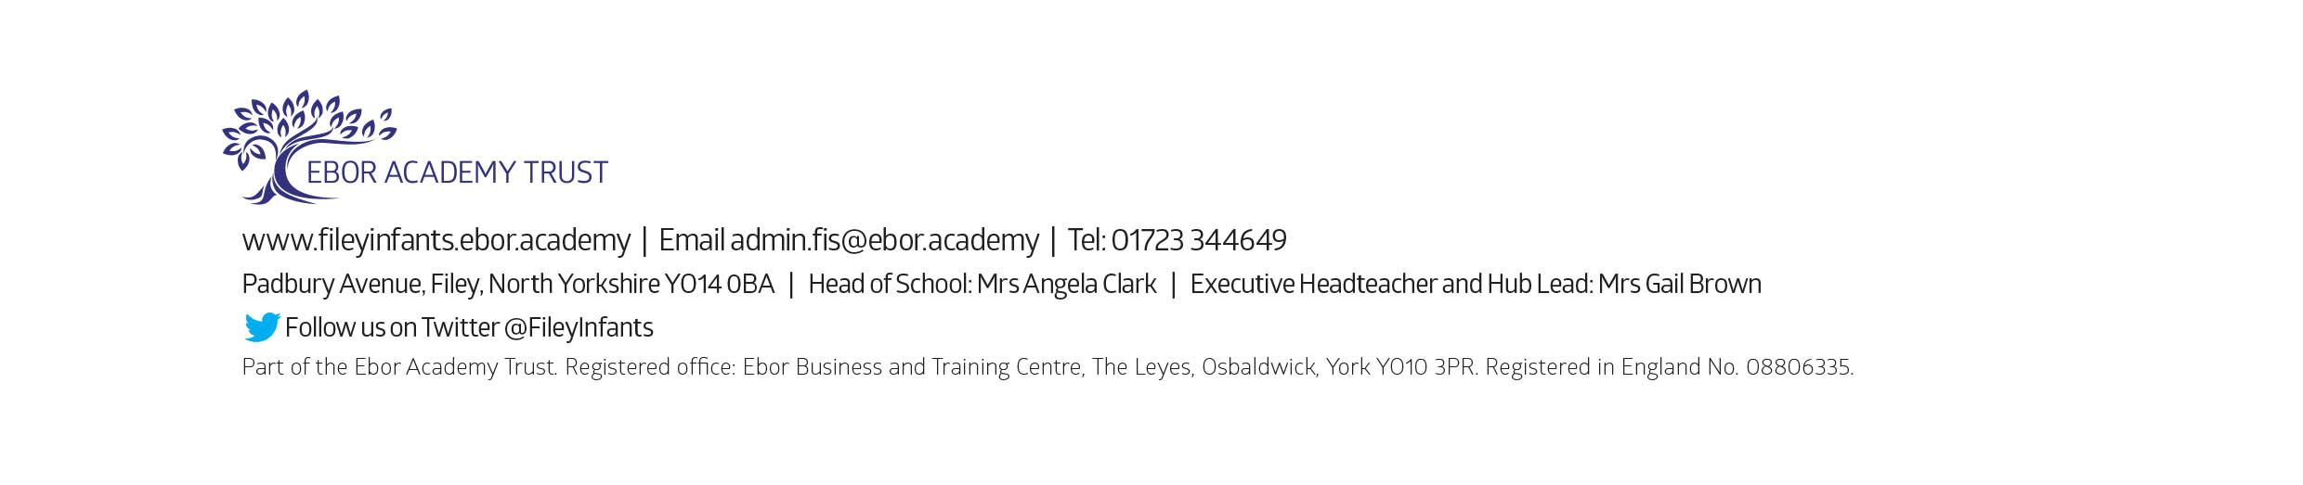
Friday 8th April – Easter hat parade/decorated egg competition & school closes for the end of term

