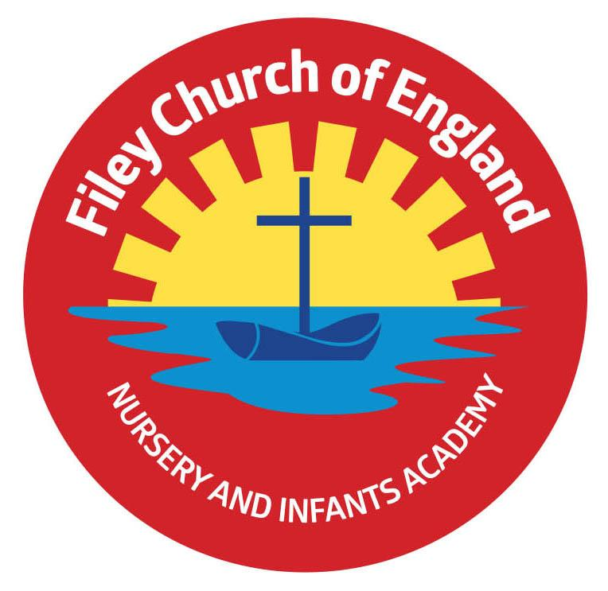
Friday 11th March 2022

Dear Parents/Carers
What a difference the sunshine makes! A beautiful week in school with children enjoying the sunshine in all our different outdoor areas. Miss Ghorst’s class had their poetry assembly this morning with a great turn out from family. This will be uploaded onto our school website for anyone who could not attend to view. It can be found in the usual place under: TEACHING & LEARNING – Classes

Swimming
I am extremely proud of our first Year 2 swimming group. All the children after eight hours of lessons have managed to achieve an award! It has been truly amazing to see the progress they have all made. Today in Collective Worship they all received their certificates and badges, well done everyone! The second group of year 2 swimmers will start their lessons next week. A text has been sent out today to remind them who they are.
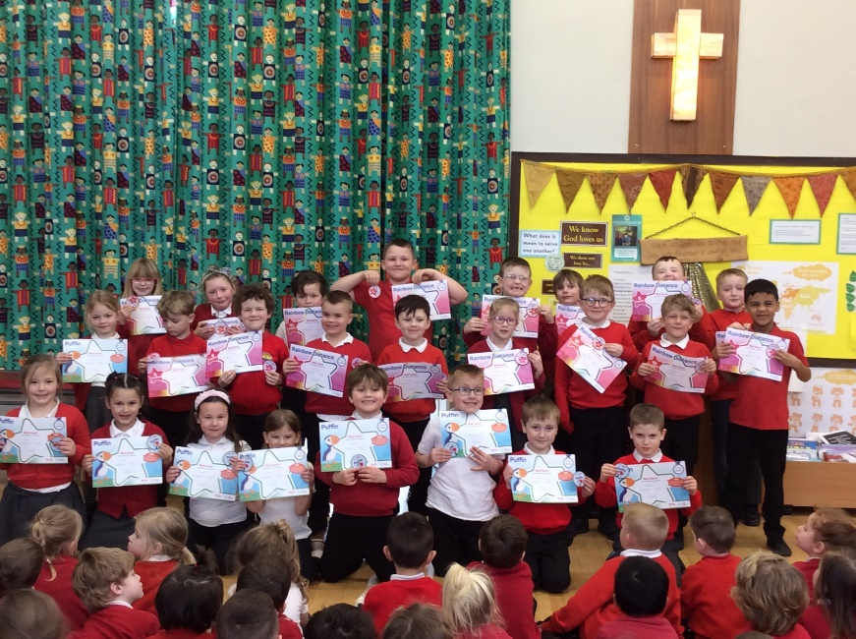
Gymnastic Celebration
Mr Ellis has been teaching our children gymnastics throughout this half term and he would like to invite parents to attend a Gymnastic celebration in the school hall. These will take place on Friday 1st April for year 1 and year 2 classes and Thursday 7th April for Reception classes and Nursery. More information will follow shortly.

Comic Relief
Friday the 18th March is Red Nose Day! Children and staff are invited to fashion funny hair on this day and make a donation towards Comic Relief. Red Noses are now available to purchase from the school office at £1.50

Book Fair
From Tuesday 22nd March until Monday 28th March we will be holding a school book fair. This will take place in the school hall after school on each of these days. We invite you and your child to come and have a look at the many books for sale. You can also save your £1 World Book Day voucher to use against the price of a book.

Parent Appointments
These will take place next week, if you do not have an appointment please phone the school office so this can be arranged.

Please see the updated list of dates for your dairy. If you have any questions or concerns please talk to your child’s class teacher or phone the office on 344649. We are here to help however we can. Remember to follow us on Twitter to see what is happening in school.

Warm Wishes
Mrs Angela Clark
Angela Clark
Headteacher

Dates for your diary:
Friday 11th March – Miss Ghorst’s poetry assembly 9am in the school hall
Monday 14th March – Mrs George’s & Miss Hiley’s Parent Appointments only 3pm-5.30pm
Tuesday 15th March – Parent Appointments 3pm-5.30pm (not including Mrs George)
Wednesday 16th March – Parent Appointments 3pm-5.30pm
Wednesday 16th March – First swimming lesson for group 2
Friday 18th March – Red Nose Day
Tuesday 22nd March – Book Fair arrives in school
Monday 28th March – Last day to visit the Book Fair

Friday 1st April – Gymnastics Celebration for Year 1 and Year 2 classes
Friday 1st April – Visitor - Ebor Academy Trustee
Monday 4th April – ‘Open the Book’ Collective Worship
Thursday 7th April – Gymnastics Celebration for Reception classes and Nursery
Thursday 7th April – Last after school PE club with Mr Ellis for Year 2
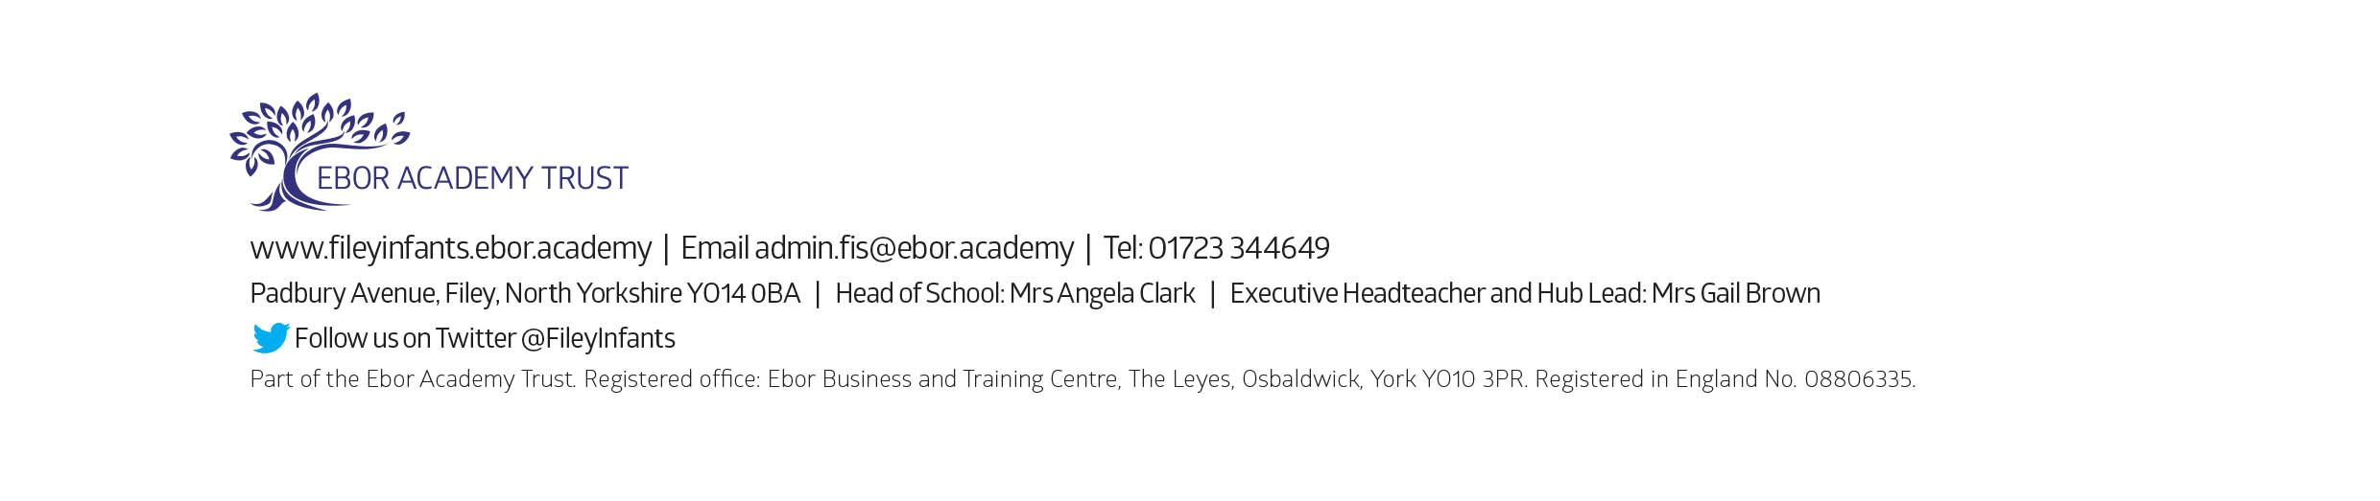
Friday 8th April – Easter hat parade/decorated egg competition & school closes for the end of term
Monday 25th April – School reopens for the Summer Term

