Friday 4th February 2022
Dear Parents/Carers
Reception and Nursery children have been celebrating Chinese New Year this week with a wonderful Dragon parade around school and a delicious Chinese Banquet! This morning we enjoyed Collective Worship time from Miss Ring’s class. A video clip and photographs will be found in the usual place on our school website later today. This can be found under: TEACHING & LEARNING – Classes – Miss Ring.

Collins E-Books
All Reception, Y1 & Y2 have a log in for Collins E-Books. This is where you and your child can access their class guided reading book for the week. A new book is issued each week and is used in class to teach decoding, prosody and comprehension. If you are having any technical difficulties accessing this resource or have further questions please talk to your child’s class teacher or phone the school office.

Parking around School
I know all schools have difficulties when it comes to parking cars safely during drop off and pick up times. Please help us by driving slowly and by parking your cars in safe places. It is NOT acceptable to pull into the bus area at the front of school, no matter how quick you will be or how much in a rush you are! Young children do from time to time run into the road and cars pulling in and out of the bus area during these busy times is a huge risk. Police staff have been patrolling the area recently and will issue tickets if people continue to park their vehicles in an illegal manner.

World Book Day
This year World Book Day is on Thursday 3rd March. Children and staff are invited to dress up as favourite book characters. This is of course optional and any children that do not want to dress up do not have to. The day will be filled with favourite book related activities and a shared assembly in the school hall. There is no need to spend a lot of money on costumes as homemade costumes show imagination and are often more fun!

Free School Uniform Cupboard
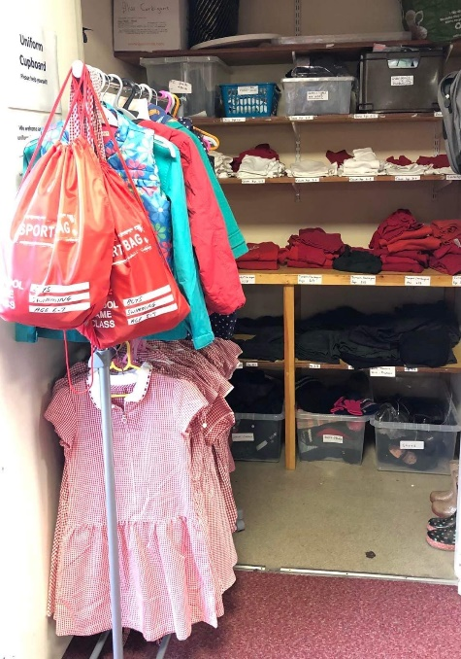
Please remember we have a fully stocked uniform cupboard in school. This includes all items of school uniform as well as coats, shoes, hats, gloves and PE items. Everything has been washed and is of good quality, some clothes have been bought new with money donated from St John’s Church. As you know we love to help the environment and recycle as much as we can. Please if there is anything you can make use of just ask your child’s class teacher or phone Mrs Newlove in the school office. We are always happy to receive good quality uniform that your children have grown out of. Please hand in at the school office.

Act of Kindness Week
The week beginning 14th February is Act of Kindness week. Our Nursery children have been talking about what makes a good friend recently and would like to help a little girl called Amelie in one of our Ebor Academy schools. Amelie has Spastic Paraplegia and needs to go to America for an operation. Nursery children would like to have a bake sale in school on Friday 18th February to raise some money to help Amelie.
If you would like to support this wonderful act of kindness please donate your buns, cakes or biscuits on the morning of Friday 18th February. Or you could send your child to school with some money to buy treats to take home at the end of the day and share with the whole family.

Remember to follow us on Twitter to see what’s happening in school and visit the school website for more information. Please see the updated list of dates for your dairy. If you have any concerns or questions please talk to your child’s class teacher or phone the office on 344649. We are here to help however we can.

Warm Wishes
Mrs Angela Clark
Angela Clark
Headteacher

Dates for your diary:
Friday 4th February – Miss Ring’s poetry assembly 9am in the school hall
Monday 7th February – Open the Book Collective Worship
Tuesday 15th February – Year 2 children visit Filey Junior School to watch the Y3 Pantomime
Wednesday 16th February – Mrs Stubb’s class enterprise 2.30pm in the school hall
Thursday 17th February – Mr Jackson’s class enterprise 2.30pm in the school hall
Thursday 17th February – Last after school PE club with Mr Ellis for Reception
Friday 18th February – Act of Kindness Bake Sale & School closes for half term

Monday 28th February – School reopens
Thursday 3rd March – World Book Day
Thursday 3rd March – After school PE club with Mr Ellis starts again for Year Two
Monday 7th March – Open the Book Collective Worship
Wednesday 9th March – Last swimming lesson for group 1
Friday 11th March – Miss Ghorst’s poetry assembly 9am in the school hall
Tuesday 15th March – Parent Appointments 3pm-5.30pm
Wednesday 16th March – Parent Appointments 3pm-5.30pm
Wednesday 16th March – First swimming lesson for group 2
Monday 4th April – Open the Book Collective Worship
Thursday 7th April – Last after school PE club with Mr Ellis for Year 2
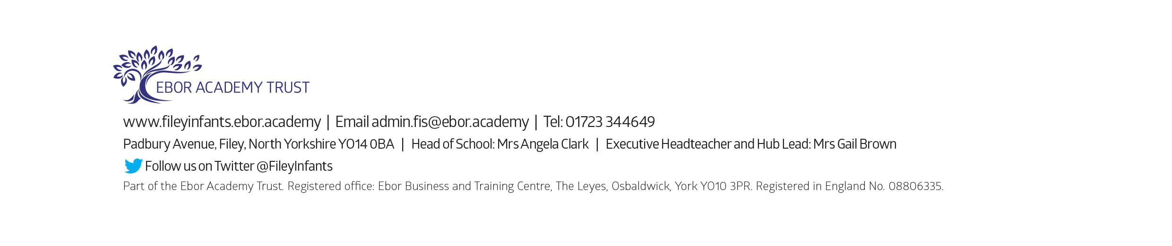
Friday 8th April – Easter hat parade/decorated egg competition & school closes for the end of term

