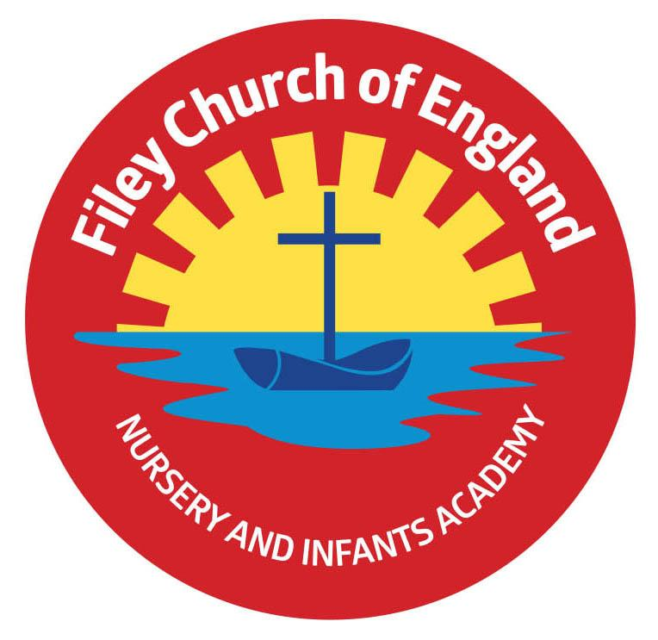
Friday 18th February 2022

Dear Parents/Carers
Another wonderful week in school with Reception class enterprise projects and a delicious bake sale from our Nursery children!

WARNING!

Roblox: The children's game with a sex problem! If your children play on this game at home you may want to read this very disturbing article: https://www.bbc.co.uk/news/technology-60314572

I know myself as a mother how important it is to have age appropriate restrictions on the devices children use at home and completely understand that not everyone knows how to do this. We will be holding a drop in service at school where you can come along with your children’s devices, log on to our school internet and someone will be there to help you set the restrictions you require. This way you know that your children can not access inappropriate material online. I will let you know when we will be holding this drop in session after the half term holiday. If you have any further questions, please just telephone or call in.

Football Flyer

Reception Enterprise Projects
Mrs Stubbs and Mr Jackson’s classes enjoyed their enterprise projects with families this week. They tell me that they did manage to make a fabulous profit of £135.35 by selling their vegan chilli & rice, recipe cards, banana bread and recycled bird feeders. We will let you know how they decide to spend their profit. A big thank you for your support!

Act of Kindness Week
Today during ‘Act of Kindness Week’ our very thoughtful Nursery children had a bake sale to help a little girl called Amelie in one of our Ebor Academy schools. Amelie has Spastic Paraplegia and needs to go to America for an operation. Nursery children managed to raise a wonderful £200 to help this little girl and show their friendship. Thank you to everyone who supported this ‘Act of Kindness’ we hope you enjoy the delicious treats!

Nursery & Reception Tapestry
If you have not yet activated your parent account for Tapestry you will have received another email today allowing you to do so. Tapestry is a platform for you to view and contribute towards your child’s learning in school.

Book Fair
From Tuesday 22nd March until Monday 28th March we will be holding a school book fair. This will take place in the school hall after school on each of these days. We invite you and your child to come and have a look at the many books for sale. You can also save your £1 World Book Day voucher to use against the price of a book.

World Book Day
This year World Book Day is on Thursday 3rd March. Children and staff are invited to dress up as favourite book characters. This is of course optional and any children that do not want to dress up do not have to. The day will be filled with favourite book related activities and a shared assembly in the school hall. There is no need to spend a lot of money on costumes as homemade costumes show imagination and are often more fun!

Remember to follow us on Twitter to see what’s happening in school and visit the school website for more information. Please see the updated list of dates for your dairy. If you have any concerns or questions please talk to your child’s class teacher or phone the office on 344649. We are here to help however we can, have a lovely half term!

Warm Wishes
Mrs Angela Clark
Angela Clark
Headteacher

Dates for your diary:
Monday 28th February – School reopens
Monday 28th February – Choir practise starts for Year 2 children
Thursday 3rd March – World Book Day
Thursday 3rd March – After school PE club with Mr Ellis starts again for Year Two
Monday 7th March – ‘Open the Book’ Collective Worship
Wednesday 9th March – Last swimming lesson for group 1
Friday 11th March – Miss Ghorst’s poetry assembly 9am in the school hall
Monday 14th March – Mrs George’s & Miss Hiley’s Parent Appointments only 3pm-5.30pm
Tuesday 15th March – Parent Appointments 3pm-5.30pm (not including Mrs George)
Wednesday 16th March – Parent Appointments 3pm-5.30pm
Wednesday 16th March – First swimming lesson for group 2
Tuesday 22nd March – Book Fair arrives in school
Monday 28th March – Last day to visit the Book Fair
Monday 4th April – ‘Open the Book’ Collective Worship
Thursday 7th April – Last after school PE club with Mr Ellis for Year 2
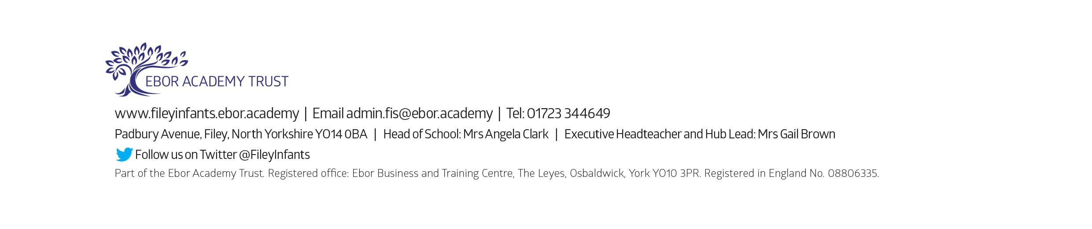
Friday 8th April – Easter hat parade/decorated egg competition & school closes for the end of term

