Friday 11th February 2022
Dear Parents/Carers
Another wonderful week in school with lots of very busy, happy classrooms. Children enjoyed ‘Open the Book’ Collective Worship on Monday from our friends at St John’s Church.

Parent Appointments
Teachers will be holding their Spring Term parent meetings on Tuesday 15th & Wednesday 16th of March. Please note Mrs George will be holding hers on Monday 14th & Wednesday 16th March. This is an opportunity to discuss your child’s progress and social/emotional development with their class teacher. Please look out for the letter coming home with your child next week so you can indicate a preferred day and time slot. If you would prefer a telephone conversation due to Coronavirus this can be arranged.

Book Fair
From Tuesday 22nd March until Monday 28th March we will be holding a school book fair. This will take place in the school hall after school on each of these days. We invite you and your child to come and have a look at the many books for sale. You can also save your £1 World Book Day voucher to use against the price of a book.

World Book Day
This year World Book Day is on Thursday 3rd March. Children and staff are invited to dress up as favourite book characters. This is of course optional and any children that do not want to dress up do not have to. The day will be filled with favourite book related activities and a shared assembly in the school hall. There is no need to spend a lot of money on costumes as homemade costumes show imagination and are often more fun!

Reception Enterprise Projects
Next week children in Mrs Stubbs and Mr Jackson’s class will be inviting their family to attend their Enterprise Projects in the school hall. Mrs Stubbs class Enterprise will take place at 2.30pm on Wednesday 16th February and Mr Jackson’s class Enterprise will take place at 2.30pm on Thursday 17th February. This is a chance for your children to share their work, learn about hopefully making a profit and then how to spend their money wisely! If you would like to support the class with their project please come to the main reception area at the front of school. You will only need a pound or two to spend and you will be helping your children learn.

Act of Kindness Week
The week beginning 14th February is Act of Kindness week. Our Nursery children have been talking about what makes a good friend recently and would like to help a little girl called Amelie in one of our Ebor Academy schools. Amelie has Spastic Paraplegia and needs to go to America for an operation. Nursery children would like to have a bake sale in school on Friday 18th February to raise some money to help Amelie.
If you would like to support this wonderful act of kindness please donate your buns, cakes or biscuits on the morning of Friday 18th February. Or you could send your child to school with some money to buy treats to take home at the end of the day and share with the whole family.
Remember to follow us on Twitter to see what’s happening in school and visit the school website for more information. Please see the updated list of dates for your dairy. If you have any concerns or questions please talk to your child’s class teacher or phone the office on 344649. We are here to help however we can.

Warm Wishes
Mrs Angela Clark
Angela Clark
Headteacher

Dates for your diary:
Tuesday 15th February – Year 2 children visit Filey Junior School to watch the Y3 Pantomime
Wednesday 16th February – Mrs Stubb’s class enterprise 2.30pm in the school hall
Thursday 17th February – Mr Jackson’s class enterprise 2.30pm in the school hall
Thursday 17th February – Last after school PE club with Mr Ellis for Reception
Friday 18th February – Act of Kindness Bake Sale & School closes for half term

Monday 28th February – School reopens
Thursday 3rd March – World Book Day
Thursday 3rd March – After school PE club with Mr Ellis starts again for Year Two
Monday 7th March – ‘Open the Book’ Collective Worship
Wednesday 9th March – Last swimming lesson for group 1
Friday 11th March – Miss Ghorst’s poetry assembly 9am in the school hall
Monday 14th March – Mrs George’s Parent Appointments only 3pm-5.30pm
Tuesday 15th March – Parent Appointments 3pm-5.30pm (not including Mrs George)
Wednesday 16th March – Parent Appointments 3pm-5.30pm
Wednesday 16th March – First swimming lesson for group 2
Tuesday 22nd March – Book Fair arrives in school
Monday 28th March – Last day to visit the Book Fair
Monday 4th April – ‘Open the Book’ Collective Worship
Thursday 7th April – Last after school PE club with Mr Ellis for Year 2
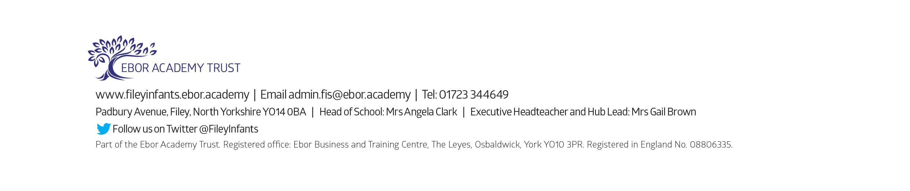
Friday 8th April – Easter hat parade/decorated egg competition & school closes for the end of term

