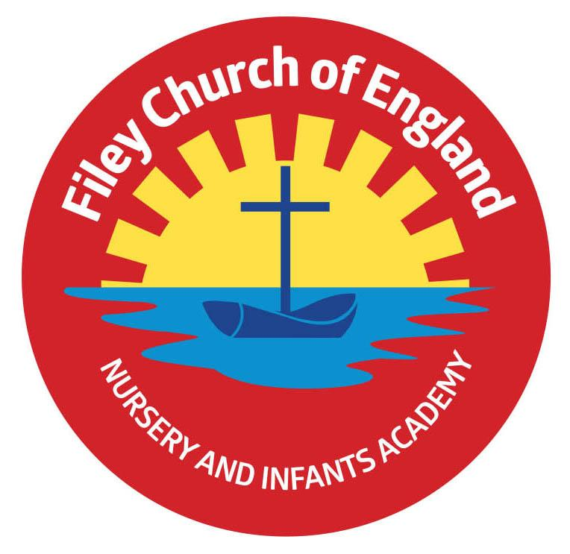
Tuesday 4th January 2022

Dear Parents/Carers

Firstly I would like to wish everyone a very Happy New Year and I hope you all had an enjoyable Christmas. We look forward to welcoming children back to school tomorrow, this letter is simply to give a few updates and reminders.

Morning Routines
The gates open at 8.40am each morning and close again at 8.55am. Children in year one and two will now come into class as soon as they arrive in a morning instead of playing on the playground. Free breakfast will still be available for those children wanting it in each of our classrooms. Please note our school day officially starts at 8.55am and finishes at 3.05pm. If your child arrives late they will need to enter school via the main office and be signed in.

Lunch Menus
Please see the new lunch menus attached to this email and note we will now be having ‘Meat Free Monday’s in support of stopping climate change.

Pupil Absence
Please remember if your child is not going to be in school it is essential that you either phone or email the school office to let us know. If we do not know why your child is absent and we are unable to make contact we have no choice than to make a home visit. If after visiting your home we are still unable to establish the whereabouts of your child we are then required to inform NY police services so they can establish whether you and your children are safe and well. PLEASE, please just let us know! We have to account for all children of legal school age on our register each day by 10am. Thank you.

Coronavirus Safety Measures
One way of reducing the risk of spreading Coronavirus in school is to ensure all areas are well ventilated whilst maintaining a comfortable teaching/learning environment. If your child is susceptible to feeling cold and you would like to send your child to school with an extra layer of clothing or an extra jumper you are welcome to do so. We will of course continue to hand sanitise children on their way into the classrooms and encourage the regular washing of hands. Our school risk assessment is updated regularly and is available for you to read on our school website.

Letter from Ebor Academy Trust
Please read the letter attached to this email from Ebor Academy Trust with some important Coronavirus updates and guidelines from the Department of Education.

Warm Wishes
Mrs Angela Clark
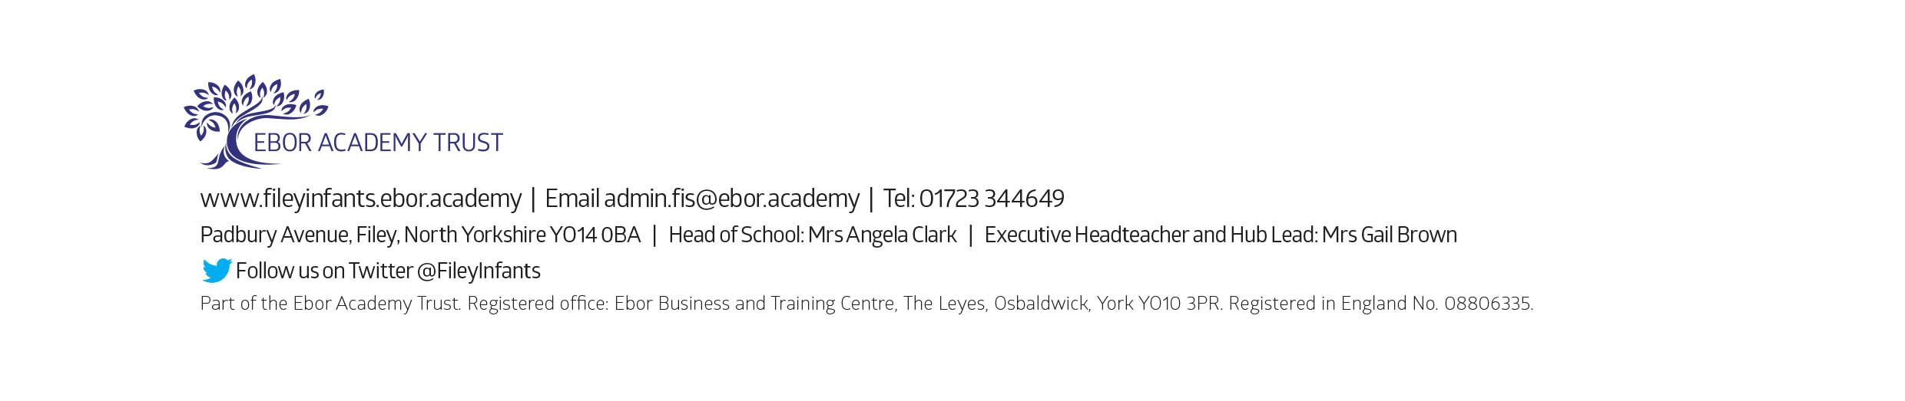
Headteacher

