Friday 28th January 2022

Dear Parents/Carers
Another wonderful week in school with lots of happy and very busy children. Some of our older children visited a special art exhibition at St John’s Church this week. They enjoyed a variety of activities and came back to school with lots of great ideas.

Everyone Welcome!
Restore Filey Community Church are having an interactive family service this Sunday 10.30am at Gristhorpe Village Hall. Everyone is welcome and there is a free lunch provided afterwards.

School Council
Our school council children asked for some outdoor beanbags for the Reflective Area in the playground. They wanted to create an area that is comfortable and safe for quiet reflection. I am delighted that these beanbags have finally arrived and can be used from next week.

Free School Uniform Cupboard
Please remember we have a fully stocked uniform cupboard in school. This includes all items of school uniform as well as coats, shoes, hats, gloves and PE items. Everything has been washed and is of good quality, some clothes have been bought new with money donated from St John’s Church.
If there is anything you need, please let Mrs Newlove know in the office and she will send them home with your child.

Year Two Choir
We are looking to start a choir for year two children, they will rehearse after school until 3.45pm each Monday. Please look out for the letter of interest coming home early next week.

Global Council
Our Global Council members have had a meeting and set us a whole school challenge! They would like everyone in school to recycle all waste paper without exception! Today each classroom and each office area has been provided with a recycling bin for paper only. The children gave a presentation in Collective Worship today and they will be monitoring how we use these bins over the next few weeks.

Food Bags
There will be no food bags today but hopefully they will start again on Friday 4th February, Mrs Newlove will send the usual text to confirm.

Empty Ink Cartridges
Remember if you have empty ink cartridges please bring them into school so we can recycle them. We will receive money for our school and be helping the environment at the same time. This project is called ‘Treasure Hunt’ the web address is www.recycle4charity.co.uk if you would like more information.

NHS Food Scanner App
You may have seen the advert on TV showing you how to swap food for healthier choices.
If you would like to find healthier food swaps for the whole family please see the leaflet attached to this email for more information.

Remember to follow us on Twitter to see what’s happening in school and visit the school website for more information. Please see the updated list of dates for your dairy. If you have any concerns or questions please talk to your child’s class teacher or phone the office on 344649. We are here to help however we can.

Warm Wishes
Mrs Angela Clark
Angela Clark
Headteacher

Dates for your diary:
Friday 4th February – Miss Ring’s poetry assembly 9am in the school hall
Monday 7th February – Open the book Collective Worship
Wednesday 16th February – Mrs Stubb’s class enterprise 2.30pm in the school hall
Thursday 17th February – Mr Jackson’s class enterprise 2.30pm in the school hall
Thursday 17th February – Last after school PE club with Mr Ellis for Reception
Friday 18th February – School closes for half term

Monday 28th February – School reopens
Thursday 3rd March – World Book Day
Thursday 3rd March – After school PE club with Mr Ellis starts again for Year Two
Monday 7th March – Open the Book Collective Worship
Wednesday 9th March – Last swimming lesson for group 1
Friday 11th March – Miss Ghorst’s poetry assembly 9am in the school hall
Tuesday 15th March – Parent Appointments 3pm-5.30pm
Wednesday 16th March – Parent Appointments 3pm-5.30pm
Wednesday 16th March – First swimming lesson for group 2
Monday 4th April – Open the Book Collective Worship
Thursday 7th April – Last after school PE club with Mr Ellis for Year 2
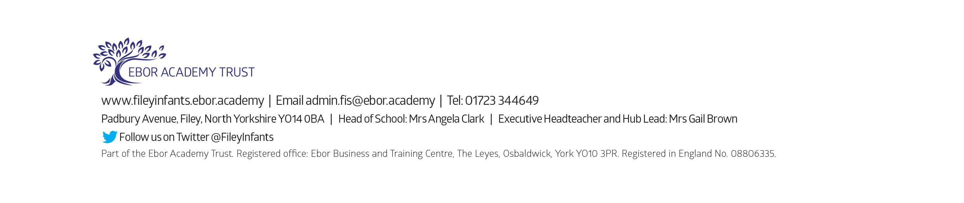
Friday 8th April – Easter hat parade/decorated egg competition & school closes for the end of term

