Friday 21st January 2022

Dear Parents/Carers

While the announcement by the government of the withdrawal of Covid-19 restrictions is welcomed, the situation in primary schools is still serious. For the time being, as we know the wearing of face coverings is effective in limiting the spread of infection we will encourage their continued use in communal areas inside our school.
I therefore continue to ask parents/governors/suppliers visiting our school, to respect our wishes to continue to wear face coverings inside our building, unless they are medically exempt. Once data shows a drop in the number of cases in schools we will re-evaluate. I am sure you will appreciate that it is in everyone’s interest to remain cautious at this delicate time.

Morning Drop-Off
If you are late bringing your child to school please come to the main office. Do not send your child to the office on their own. Cars drive in and out of the car park and Mrs Newlove is not always in the office to receive them. Thank you.

Lunchtimes
We try hard to make lunchtimes as enjoyable as possible for all children in our school.
A variety of play equipment is provided to keep the children occupied during lunchtime play including skipping, hoops, dolls, books, cars, drawing, bean bags, bats, climbing frame, climbing wall and circle games.
There is also a quite area with benches if children want to have a quiet time out. Although the school hall is busy with children eating their lunch, we try to make it a calm/quiet experience with table cloths and flowers on the tables and music playing in the background. Both inside the hall and out on the playground we have a large number of staff supervising, helping and interacting with the children. We also provide several lunchtime clubs including:
Reception
Yoga club with Mrs Haddington 12.40-1pm each day
Nurture club with Miss Barr & Miss Butterfield 12-1pm each day (this is for children that do not want to be on the large playground and prefer a smaller/quieter space to play).
Year 1
Art club with Miss Roen 12.30-1pm Wednesday’s only
Mindfulness club with Miss Campbell 12.30-1pm Thursday’s only
Nurture club with Mrs Egan 12.30-1pm each day (this is for children that like to play in a small supervised group whilst still on the large playground)
Year 2
Art club with Miss Roen 12-12.30pm Monday’s only
Mindfulness club with Miss Campbell 12.30-1pm Wednesday’s only
Nurture club with Mrs Edwards 12-12.30pm each day (this is for children that like to play in a small supervised group whilst still on the large playground)

If you have any questions, concerns or would like your child to be part of a particular club/group, please talk to your child’s class teacher or phone the school office.

Teacher Emails
If you need to email your child’s class teacher for any reason please use the following email address: admin.fis@ebor.academy this will then be passed onto your child’s class teacher.

Food Bags
There will be no food bags for the next two Friday’s. They will hopefully resume again on Friday 4th February, Mrs Newlove will send the usual text to confirm.

Empty Ink Cartridges
If you have empty ink cartridges please bring them into school so we can recycle them. We will receive money for our school and be helping the environment at the same time. This project is called ‘Treasure Hunt’ the web address is www.recycle4charity.co.uk if you would like more information.

NHS Food Scanner App
You may have seen the advert on TV showing you how to swap food for healthier choices.
If you would like to find healthier food swaps for the whole family please see the leaflet attached to this email for more information.

Remember to follow us on Twitter to see what’s happening in school and visit the school website for more information. Please see the updated list of dates for your dairy. If you have any concerns or questions please talk to your child’s class teacher or phone the office on 344649. We are here to help however we can.

Warm Wishes
Mrs Angela Clark
Angela Clark
Headteacher

Dates for your diary:
Friday 4th February – Miss Ring’s poetry assembly 9am in the school hall
Monday 7th February – Open the book Collective Worship
Wednesday 16th February – Mrs Stubb’s class enterprise 2.30pm in the school hall
Thursday 17th February – Mr Jackson’s class enterprise 2.30pm in the school hall
Thursday 17th February – Last after school PE club with Mr Ellis for Reception
Friday 18th February – School closes for half term

Monday 28th February – School reopens
Thursday 3rd March – World Book Day
Thursday 3rd March – After school PE club with Mr Ellis starts again for Year Two
Monday 7th March – Open the Book Collective Worship
Wednesday 9th March – Last swimming lesson for group 1
Friday 11th March – Miss Ghorst’s poetry assembly 9am in the school hall
Tuesday 15th March – Parent Appointments 3pm-5.30pm
Wednesday 16th March – Parent Appointments 3pm-5.30pm
Wednesday 16th March – First swimming lesson for group 2
Monday 4th April – Open the Book Collective Worship
Thursday 7th April – Last after school PE club with Mr Ellis for Year 2
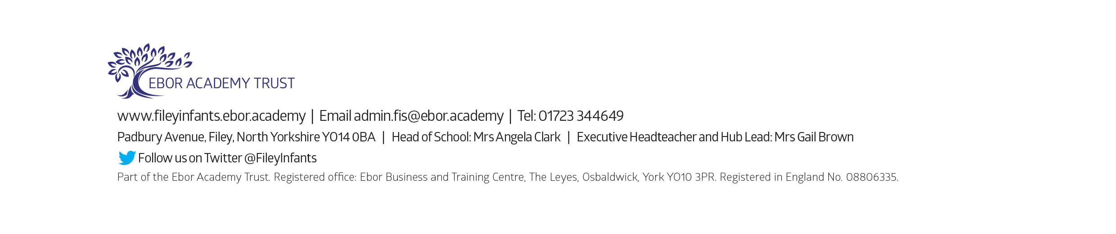
Friday 8th April – Easter hat parade/decorated egg competition & school closes for the end of term

