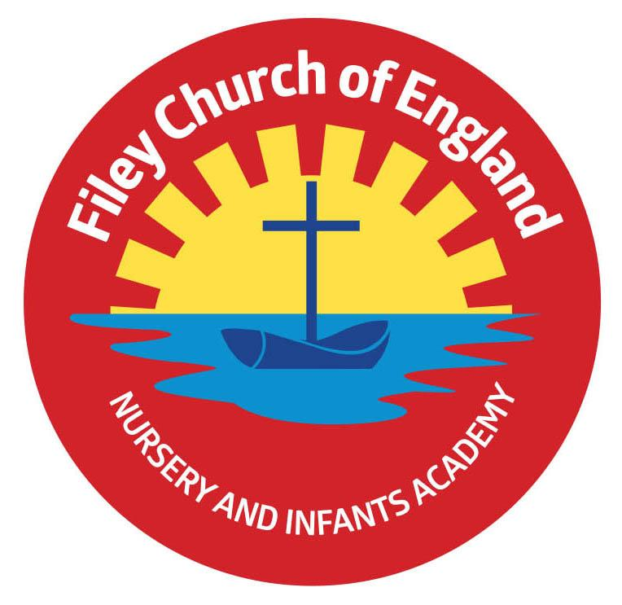
Friday 10th December 2021

Dear Parents/Carers
Another wonderful week in school! I hope everyone enjoyed the Christmas performances. These will be available to view on our school website hopefully by the end of today. Photographs will also be uploaded onto the website for you to view and print as required. The recordings and photographs from all the year group performances can be found under: TEACHING & LEARNING – classes – class teacher’s name

Christmas Parties
Next week will be our school Christmas parties. Nursery & Reception will have their party on Tuesday afternoon and Year One & Two will be on Wednesday afternoon. Children are invited to come to school on their party day wearing their party clothes ready for the afternoon. We please ask that Nursery and Reception children make a donation of buns, Year One contribute biscuits and Year Two bring crisps. Please could these be brought into school on Monday 13th December.

Christingle Service
We enjoyed a wonderful Christingle service at St John’s Church last Friday. A big thank you to Reverend Nigel for the invitation and to our year one children for making the Christingles. Please check our school website to see photographs taken in St John’s Church.

Stephen Joseph Theatre
Next week all children will go to The Stephen Joseph Theatre in Scarborough. There is no charge for this theatre visit or for transport because we are using money raised from the Summer raffle and the Sponsored walk. If your child is in Nursery and does not normally attend on this day and would like to come, please ask the office to arrange a theatre ticket ASAP, you will need to bring your Nursery child to school at the normal time and collect them at 12.30pm.

Christmas Lunch & Christmas Jumper Day
Christmas lunch will take place on Thursday 16th December and is always a wonderful experience with Christmas Crackers and everyone together in the hall. There will be no sandwich or jacket potato option on this day, children are welcome to bring a packed lunch from home although we would encourage children to try the roast turkey dinner if they can.
Remember all children are entitled to Universal free school meals, unfortunately Nursery children do have to pay £1.60.

Change to the Lunch Menu
Next week on Wednesday the hot meal option will be chicken pie instead of roast dinner.

Year Two Swimming Lessons
We are delighted to start the free swimming lessons for year two children after the Christmas holiday. Year Two children have taken a letter home this week with more information. If you have not received this letter please phone the school office on 344639 or ask your child’s
class teacher.

After School PE Club
Mr Ellis will continue the Year One PE club until the end of term. The last session will be on Thursday 16th December. After the Christmas holiday it will be the Reception children’s turn to take part in the after school PE club with Mr Ellis, please look out for the letter coming home soon with your child.

Christmas Fair
Thank you to everyone who supported us with the Christmas Fair. It was a lovely occasion and we raised a wonderful £855.64 towards school funds. This money will as always be used to buy the little extras for our children throughout school.

Pupil Absence
If your child is not going to be in school it is essential that you either phone or email the school office to let us know. If we do not know why your child is absent and we are unable to make contact we have no choice than to make a home visit. If after visiting your home we are still unable to establish the whereabouts of your child we are then required to inform NY police services so they can establish whether you and your children are safe and well. PLEASE, please just let us know! We have to account for all children of legal school age on our register each day by 10am. Thank you.

One again, thank you for your support and many kind words, it is always very much appreciated. I have included a list of dates below, including some dates for the New Year.

Warmest Wishes

Mrs Angela Clark
Angela Clark
Headteacher

DIARY DATES
Friday 10th December – All Christmas productions and photographs will be available on the school website.
Friday 10th December – Mrs George’s class poetry assembly will be available to view on the school website.
Monday 13th December – Open the Book Collective Worship
Tuesday 14th December – Year 1 and Year 2 children visit the Stephen Joseph Theatre to see ‘Jack and the Beanstalk’
Tuesday 14th December – Nursery & Reception children’s Christmas party 1pm
Wednesday 15th December – Nursery & Reception children visit the Stephen Joseph Theatre to see ‘The Giant Who Had It All’
Wednesday 15th December – Year 1 & Year 2 children’s Christmas party 1pm
Thursday 16th December – School Christmas Lunch and Christmas Jumper Day
Friday 17th December – School closes for the Christmas holidays.

Wednesday 5th January 2022 – School reopens
Thursday 6th January – Reception after school PE club starts with Mr Ellis
Monday 10th January – Family reading club sessions start again on ‘Big Red’
Tuesday 11th January – Family learning sessions with Lucy start again.
Wednesday 12th January – Group one swimming club starts
Monday 17th January – Open the book Collective Worship
Friday 4th February – Miss Ring’s poetry assembly 9am
Monday 7th February – Open the book Collective Worship
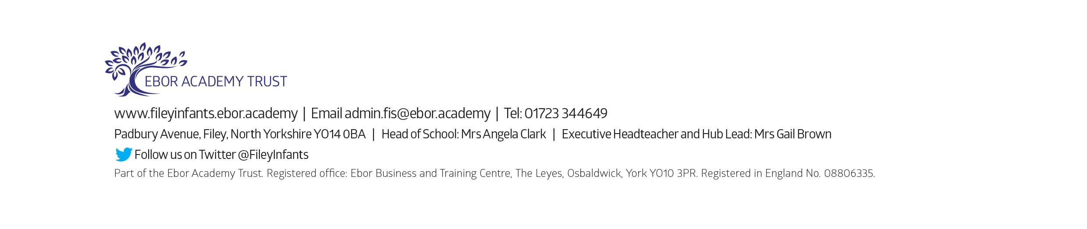
Friday 18th February – School closes for half term

