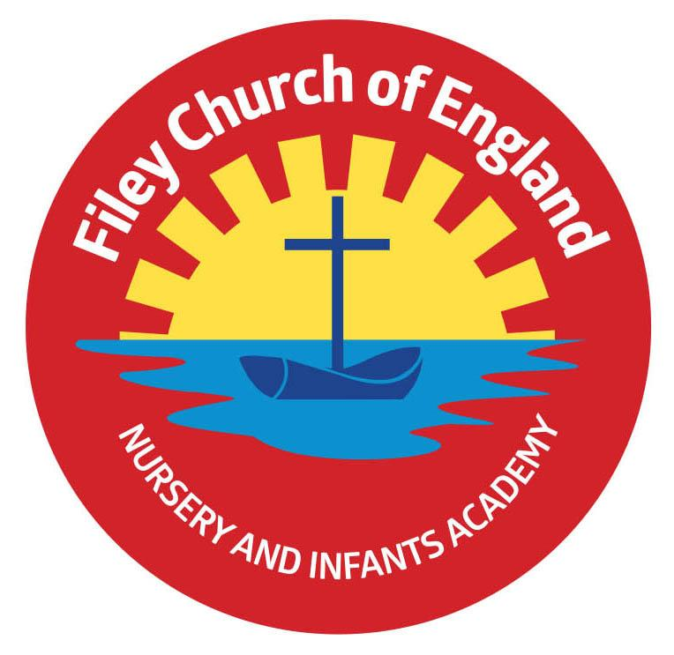
Wednesday 1st December 2021

Dear Parents/Carers
Well, we tried to have a very special Christmas Fair outside this year with twinkling fairy lights! Unfortunately the wind came last night and blew the Marquee down, damaging it beyond repair. Determined as ever, we will make sure the Christmas Fair goes ahead but with some extra Covid-19 systems in place.

The Christmas Fair will now take place inside school, you will need to collect your child as normal and then come through the main reception area. We will spread the stalls and activities out in a few different areas so people have room to move around. We will also keep windows and doors open to provide a good level of ventilation. All adults will be asked to wear a face covering (unless medically exempt) and hand sanitiser will be provided on entry. Please see the list below, so you know where to find all the various stalls and activities.

- The snow machine, music and little donkey will be outside the front of school.
- The bottle tombola, raffle and refreshments will be in the school hall.
- Santa’s Grotto will be in Mrs Stubbs classroom opposite the school office.
- Face painting and sand art decorations will take place in Mr Jackson’s classroom.
- All other festive games and activities will be held in the Nursery areas.

Staff will be on hand to direct you so please just ask if you are not sure.

Christmas Cards
It has been suggested that children might simply like to send one card into school for their whole class this year. This card would then be displayed in the classroom for everyone to see and enjoy. This is just a suggestion and of course is completely up to individuals, children are welcome to bring into school as many or as few Christmas cards as they like.

Family Learning & Reading Club
Family learning sessions will finish this week, with the last session held on Thursday 2nd
December. Reading club has now also finished until after the Christmas holidays. Both clubs will start again in the New Year.

Mrs George Poetry Assembly
Because the children had already written their poems Mrs George has decided to record the class poetry assembly and share it on our school website. This will be available to view from Friday 10th December under: TEACHING & LEARNING – Classes – Mrs George
They will prepare another assembly later in the academic year that parents/carers will be invited to.

Christmas Productions
Tickets have been available for you to collect from your child’s class teacher since Monday 22nd November. There is no charge for the tickets but we do have a strict policy of two tickets per family. This is so we can monitor the number of adults in the school hall at any one time. If you have not yet asked for your tickets please remember to do so ASAP.

Christmas Lunch & Christmas Jumper Day
PLEASE NOTE: We have had to change the date of our Christmas lunch and Christmas jumper day. This will now take place on Thursday the 16th December.

Thank you once again for all your wonderful support. If you have any questions or concerns please come to the main office or telephone 344649, we will always help however we can. Please see below a list of dates taking us to the end of term on Friday 17th December 2021.
Warm Wishes
Angela Clark
Mrs Angela Clark
Headteacher

Friday 3rd December – Christmas fair 3pm, please come to the main reception area at the front of school.

Friday 3rd December – Christingle Service at St John’s Church
Monday 6th December – Nursery & Reception’s Production ‘The Big Little Nativity’ 2pm
Tuesday 7th December – Nursery & Reception’s Production ‘The Big Little Nativity’ 10am
Tuesday 7th December – Year 1 children’s Production ‘Born in a Barn’ 1.30pm
Wednesday 8th December – Year 1 children’s Production ‘Born in a Barn’ 10am
Wednesday 8th December – Year 2 dress rehearsal – Year 3 children are invited to attend.
Thursday 9th December – Year 2 children’s Production ‘The Angel Who Nearly Missed It All’ 9.30am and 1.30pm
Friday 10th December – School Christmas Lunch & Christmas Jumper Day Date changed!
Friday 10th December – Mrs George’s class poetry assembly will be available to view on the school website.
Monday 13th December – Open the Book Collective Worship
Tuesday 14th December – Year 1 and Year 2 children visit the Stephen Joseph Theatre to see ‘Jack and the Beanstalk’
Tuesday 14th December – Nursery & Reception children’s Christmas party 1pm
Wednesday 15th December – Nursery & Reception children visit the Stephen Joseph Theatre to see ‘The Giant Who Had It All’
Wednesday 15th December – Year 1 & Year 2 children’s Christmas party 1pm
Thursday 16th December – School Christmas Lunch and Christmas Jumper Day
Friday 17th December – school closes for the Christmas holidays.

Wednesday 5th January 2022 – school reopens
