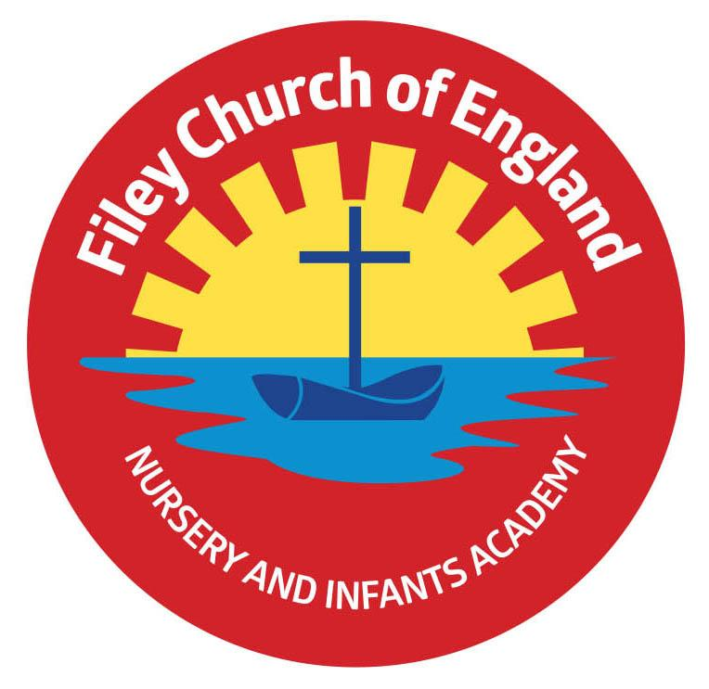
Friday 26th November 2021

Dear Parents/Carers
Another busy week in school with everyone looking lovely in their casual clothes today. Thank you to everyone who donated a bottle for our Christmas Fair next Friday.

Newsletters
I do write newsletters most Friday’s and these are emailed out to everyone and posted on our school website home page under: LATEST NEWS
We also send a text message to everyone notifying them that a newsletter has been issued. There are several reasons why we no longer give paper copies to the children, these being:
- We can’t guarantee your child actually takes the letter home.
- They would often be left in book bags without being read.
- We are trying hard to be more environmentally friendly by not using as much paper.
- It costs us less money on photocopying expenses.
- Parents that are no longer together, providing they have informed the school office will both receive the letters via email at the same time.
- We know that the emails & text messages have been delivered successfully to each individual email address & mobile phone number because our computer system keeps a record of this information.
I hope everyone understands there really is no more we can do to ensure everyone is kept up to date and informed of upcoming events. In fact I have had many parents/carers praise and thank us for the level of communication we provide. If you change your email address or mobile phone number please let us know as soon as possible so we can update our system.

Christmas Fair
We are planning a very special Christmas Fair this year with a snow machine and a little donkey called Dotty! We also have some amazing raffle prizes: 1st prize – 32 Inch Sharp Freeview TV! 2nd prize – A Christmas food and drinks hamper worth £50 + many other wonderful prizes and gift vouchers! Your child should have brought home a sheet of raffle tickets today for anyone wanting to buy some tickets in advance of the fair. Please return your sheet with the correct amount of money any day next week.

The fair will take place at the back of our school, partly inside the building and partly in a decorated marquee on the field. Stalls and activities will be as follows:
- Santa’s Grotto will be in Miss Haldenby’s classroom.
- Cakes, hotdogs and refreshments will be in Miss Williams’s classroom.
- Face painting will be in the link corridor next to Miss Haldenby’s and Miss William’s classrooms.
- The marquee will hold a bottle tombola, raffle stall, guess the weight of the Christmas cake, Christmas sand decorations, name the dog and many other festive games and activities!

Toy Swap
Every year it is estimated that 8.5 million good as new toys go to landfill. If you would like to take part in a ‘Toy Swap’ at The Street in Scarborough on Friday 17th December please see the leaflet attached to this email.
Christmas Lunch & Christmas Jumper Day
PLEASE NOTE: We have had to change the date of our Christmas lunch and Christmas jumper day. This will now take place on Thursday the 16th December.

Christmas Productions
Tickets have been available for you to collect from your child’s class teacher since Monday 22nd November. There is no charge for the tickets but we do have a strict policy of two tickets per family. This is so we can monitor the number of adults in the school hall at any one time. If you have not yet asked for your tickets please remember to do so ASAP.

Mrs George Poetry Assembly
Unfortunately due to staff absence we had to postpone Mrs George’s poetry assembly. This will be rescheduled at a later date.

Thank you once again for all your wonderful support. If you have any questions or concerns please come to the main office or telephone 344649, we will always help however we can. Please see below a list of dates taking us to the end of term on Friday 17th December 2021.
Warm Wishes
Angela Clark
Mrs Angela Clark
Headteacher

Friday 3rd December – Christmas Fair 3pm

Friday 3rd December – Christingle Service at St John’s Church
Monday 6th December – Nursery & Reception’s Production ‘The Big Little Nativity’ 2pm
Tuesday 7th December – Nursery & Reception’s Production ‘The Big Little Nativity’ 10am
Tuesday 7th December – Year 1 children’s Production ‘Born in a Barn’ 1.30pm
Wednesday 8th December – Year 1 children’s Production ‘Born in a Barn’ 10am
Wednesday 8th December – Year 2 dress rehearsal – Year 3 children are invited to attend.
Thursday 9th December – Year 2 children’s Production ‘The Angel Who Nearly Missed It All’ 9.30am and 1.30pm
Friday 10th December – School Christmas Lunch & Christmas Jumper Day Date changed!
Monday 13th December – Open the Book Collective Worship
Tuesday 14th December – Year 1 and Year 2 children visit the Stephen Joseph Theatre to see ‘Jack and the Beanstalk’
Tuesday 14th December – Nursery & Reception children’s Christmas party 1pm
Wednesday 15th December – Nursery & Reception children visit the Stephen Joseph Theatre to see ‘The Giant Who Had It All’
Wednesday 15th December – Year 1 & Year 2 children’s Christmas party 1pm
Thursday 16th December – School Christmas Lunch and Christmas Jumper Day
Friday 17th December – school closes for the Christmas holidays.

Wednesday 5th January 2022 – school reopens
