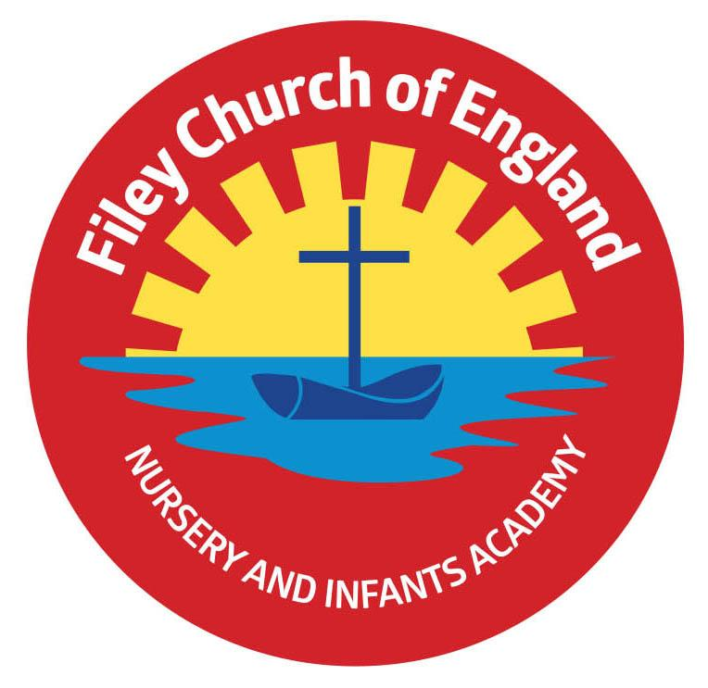
Friday 19th November 2021

Dear Parents/Carers
Another wonderful week in school with an especially fun day for ‘Children in Need’ today. Thank you to everyone who took part and donated to this worthwhile charity. Together we raised a fantastic £180.00!

Christmas Lunch & Christmas Jumper Day
PLEASE NOTE: We have had to change the date of our Christmas lunch and Christmas jumper day. This will now take place on Thursday the 16th December.

Christmas Productions
We are still planning on holding our productions in the school hall and inviting parents to attend. Tickets will be available for you to collect from your child’s class teacher from Monday 22nd November. There is no charge for the tickets but we do need to have a strict policy of two tickets per family. This is so we can monitor the number of adults in the school hall at any one time. To ensure you receive tickets for your chosen performance please act quickly to avoid disappointment!

Casual Clothes Day
Friday the 26th November is casual clothes day and we ask all pupils to ‘Bring a Bottle’ for our Christmas Fair Tombola. Please bring bottles to the classrooms or the school office on casual clothes day. We welcome bottles of shampoo, bubble bath, wine, sauce, spirits, soft drinks etc (unopened bottles only please). Thank you for your support.

Christmas Fair
We are planning a very special Christmas Fair this year with a snow machine and music!
The fair will take place at the back of our school, partly inside the building and partly in a decorated marquee on the field. Stalls and activities will be as follows:
- Santa’s Grotto will be in Miss Haldenby’s classroom.
- Cakes, hotdogs and refreshments will be in Miss Williams’s classroom.
- Face painting will be in the link corridor next to Miss Haldenby’s and Miss William’s classrooms.
- The marquee will hold a bottle tombola, raffle stall, guess the weight of the Christmas cake, Christmas sand decorations, name the teddy bear and many other festive games and activities!

Nuffield Early Language Intervention for all Reception Children (NELI)
As part of an initiative funded by the Department for Education in response to COVID-19, our school is being offered access to a programme called the Nuffield Early Language Intervention (NELI). If your child is in Reception and you would like to know more about this programme please see the letter attached to this email. We hope you will be as excited as we are about this wonderful opportunity for our Reception children. If you have any concerns, or do not wish your child to be assessed using LanguageScreen, please let us know by phoning the school office on 344649.

Flu Vaccinations
PLEASE NOTE: NO children were given the flu vaccination unless parents had given their consent. Nurses ensure that they only administer the vaccination to the children on their list. They check the child’s name, date of birth and the names of their parents to make sure mistakes do not occur. This is also monitored and checked thoroughly by school staff.

Mrs George Poetry Assembly
Please remember Mrs George’s class poetry assembly will take place on Friday 26th November 9am in the school hall. This is limited to no more than two adults per child.

Thank you once again for all your wonderful support. If you have any questions or concerns please come to the main office or telephone 344649, we will always help however we can. Please see below a list of dates taking us to the end of term on Friday 17th December 2021.
Warm Wishes
Angela Clark
Mrs Angela Clark
Headteacher

Friday 26th November – Mrs George’s poetry assembly 9am in the school hall
Friday 26th November – Casual Clothes Day – ‘Bring a Bottle’ for the Christmas Tombola

Friday 3rd December – Christmas Fair 3pm
Friday 3rd December – Christingle Service at St John’s Church
Monday 6th December – Nursery & Reception’s Production ‘The Big Little Nativity’ 2pm
Tuesday 7th December – Nursery & Reception’s Production ‘The Big Little Nativity’ 10am
Tuesday 7th December – Year 1 children’s Production ‘Born in a Barn’ 1.30pm
Wednesday 8th December – Year 1 children’s Production ‘Born in a Barn’ 10am
Wednesday 8th December – Year 2 dress rehearsal – Year 3 children are invited to attend.
Thursday 9th December – Year 2 children’s Production ‘The Angel Who Nearly Missed It All’ 9.30am and 1.30pm
Friday 10th December – School Christmas Lunch & Christmas Jumper Day Date changed!
Monday 13th December – Open the Book Collective Worship
Tuesday 14th December – Year 1 and Year 2 children visit the Stephen Joseph Theatre to see ‘Jack and the Beanstalk’
Tuesday 14th December – Nursery & Reception children’s Christmas party 1pm
Wednesday 15th December – Nursery & Reception children visit the Stephen Joseph Theatre to see ‘The Giant Who Had It All’
Wednesday 15th December – Year 1 & Year 2 children’s Christmas party 1pm
Thursday 16th December – School Christmas Lunch and Christmas Jumper Day
Friday 17th December – school closes for the Christmas holidays.

Wednesday 5th January 2022 – school reopens
