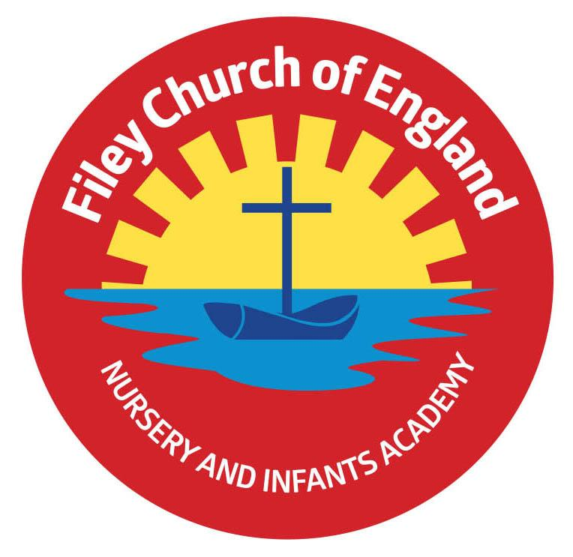
Friday 12th November 2021

Dear Parents/Carers

What a wonderful surprise in school on Wednesday morning when Miss Ring arranged for a hot air balloon display on our school field. Please follow us on Twitter to see the fabulous hot air balloon photos and all the other great things your children do while they are in school.

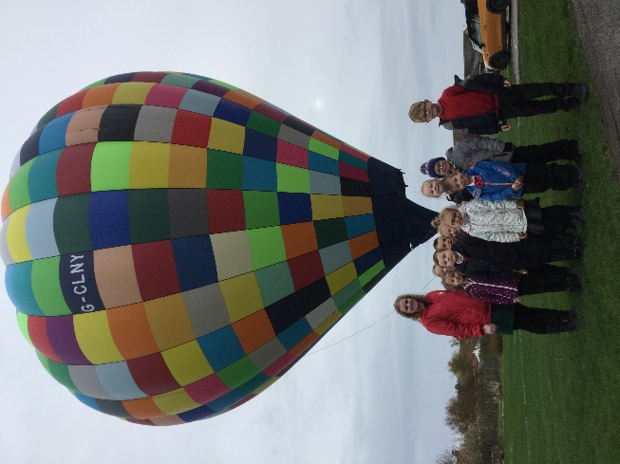
The Royal British Legion Poppy Appeal
Thank you to everyone who has bought poppies this week to support the Royal British Legion. On Thursday our year two children attended the Remembrance Service at Filey Memorial Gardens. They planted their handmade poppies in the soil and took part in the service. They were all an absolute credit to our school, I felt very proud of their behaviour and how they listened to veteran John who was a solider during World War Two.

Flu Vaccinations
These will be taking place on Monday 15th November 2021 in school for Reception, Year 1 and Year 2 children. You will already have given permission if you are wanting your child to have this vaccination.

Asthma Inhalers
If your child has asthma and requires an inhaler in school please complete a medical form if you have not already done so. These forms are available from Mrs Newlove in the school office.

Mrs George Poetry Assembly
Please note there is a change of date for Mrs George’s class poetry assembly. This will now take place on Friday 26th November 9am in the school hall. You are very welcome to attend this event, however I do ask that this is limited to no more than two adults per child.

Miss Haldenby’s Poetry Assembly
Thank you for all those who attended Miss Haldenby’s class poetry assembly today. There will be a recording of part of the performance uploaded onto our school website later today. This can be found in the usual place under: TEACHING & LEARNING – Classes – Miss Haldenby.

Children in Need
Children in need day will be on Friday 19th November. Children and staff are all invited to wear something spotty on this day and raise money for this worthwhile cause.
Class teachers will have a collection pot for any families wanting to make a donation.

Thank you once again for all your support. Please see below a list of dates taking us to the end of term on Friday 17th December 2021.

Warm Wishes
Angela Clark
Mrs Angela Clark
Head of School

Friday 12th November – Miss Haldenby’s poetry assembly 9am in the school hall
Friday 19th November – Children in Need Day – wear something spotty!
Friday 26th November – Mrs George’s poetry assembly 9am in the school hall

Friday 3rd December – Christmas Fair 3pm
Friday 3rd December – Christingle Service at St John’s Church
Monday 6th December – Nursery & Reception’s Christmas Production 2pm
Tuesday 7th December – Nursery & Reception’s Christmas Production 10am
Tuesday 7th December – Year 1 children’s Christmas Production 1.30pm
Wednesday 8th December – Year 1 children’s Christmas Production 10am
Wednesday 8th December – Year 2 children’s dress rehearsal 1.30pm
Thursday 9th December – Year 2 children’s Christmas Production 9.30am and 1.30pm
Friday 10th December – School Christmas Lunch and Christmas Jumper Day
Monday 13th December – Open the Book Collective Worship
Tuesday 14th December – Year 1 and Year 2 children visit the Stephen Joseph Theatre
Tuesday 14th December – Nursery & Reception children’s Christmas party 1pm
Wednesday 15th December – Nusery & Reception children visit the Stephen Joseph Theatre
Wednesday 15th December – Year 1 & Year 2 children’s Christmas party 1pm
Friday 17th December – school closes for the Christmas holidays.

Wednesday 5th January 2022 – school reopens

