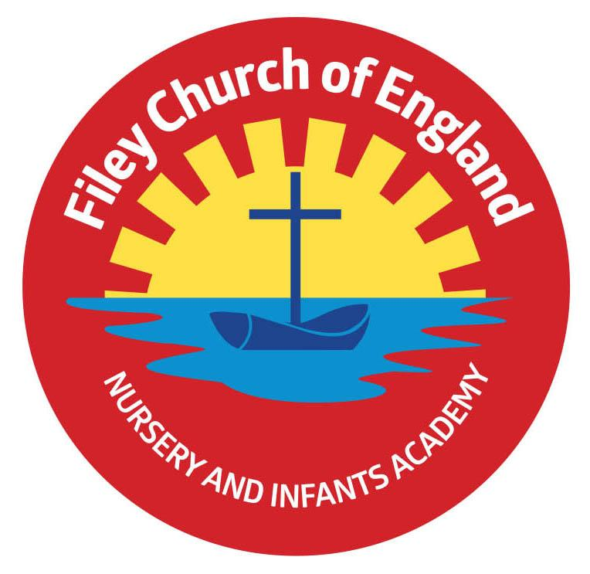
Friday 22nd October 2021

Dear Parents/Carers
Just a short letter today with a few reminders and lots of thanks!

School Meals
Just to remind everyone that all children in Reception, Year 1 and Year 2 are entitled to Universal Free School Meals, unfortunately Nursery meals have to be paid for.
Each day in school your child can choose between a jacket potato with a choice of fillings (tuna, cheese or beans), sandwich with a choice of filings (tuna, cheese, ham or egg) or a hot meal (see the menu attached to this email). They also have a dessert (cake, fruit, jelly or ice-cream) and a drink of water.

Year One PE Club
After half term it will be the year one children’s turn to attend an after school PE club with
Mr Ellis. Your child will have a letter today in their book bag, please return after the holiday.

Final Sponsored Walk Total!
Wow! With everyone’s help we raised a staggering £2’048 towards school funds. This is the most we have ever raised and I would like to say a massive thankyou to everyone for such amazing generosity! This will pay for all our children to visit the theatre just before Christmas and other treats too!

Wear Pink to School Day!
Today was a fun day in school with many children helping us to support the Breast Cancer research charity. We raised a wonderful £108 and had a lovely time too. Please check out our school tweets to see more.

School Uniform
Please remember to write your child’s name in all their school clothes. It is very difficult to return jumpers and cardigans to the right child when so many are un-named.

Download your child’s Learning Journey.
If your child was in one of our reception classes last year and you would like to download their learning journey from Tapestry, please log on and follow the instructions to download. This will be available for you to download until the last day in October. From Monday the 1st November it will no longer be possible to download your child’s learning journey from Reception. If you need help doing this please ask Mrs Newlove in the school office.

Thank you once again for all your wonderful support. Please see below a list of provisional dates taking us up to the end of term on Friday 17th December 2021.
I hope you all have a lovely half term holiday and stay safe & healthy.

Warm Wishes
Angela Clark
Mrs Angela Clark
Head of School

Friday 22nd October – school closes for the half term holidays.

Monday 1st November – School reopens
Wednesday 3rd November – Year 3 children from the Junior School visit our reading bus.
Thursday 4th November – Year One PE club starts 3pm-4pm
Monday 8th November – Open the Book Collective Worship
Thursday 11th November – Year 2 children visit Filey Memorial Gardens 11am
Friday 12th November – Miss Haldenby’s poetry assembly 9am in the school hall
Friday 19th November – Mrs George’s poetry assembly 9am in the school hall

Friday 3rd December – Christmas Fair
Monday 6th December – Nursery & Reception’s Christmas Production 2pm
Tuesday 7th December – Nursery & Reception’s Christmas Production 10am
Tuesday 7th December – Year 1 children’s Christmas Production 1.30pm
Wednesday 8th December – Year 1 children’s Christmas Production 10am
Wednesday 8th December – Year 2 children’s dress rehearsal 1.30pm
Thursday 9th December – Year 2 children’s Christmas Production 9.30am and 1.30pm
Friday 10th December – School Christmas Lunch
Tuesday 14th December – Year 1 and Year 2 children visit the Stephen Joseph Theatre
Tuesday 14th December – Nursery & Reception children’s Christmas party 1pm
Wednesday 15th December – Nusery & Reception children visit the Stephen Joseph Theatre
Wednesday 15th December – Year 1 & Year 2 children’s Christmas party 1pm
Friday 17th December – school closes for the Christmas holidays.

Wednesday 5th January 2022 – school reopens

