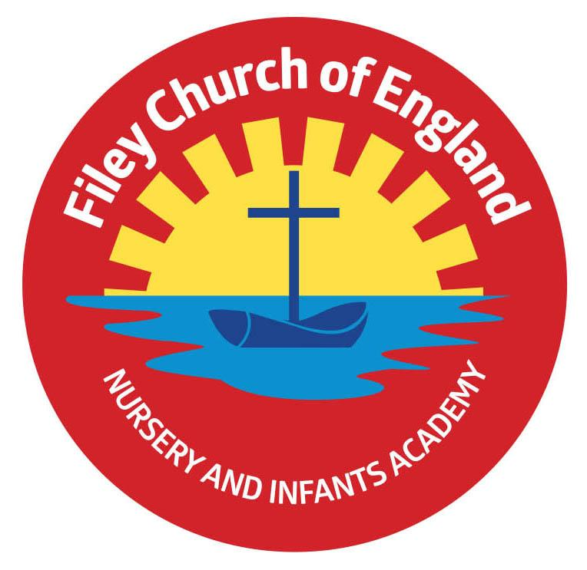
Monday 18th October 2021

Dear Parents/Carers

We have been alerted to a number of Facebook ‘moans’ over the last few weeks! Please, please, please if you have reason to question or disagree with any incident or decision related to our school arrange a time to come and discuss the matter with your child’s class teacher or myself via the school office on 344649. Using social media to criticize and condemn our school staff or pupils only complicates matters and creates feelings of negativity and mistrust. It also does not solve or improve a situation and may well cause unnecessary upset.

Sponsored Walk
Wow! With everyone’s help we raised a staggering £1,715 towards school funds. This will pay for all our children to visit the theatre just before Christmas and other little treats too!
A massive thankyou to everyone. If you still have sponsor money to collect, please try to do this before this Friday 22nd October 2021.

Wear Pink to School Day!
In support of the Breast Cancer research charity, all staff in school will be wearing pink to work this Friday 22nd October 2021 and making a small donation. If your child would like to join us in support of this worthwhile charity they are very welcome to wear pink too! There is no pressure to take part this is of course completely your own personal choice. Thank you!

School Uniform
Please remember to write your child’s name in all their school clothes. It is very difficult to return jumpers and cardigans to the right child when so many are un-named.

Download your child’s Learning Journey.
If your child was in one of our reception classes last year and you would like to download their learning journey from Tapestry, please log on and follow the instructions to download. This will be available for you to download until the last day in October. From Monday the 1st November it will no longer be possible to download your child’s learning journey from Reception. If you need help doing this please ask Mrs Newlove in the school office.

Success at school starts with attendance!
As a school we appreciate and have sympathy for families that have been unable to book holidays over the last couple of years due to financial or travel restrictions. We understand that time spent with family is important and can offer a wealth of new experiences. Unfortunately, following the disruption of Covid, the Government has stated that all children are expected to attend school as normal and holidays cannot be authorised during term time.
As a result, families taking leave of absence during term time may be subject to a fine issued by the local authority, not by school. There are exceptional cases that may lead to an absence being authorised in the following circumstances:
- A parent is service personnel returning from a tour of duty abroad.
- An absence from school is recommended by a health professional.
- The death or terminal illness of a close relative.
- Religious observance – The Education Act 1996 S444
In all of the above cases, it is for the family of the child to provide evidence that the circumstances are truly ‘exceptional’.
It is also important to note that there are in fact 175 non-school days a year – that’s 175 days to spend on family time, holidays, shopping and everything else.

Thank you once again for all your wonderful support. Please see below a list of provisional dates taking us up to the end of term on Friday 17th December 2021.

Warm Wishes
Angela Clark
Mrs Angela Clark
Head of School

Thursday 21st October – Miss Williams class Enterprise in the school hall 9am
Thursday 21st October - Mrs George’s class Enterprise in the school hall 2.30pm
Friday 22nd October – Miss Haldenby’s class Enterprise in the school hall 9am
Friday 22nd October – school closes for the half term holidays.

Monday 1st November – School reopens
Wednesday 3rd November – Year 3 children from the Junior School visit our reading bus.
Monday 8th November – Open the Book Collective Worship
Thursday 11th November – Year 2 children visit Filey Memorial Gardens 11am
Friday 12th November – Miss Haldenby’s poetry assembly 9am in the school hall
Friday 19th November – Mrs George’s poetry assembly 9am in the school hall

Friday 3rd December – Christmas Fair
Monday 6th December – Nursery & Reception’s Christmas Production 2pm
Tuesday 7th December – Nursery & Reception’s Christmas Production 10am
Tuesday 7th December – Year 1 children’s Christmas Production 1.30pm
Wednesday 8th December – Year 1 children’s Christmas Production 10am
Wednesday 8th December – Year 2 children’s dress rehearsal 1.30pm
Thursday 9th December – Year 2 children’s Christmas Production 9.30am and 1.30pm
Friday 10th December – School Christmas Lunch
Tuesday 14th December – Year 1 and Year 2 children visit the Stephen Joseph Theatre
Tuesday 14th December – Nursery & Reception children’s Christmas party 1pm
Wednesday 15th December – Nusery & Reception children visit the Stephen Joseph Theatre
Wednesday 15th December – Year 1 & Year 2 children’s Christmas party 1pm
Friday 17th December – school closes for the Christmas holidays.

Wednesday 5th January 2022 – school reopens

