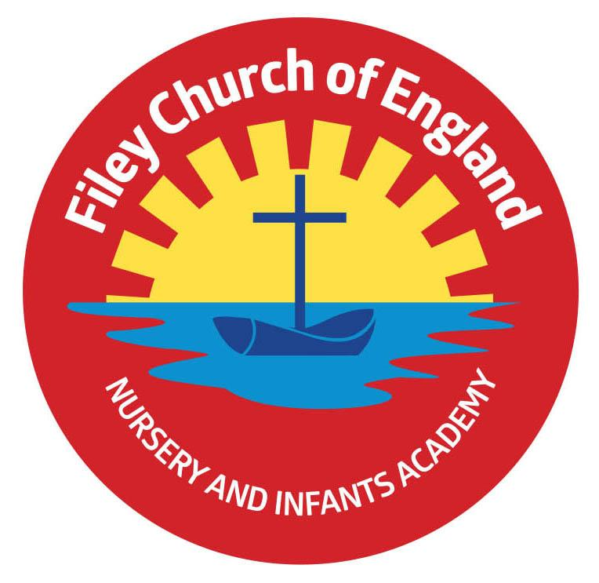
Friday 1st October 2021

Dear Parents/Carers

Harvest Festival was a great success this morning, it was so lovely to welcome parents back into our school hall. A big thank you for all the wonderful Harvest gifts. All our children (except Nursery) took packets and tins to St John’s Church this morning where we shared a Harvest service with Reverend Nigel. This afternoon some of our year 2 children delivered the fresh fruit and vegetables into the local community.
Please visit our school website later today to see each year groups special Harvest songs. These can be found under TEACHING & LEARNING – Classes – Then your child’s class teacher’s name. Enjoy!

‘Big Red’ the reading bus!
BBC Radio York came to visit us on Wednesday 29th September. We took part in three live broadcasts on Georgey Spanswick’s morning show. If you would like to hear our interviews they can be found by copying this link into your search bar: https://www.bbc.co.uk/sounds/play/p09v992j the following numbers will take you straight to our three interviews: 1:22:48, 2:19 and 2:52:08

Family Sponsored Walk - Friday 8th October
Your child should have brought a sponsor form home already to collect sponsors if you would like to help raise some money towards school funds. We will use some of this money towards taking all children to the Theatre in December, which is always a wonderful experience. You are invited to walk with us from school, down along the beach and back to school. If you are joining us the gates will open at 1pm where you will need to meet outside your child’s outside classroom door. This does not include Nursery, they do a little walk inside the school grounds without accompanying adults. They are still welcome to collect sponsors on a form if they would like.
If your child is in Nursery and does not normally attend on a Friday afternoon they are invited to attend for the sponsored walk. They will need to arrive at the usual Nursery door at 1pm and be collected at 3pm.

Morning drop-off times
A couple of parents have asked recently if it is possible to have an earlier drop-off time for children in a morning to allow them more time to walk to the Junior school. This issue was raised and discussed at our Governing body meeting on Wednesday 29th September 2021.
The school gates open at 8.40am prompt, children are invited into class for either a free breakfast or allowed to play outside until the bell rings at 8.55am. The playground and school gates are all supervised for our children’s safety.
Due to the fact that our school day does not start until 8.55am and we open the gates at 8.40am, taking into account staff working hours and teachers needing time to prepare for the day ahead, it was agreed that unfortunately we are not able to allow children into school before 8.40am. We do offer a before and after school club which has a charge and is staffed separately (please see below).

Seashells Before and After School Club
We run a very successful before and after school club for busy parents.
Before school club starts from 7.30am and includes breakfast £4.50 per day.
After school from 3.05pm till 5pm including snack £7 per day.
After school from 3.05pm till 6pm including snack £9 per day.
Breakfast + after school from 7.30am till 6pm including breakfast and evening snack £12 per day. This can be booked through Parent Pay or the school office.

School Meals
Next week our menu has a slight change. Tuesday will be chicken pie for the hot option and Thursday will be ham & cheese pizza. Most children love pizza so if your child would like to try a free school hot meal, Thursday might be the day! Free school meals are available for all children in Reception, Year 1 and Year 2.

Remember to follow us on Twitter to see all the lovely things happening in school and check our school website for further information. Thank you for your continued support. Please keep the updated diary dates below for your information.

Best Wishes
Mrs Angela Clark
Angela Clark
Head of School

Diary Dates
Friday 1st October – Year 2 Harvest Festival 9am in the school hall
Friday 1st October – Visit our school website to see each year groups special Harvest songs etc.
Friday 8th October - Stephen Joseph Theatre workshops in school
Friday 8th October – Family sponsored walk 1pm
Monday 11th October – Parents Evening – 3pm-5pm
Tuesday 12th October – Parents Evening – 3pm-5pm
Wednesday 13th October – Parents Evening – 3pm-5pm
Friday 15th October – Miss Williams Poetry Assembly – 9am in the school hall
Thursday 21st October – Miss Williams Class Enterprise – 9am in the school hall
Thursday 21st October – Mrs George’s Class Enterprise – 2.30pm in the school hall
Friday 22nd October – Miss Haldenby’s Class Enterprise – 9am in the school hall
Friday 22nd October – School closes for half term

Monday 1st November – School reopens

